Contemplation and Conversation: Baptism of our Lord, Sunday, January 10, 2020
Scripture: Psalm 29 https://www.biblegateway.com/passage/?search=Psalm+29&version=NRSV
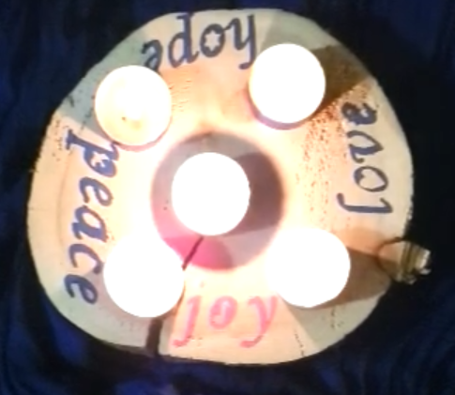
Contemplation and Conversation: "What helped you find hope in the advent season in 2020?"
From Brian Mack:
Just a few short weeks ago, as we entered the Advent season, it would have been easy to dwell on the past and to unceasingly lament that which we perceived as lost because we could not gather in person. It would have been easy to wring our hands in despair and to choose pessimism over possibility. As we were confronted by the reality of the second wave of COVID-19, it would have been easy for us to slip from joy into disillusionment, from love to hatred, from peace to destructive argument, and from hope into perpetual angst.
We could have become fixated on the notion that we could not possibly experience the peace we associate with the beauty of our decorated sanctuaries. Instead, we created outside scenes complete with environmentally friendly decorations, manger scenes, and benches. We offered ourselves and the wider community, a place for solace, quiet rest, and reflection. In so doing, we worshiped the Lord.
We could have bemoaned the fact that we would not be able to fully experience the joy we associate with listening to our choirs, participating in the carol sing hosted by the Eramosa Ensemble, or by welcoming the calming effect of the flute in a reflective service unless we were in the pews. Instead, we found ways to make music together safely, to record it, and to share it with a wider audience through You Tube and zoom. In so doing, we worshiped the Lord.
We could have resigned ourselves to not being able to share our love with those less fortunate through our seasonal outreach projects. Instead, we re-invented the car rally of yester year in the form of the Magi March to offer support to East Wellington Community Services. We envisioned new ways to support Anishinabeg Outreach by collecting funds to support new initiatives involving sewing machines and scholarships. In so doing, we worshiped the Lord.
We could have told ourselves that not being able to meet in person would prevent us from experiencing hope. Instead, we found new ways to offer connectedness through the creation and distribution of advent wreaths. Our young people used their talents to produce slide shows involving scripture, dance, vignettes, vocalization, and the skillful playing of instruments. Our minister shared poignant messages from the comfort of her living room throughout the Advent season. It felt like we were welcomed guests sharing in celebration as we visited and got to know each other better via zoom. In so doing, we worshiped the Lord.
What a pity it would have been if we had not been intentional in our approach to Advent. What a pity it would have been if we had not been open to the words of the psalmist in verse 2 of Psalm 29. By continuously worshiping the Lord in all his holiness, we were able to fully embrace peace, joy, love, and hope. As we were given once again the opportunity to open for ourselves that simple, rustic stable door in Bethlehem, we were able to bask in the same light that enveloped the Shepherds so long ago. Thanks be to God.

Whether you are at home trying to help slow the spread of the virus,
working to help care for those who are impacted most by COVID-19
or working to keep some normalcy in this time,
may you know God’s deep and abiding love in your life.
Know you are a valued part of our Rockwood and Stone United Church families.

Further Conversation … Would you like to talk more about today’s reflection? Email Heather at hleffler@rogers.com. Following worship next Sunday, she will invite others to join you in a Zoom break out room to share in further conversation.

From our Rockwood Stone Affirming Discernment Circle
This morning we enjoyed special music from the Waterloo-Wellington Rainbow Chorus.
Rainbow Chorus Waterloo-Wellington (RCWW) is a community chorus that welcomes members of all genders, sexualities, and gender expressions – and allies of the LGBTQ+ community. They invite members from all levels of experience who enjoy singing a diverse repertoire of choral music, no audition required. They strive to create a supportive community for our members, sing together and have fun. RCWW is a registered charity that succeeds with financial supports from its members, sponsors and communities. If you would like to learn more about the RCWW and how you can support them visit: https://rainbowchorus.ca/
To celebrate Pride 2020, Artistic Director Alison MacNeill and Pianist Chris Fischer brought us together virtually to produce the song “I Choose Love”. RCWW dedicates this song to Marley Yott, a former chorus member who passed away in June. Enjoy the video here: https://www.youtube.com/watch?v=QYCXkQ88nUE

United Church of Canada – January 7 at 11:59 am
Prayer for peace and wisdom in the US
Horrified by the newsletters and the Capitol Assault on the United States of America, we look to you, Creator of All-Love.
With pain, we remember these peaceful demonstrations, in response to concrete and well-attested injustices, under the leadership of people in black and indigenous communities who were bitterly faced by unjustified and violent hostility and labeled rioters. What a contrast in the response and media coverage of current violence overflows, caused by Trump supporters, on behalf of baseless claims.
We pray for the people who live intensely the terror of such acts, and for the people who grasp the depth of hate and racism that fuel them.
We call upon you, Prince of Peace; we pray for your wisdom, direction and love; we pray for the rioters to leave Washington, so that elected decision makers can return to their chambers and continue their task, in accordance with the law and according to the will of the people of the United States.
We pray, with all that we are, God of love. Amen. Amen.
- Moderator Richard Bott, Adele Halliday and Alydia Smith

A gift of belonging to a church is that the practice of gathering together for worship … to pray, sing, listen to scripture and share how God touches our lives – helps us grow in deeper relationship to God and each other. With COVID-19 keeping us at home and physically distant from our Stone or Rockwood families, we are missing each other. We are offering this practice of sharing beyond Sunday morning to deepen our connection. Each week you will be offered a picture, a scripture and a question for contemplation, as well as a short reflection for you to contemplate, have conversation with people in your life and/or join an online conversation on our Rockwood Stone Facebook page.

