Contemplation and Conversation: 2nd Sunday of Easter, April 11, 2021
Scripture: Acts 4:32-35 https://www.biblegateway.com/passage/?search=Acts%204%3A32-35&version=NRSV
Contemplation and Conversation: What is the Spirit inviting you to share?
From Brent Stiles:
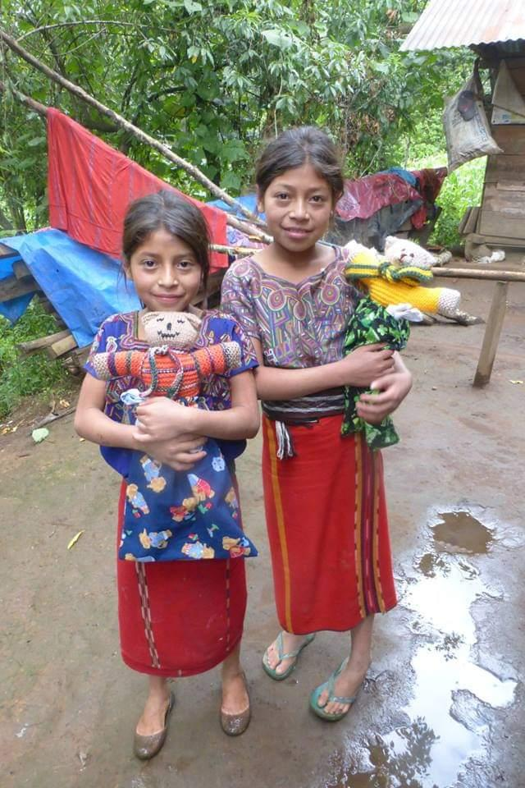
Enrique's sisters … I was visiting my sponsor child Enrique in Rio Azul, Guatemala and brought along some teddy bears for all his siblings. The teddies look like they were hand-made by loving hands and they were given to me to distribute to children in Guatemala. Living in poverty, these girls had very few toys of their own. They lived in the remote mountains far away from big box stores with aisles and aisles of toys that are obtainable to many Canadian children. The children spoke Ixil (Mayan language) so there was that language barrier between us. However, the smiles on their faces told me they were grateful for their gifts.
As I journeyed through Lent I was reminded of the faces where I have seen Jesus in smiles and loving eyes. I am reminded of His love for children and how he brought them into His warm embrace. He cared for all children … including the children with few toys and the children with a room full of toys. (Image taken by me in Rio Azul, Guatemala.)
Jesus said, "Let the little children come to me and do not stop them; for it is to such as these that the kingdom of heaven belongs." Matthew 19:13-15

"Holy Parent, you fashioned us with your own hands. You knew us intimately before we were born.
We are your children. Thank you for loving us as we are and welcoming us into your embrace. Amen."
Prayer taken from: Confronted by Jesus; Daily Reflections for Lent, United Church Publishing House.

Whether you are at home trying to help slow the spread of the virus,
working to help care for those who are impacted most by COVID-19
or working to keep some normalcy in this time,
may you know God’s deep and abiding love in your life.
Know you are a valued part of our Rockwood and Stone United Church families.

Further Conversation … Would you like to talk more about today’s reflection? Email Heather at hleffler@rogers.com. Following worship next Sunday, she will invite others to join you in a Zoom break out room to share in further conversation.

United Church of Canada
Moderator Richard Bott’s Prayer on Prince Philip's passing
#UCCan #princephilipdukeofedinburgh #prayer
https://united-church.ca/.../death-his-royal-highness...
Loving God,
In this muted Eastertide,
when we celebrate symbols of new life, hope, and resurrection
amidst a global pandemic,
we mourn the death of His Royal Highness, Prince Philip, Duke of Edinburgh,
while celebrating the love His Royal Highness shared during his long life of public service.
We are especially grateful for the ways His Royal Highness worked to empower young people, and for the continued legacy of The Duke of Edinburgh’s International Award.
Every Eastertide,
we are reminded that nothing, neither life nor death,
can separate us from your love,
and the love that we share with each other.
With this assurance,
we commend His Royal Highness’s passion to our hearts,
and extend our prayers to the Queen, the other members of the Royal Family, and all who knew and loved the Duke of Edinburgh.
Amen.

A gift of belonging to a church is that the practice of gathering together for worship … to pray, sing, listen to scripture and share how God touches our lives – helps us grow in deeper relationship to God and each other. With COVID-19 keeping us at home and physically distant from our Stone or Rockwood families, we are missing each other. We are offering this practice of sharing beyond Sunday morning to deepen our connection. Each week you will be offered a picture, a scripture and a question for contemplation, as well as a short reflection for you to contemplate, have conversation with people in your life and/or join an online conversation on our Rockwood Stone Facebook page.

