Contemplation and Conversation: 5th Sunday of Easter, May 2, 2021
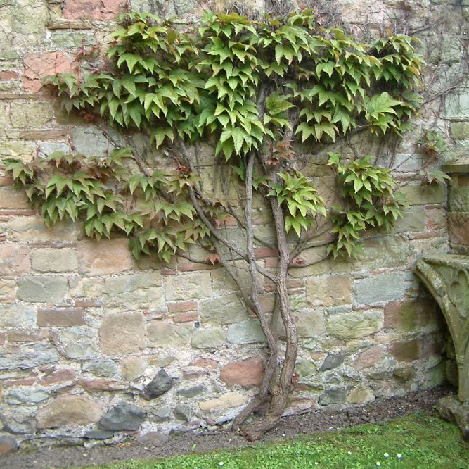
Scripture: John 15:1-8 https://www.biblegateway.com/passage/?search=John%2015%3A1-8&version=NRSV
Contemplation and Conversation: What does being a branch in the vine that is Jesus mean to you?
From Rev. Heather Leffler:
This passage always reminds me of attending my Aunt’s church for vacation Bible School. I still remember the felt banner of a vine with branches I made and feeling very connected to Jesus.
The church was Erb Street Mennonite. Through them I was introduced to the Mennonite Central Committee (MCC) and the wonderful work they do in Canada and around the world. The Toronto Ontario Opportunities for Learning and Service (TOOLS) trip that Brent Stile led is part of their work reaching out with compassion to people who live on the streets in Toronto.
Thinking about the many churches and people in Canada and around the world who have shaped my faith and helped me connect to Jesus, the image of the vine grounds me.
Together we are a living body that grows and bears fruit. From time to time, when we aren’t as productive, we need to prune out practices, patterns of conversations and beliefs that get in the way of loving as Jesus loved. Today as we mark Mental Health Sunday, we become aware of things we have said that have hurt or judged people living with mental health conditions, challenges and illness – offering them pat answers or fixes. Pruning will help us listen with compassion and hold those in need in prayer.
May knowing you are a part of the vine that is Jesus bring you comfort, healing and hope today.

Whether you are at home trying to help slow the spread of the virus,
working to help care for those who are impacted most by COVID-19
or working to keep some normalcy in this time,
may you know God’s deep and abiding love in your life.
Know you are a valued part of our Rockwood and Stone United Church families.

Further Conversation … Would you like to talk more about today’s reflection? Email Heather at hleffler@rogers.com. Following worship next Sunday, she will invite others to join you in a Zoom break out room to share in further conversation.

From our Rockwood Stone Affirming Discernment Circle
Attached to this email is a bulletin insert from The United Church of Christ Mental Health Network and The United Church of Canada marking Mental Health Sunday. It offers us ways to respond to people experiencing mental health concerns so that we can make our churches communities of radical belonging.

United Church of Canada: From Moderator Richard Bott
Oh, God, how will I meet you
as sun breaks on this day?
In challenge or celebration,
as I wander on life's way?
Your presence is my touchstone,
throughout life's twists and turns;
in slumping or in dancing,
in hopes and in concerns.
Your love holds all creation,
binding each to all-in-all;
life-giver, liberator,
from the largest to the small;
you know each part and being,
the quarks that spin around,
the symphony of this universe,
the chaos of its sound!
In each moment that passes,
in nighttime or the day,
alone or with the masses,
it is to you I pray;
Creator, Christ, and Spirit,
the Holy Trinity,
bless all the world with hope and love,
thoughout eternity!
(Edit: Can be sung to St. Theodolph, 7676D, VU31 "O Lord, how shall I meet you")

A gift of belonging to a church is that the practice of gathering together for worship … to pray, sing, listen to scripture and share how God touches our lives – helps us grow in deeper relationship to God and each other. With COVID-19 keeping us at home and physically distant from our Stone or Rockwood families, we are missing each other. We are offering this practice of sharing beyond Sunday morning to deepen our connection. Each week you will be offered a picture, a scripture and a question for contemplation, as well as a short reflection for you to contemplate, have conversation with people in your life and/or join an online conversation on our Rockwood Stone Facebook page.

