Contemplation and Conversation: 6th Sunday of Easter, May 9, 2021
Scripture: Psalm 67 https://www.biblegateway.com/passage/?search=psalm+67&version=NRSV
Contemplation and Conversation: What blessings in your life do you give thanks for today?
From Lisa Leffler
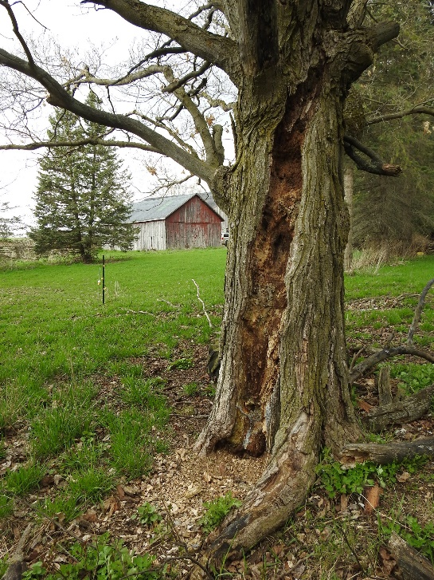
I find the Psalms to be one of the most under-used pieces of scripture. They express joy and sorrow, fear and love, anger and optimism, all while holding God at the centre of our experience. One hesitation I have heard people express about using the Psalms is that they may be expressing something that the reader or listener is not feeling at the time. Although it is true that there will times when you identify with one Psalm more than another, I think this concern fails to acknowledge the complexity of our emotions. You don’t just feel happy or sad, joyful or angry, optimistic or anxious. Our lives are complicated and so our emotional experience is also complicated and varied.
Over the past year I decided to spend time with the Psalms by following the theme (and usually the style) of a Psalm and writing it in my own words – speaking to my own experience. There are days when the Psalm has aligned with my dominate experience and the words have flowed easily. Other times I have had to dig a little deeper to past experiences or things I have been ignoring in my life. This journey of writing has been such a blessing because it has pushed me to confront challenges that I needed to work through, and it has encouraged me to celebrate the joys in my life.
Today’s Psalm is inviting us to praise God for our blessings. Whether that is something you can do easily today or something that requires digging a little deeper remember that God is there with you for every step of the journey.
Here is my re-imaging of Psalm 67:
May you feel God’s presence in your life
and know God’s blessing,
May God’s plan for us be apparent
throughout all the earth.
Let us all sing praises to God;
Sing praises to God
in thanksgiving for God’s wondrous works.
May all people know God’s love
and sing God’s praises,
For God teaches us the importance of equity
and making sure that everyone is cared for.
Let us all sing praises to God;
Sing praises to God
in thanksgiving for God’s wondrous works.
God’s gifts abound throughout the earth,
God has offered us God’s blessing,
to share with one another.
Let us all sing praises to God;
Sing praises to God
in thanksgiving for God’s wondrous works.
If you are interested in the rest of my Psalm project you can find it here: http://musingsandmeditations.com/

Whether you are at home trying to help slow the spread of the virus,
working to help care for those who are impacted most by COVID-19
or working to keep some normalcy in this time,
may you know God’s deep and abiding love in your life.
Know you are a valued part of our Rockwood and Stone United Church families.

Further Conversation … Would you like to talk more about today’s reflection? Email Heather at hleffler@rogers.com. Following worship next Sunday, she will invite others to join you in a Zoom break out room to share in further conversation.

From our Rockwood Stone Affirming Discernment Circle
In a blog post for Mental Health Awareness Week, Rev. Cindy Bourgeois considers how a world without transphobia would improve the mental health of trans people.
"I wonder what it would mean that instead of wishing I am not trans, I wished I lived in a world where transphobia was no more. I wonder what it would mean if everybody who doesn’t hate trans people wished for a world where being trans was not only accepted but perhaps even celebrated. Maybe if we did that, we could improve not only my mental health but the mental health of every trans person who is struggling in this broken world."
For the full blog click here: https://united-church.ca/blogs/round-table/wishing-better-world?fbclid=IwAR14C4ymZ_-jWEqTmw8472lj-tLKgZXasW0FRvqwGlmSiuRX7IqyOuHBaYE
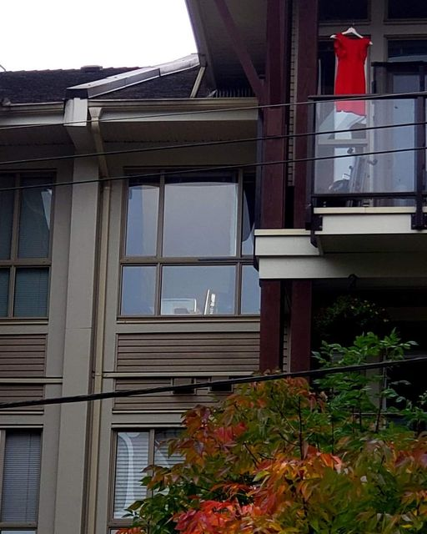
United Church of Canada: From Moderator Richard Bott
Today, I saw red dresses hanging - from tree branches, from lamp poles, from doors and windows. Moving in the breeze, they commemorate the thousands and thousands of murdered and missing Indigenous women and girls across this land.
For me, as a settler, each of them was also a banner that said, over and over, "what are you going to do, to make a difference for our sisters and daughters, our aunties and grandmothers, the Indigenous girls and women who live *now*?"
I sat, tonight, reading again the executive report of National Inquiry into Missing and Murdered Indigenous Women and Girls.
There were so many words that struck me:
"As the evidence demonstrates, human rights and Indigenous rights abuses and violations committed and condoned by the Canadian state represent genocide against Indigenous women, girls, and2SLGBTQQIA people. These abuses and violations have resulted in the denial of safety, security, and human dignity. They are the root causes of the violence against Indigenous women, girls, and 2SLGBTQQIA people that generate and maintain a world within which Indigenous women, girls, and 2SLGBTQQIA people are forced to confront violence on a daily basis, and where perpetrators act with impunity.
The steps to end and redress this genocide must be no less monumental than the combination of systems and actions that has worked to maintain colonial violence for generations.
A permanent commitment to ending the genocide requires addressing the four pathways explored within this report, namely:
• historical, multigenerational, and intergenerational trauma;
• social and economic marginalization;
• maintaining the status quo and institutional lack of will; and
• ignoring the agency and expertise of Indigenous women, girls, and 2SLGBTQQIA people."
There is work that needs to be done.
This link is to the executive summary.
https://www.mmiwg-ffada.ca/publication/executive-summary-english/

A gift of belonging to a church is that the practice of gathering together for worship … to pray, sing, listen to scripture and share how God touches our lives – helps us grow in deeper relationship to God and each other. With COVID-19 keeping us at home and physically distant from our Stone or Rockwood families, we are missing each other. We are offering this practice of sharing beyond Sunday morning to deepen our connection. Each week you will be offered a picture, a scripture and a question for contemplation, as well as a short reflection for you to contemplate, have conversation with people in your life and/or join an online conversation on our Rockwood Stone Facebook page.

