Contemplation and Conversation: 3rd Sunday after Pentecost, June 13, 2021
Scripture: Mark 4 :26-34 https://www.biblegateway.com/passage/?search=Mark%204%3A26-34&version=NRSV
Contemplation and Conversation: Where is God calling you into deeper relationship?
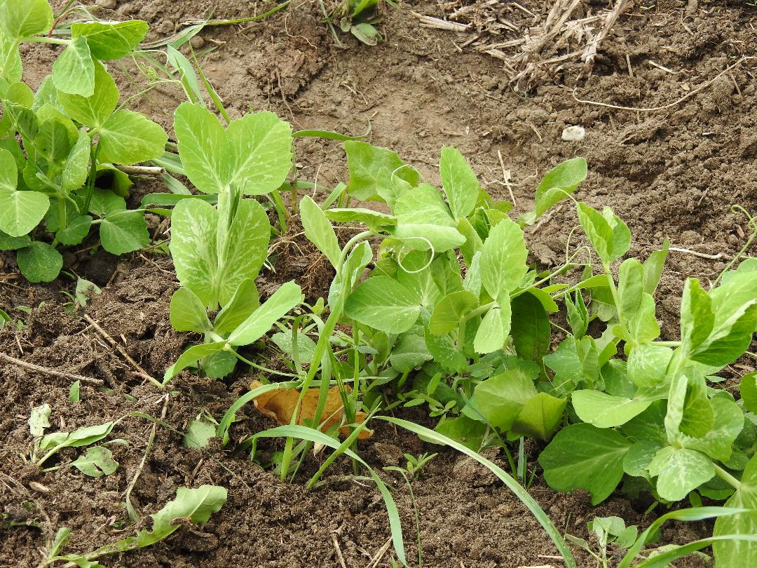
From Lisa Leffler:
When I was a child my grandpa had a garden for me and my sisters. We got to decide what to plant in our own gardens and then we helped grandpa with the planting. My garden was pretty much exclusively peas and flowers. Peas for me because there is nothing better than eating peas fresh from the garden and flowers for my grandma because she wasn’t able to get outside very much so I wanted her to be able to enjoy the beauty of nature indoors.
Much like the person who planted the seeds in the parable I put the seeds in the ground and then forgot about them until it was time to harvest. I didn’t have to worry about watering or weeding my garden. That was all taken care of for me by my grandpa. As I child I don’t think I was aware of how much care he was putting into my garden. Looking back, I wish I would have paid more attention. I wish I would have taken the time to slow down and care for the garden with him.
God works like that in our lives. God loves us and wants the best for us, so God will continue to work behind the scenes to care for and support us. The unconditional love of God is an amazing gift in our lives, but this parable reminds me to take time to slow down and appreciate that gift – through spending time in prayer, through looking for the opportunities God is calling me to, and through taking time “in the garden” to spend with loved ones.

Whether you are at home trying to help slow the spread of the virus,
working to help care for those who are impacted most by COVID-19
or working to keep some normalcy in this time,
may you know God’s deep and abiding love in your life.
Know you are a valued part of our Rockwood and Stone United Church families.

Further Conversation … Would you like to talk more about today’s reflection? Email Heather at hleffler@rogers.com. Following worship next Sunday, she will invite others to join you in a Zoom break out room to share in further conversation.

From the Affirming Discernment Circle
We would like share with you the words from Rev. Richard Bott on June 8 as we grieve the family who lost their lives in London this past week:
Tonight, I join with many across Canada to condemn the act of religiously motivated hatred and violence that took place in London, Ontario, on Sunday - the murder of a Muslim family and an act of terror against Islam.
Let us be with all those who mourn.
Let us use all that we have and all that we are to stand in the face of the evil that would allow and cause this crime of hatred. Even as one man has been arrested for his actions, let us uncover and work against the beliefs, the worldview, the racism and the hatred that supported his choice.
May the Most Compassionate and Most Merciful God dwell with those who have died, in paradise; and give patience and blessing to those who mourn through this time of trial.
https://www.cbc.ca/news/canada/london/muslim-family-hit-run-london-reactions-1.6056693?fbclid=IwAR3Lzmvbkir4CQV-7pJPyS5FME3lRLHKQq-3nGBLNWBB0BteDBP7qLrw88c
From Rev. Heather Leffler
One of the gifts of this strange time we find ourselves in is time. In ordinary times, many of us were so busy that stories of other people’s struggles and suffering caught our attention for a moment. We expressed sadness and moved on with our lives.
In this time when we hear of the unmarked graves at former residential schools or the deaths of four members of the Afzal family in the news, we hear them in a different way. Their stories are no longer just someone else’s sadness. With time to prayerfully reflect, we begin to recognize how they intersect with our stories. We hear where the Spirit is calling us to listen with compassion, change, stand with and respond to these siblings with the love of Jesus.
I commend to you, our friend Stephen Jackson’s recent email for your prayerful reflection and response.

From Stephen Jackson, Anishnabeg Outreach
Stephen Jackson stephen@aocan.org Fri., Jun. 11 at 8:16 a.m.
“Reconciliation requires that a new vision, based on a commitment to mutual respect, be developed.” (Executive Summary, pg. VI, TRC, 2015)
Section I - 215
It has been a long and challenging week at AO which is the primary reason for this delayed email. Many leaders have reached out to express profound feelings, condolences and offers of support. First, I want to thank all of you for reaching out, your thoughts, kind words and offers of hugs and support. I apologize that one comprehensive email will be given to all but, this will have to suffice as I simply don’t have enough weeks to write individual emails to all who reached out.
In terms of last week, on one end of the spectrum, we have the traumatizing impact of 215 children discovered in unmarked graves at a former residential school site. At the other end of the spectrum, we held 4 Indigenous vaccination clinics last week which means we provided about 600 second and first doses to Indigenous youth and adults. This was on top of our already fully packed work week and anyone who knows AO, knows how busy we are in any given week.
It has been an extremely challenging week for Indigenous and non-Indigenous people across the country. Some of my words may seem darker today but, words do not suffice to adequately reflect my feelings on the harm done and re-traumatization this will cause Indigenous people across the nation. Many non-Indigenous are also suffering from these traumatizing events. As an Indigenous leader, I can honestly state, it has been even more challenging for me. Almost all of the time, I look forward to the future and I spend most of my time building the future. This past week, my eternal optimism was being challenged. Other sites are starting to be examined and as those sites are examined, I know we will find many more missing, abandoned and unacknowledged children. And many more, we simply won’t find. But know, this will become many thousands and we are in for a long haul of reconciliation-based trauma.
Last Sunday, I responded to a couple of leaders before the flood of emails. In my response, I named it genocide because that is what this is. I see that PM Trudeau and the government are now also using this term. Personally, I am profoundly saddened by this discovery. The truly sad part of this genocide is that it was vehemently denied. Indigenous people knew but were not believed. It seems that unless there is video, voice or physical evidence, Indigenous people are ignored and not take for their word. In reality, Kamloops is just the tip of this iceberg. I have heard there are another 6,000 or more spread across the country at other sites. I have also heard there are many more thousands more south of the border. This reality was also in the USA.
Section II – Relationships
While news of the 215 bodies made its way through media outlets, many individuals and organizations across the country set up vigils and memorials. Some organizations have put on regalia, drummed and sung. From an Indigenous perspective, it took until 1950’s for regalia to be accepted and legalized. It was illegal. If an Indigenous-led organization wishes to do this, that is one thing, but to highlight and showcase this single image of Indigenous solidarity as the only source of information, is often troubling. Unfortunately, these images make the news because the news wants Hollywood Indians to put on a show. These images perpetuate a contemporary stereotype that is finding its way in media and is becoming more mainstream. Many of us do not have the teachings or ceremonies and as Indigenous, we are much more than regalia, drumming and trauma. At AO, we are not Hollywood Indians. When it comes to media events, we don’t don jingle dresses or regalia, nor do we drum. Seldom do we offer public ceremony for non-Indigenous. We did not create a guilt-ridden memorial but rather, we chose to continue to honour the children by doing our part to soothe the hurt and doing the work to transform future. We held a private pipe ceremony for the dead and for the living: just our staff and a couple of invited partners, with whom we have relationships. We support all of our partners at least as much as they support us because that is what it means to partner with us. Relationships from our perspective is one that is grounded in mutual understanding that as an Indigenous led organization, we are our own ‘sovereign’ entity that has our own ways of doing, working and governing. Far too often, our sovereignty is forgotten when building relationships.
I am deeply saddened that this is Canada’s history and current situation. A blight on our nation. I am sad and frustrated that very few settlers and eurocentric organizations have done anything to change the future for Indigenous people. The statistics are still astounding and the outcomes have not changed. For reconciliation, we have to enable those opportunities to soothe from the traumas and then strive towards healing. Reconciliation will only happen in partnership between Indigenous and non-Indigenous – individuals, organizations, companies and communities. It is a model that can be used to build a new future.
I don’t believe reconciliation has moved much, if at all, beyond a few tokenistic gestures related to actionable items which were only meant to be a starting point. The entire report including the Executive Summary and the Principles highlight the importance of relationships and the onus of reconciliation is on non-Indigenous. The action items have been published since 2015 and I would ask, has even a single organization looked at Action Item 92.ii in the Section “Business and Reconciliation”, which “Ensure that Aboriginal peoples have equitable access to jobs, training, and education opportunities in the corporate sector, and that Aboriginal communities gain long-term sustainable benefits from economic development projects.” From my extensive corporate background, this basically means removing barriers to all talent management (HR) policies/processes and corporate processes and programs. This means starting with policies and then HR practices and eventually looking at culture. Which organizations have achieved equity from an Indigenous representation perspective? It has been 6 years and what has been done? From an HR perspective, it only takes 1-3 years depending on the company size to transform all talent management policies, processes and practices. I know this because I used to do this work for large organizations both internally and as a consultant. This work isn’t all that hard. It just takes time and thoughtful leadership. It is simply transformative projects with some change management thrown in. Ironically, there are massive corporate cost savings to be found if this work is undertaken because many HR processes are inefficient. There are huge improvements to corporate performance outcomes when Indigenous and racialized talent pools are given an opportunity to contribute and thrive. In terms of opportunity for equity (Indigenous or racialized group), look at your corporate turnover (including retirements) and growth rates. Some organizations are at 5%, others 10 – 500% turnover and growth combined per year. In other words, there has been an incredible opportunity to move the needle on equity using just growth and turnover rates by establishing equity and Indigenous reconciliation a priority. Getting equity groups into your organizations is easy enough but, unless you fix your talent management system and culture, retention will be impossible. Believe me when I say I am extremely disappointed that no organization in the region has leveraged their growth or turnover rates to achieve equity in their organizations.
If there is any silver lining to this traumatizing reality. I hope this becomes the galvanizing moment, when we as a society say no more atrocities against Indigenous people. While we have the past to reflect on, I hope these events that are in mainstream media becomes the impetus for people and organizations in Canada to embrace reconciliation in a way that helps Indigenous people heal and helps to remove barriers which prevents their economic independence. As leaders and individuals, you can advocate or lead change to help move the needle on reconciliation. I challenge you, as organizations, to lead the change. “Reconciliation is not an Aboriginal problem; it is a Canadian one. Virtually all aspects of Canadian society may need to be reconsidered”. Executive Summary of Truth and Reconcilation Commission
This excellent article written by our Board Chair, Tammy Webster, was recently published in The Record and highlights the same sentiment.
https://www.therecord.com/opinion/community-editorial-board/2021/06/07/discovery-of-graves-in-kamloops-has-thrust-me-into-the-role-of-grief-navigator.html
Section III – Next steps
I am happy for the friendships and relationships I have built. I am thankful for the support I have received for AO. I am thankful for all of those organizations and individuals who have partnered with us and helped us lead reconciliation-based change and for everyone who has helped us move the needle on reconciliation. I am thankful for the impact we have been able to achieve to date and the significantly greater impact we will be able to achieve from a healing and economic perspective, as we continue to build more partnerships. I know what we need to overcome and I am happy that we have a vision to repair and build our reconciliation-based solutions. It is also equally significant that non-Indigenous do their reconciliatory and relationship building work. We are always open to more partnership and offers of support.
In the three years of AO’s expansion, our outcomes and achievements are a direct measure of partnerships and relationships that have contributed in a multitude of ways to achieving reconciliatory goals. Tech companies continue to donate laptops to our new mentoring program and are helping us build our LMS system. Other organizations are helping to build programs with us.
Our newly launched Sports Program, which provides sports equipment and online tutorials to families was a result of corporate funders and growing partnerships. Our commercial freezers, fridges and freezer truck were courtesy of Covid-19 related funding to support our Spirit Bundle home deliveries. Our EarlyON offers online supports, programming and has reached out to many families with at home kits (e.g., art, sports, learning). Every contribution made to AO is amplified to support the programs as well as to establish legacy programs. Financial contributions through our charity continue to grow so we can help move the needle on healing and economic independence.
Individuals have also stepped up to make a difference. One couple offered to purchase bikes on KIJIJI, repair them and donate them to our bike lending library. Three young girls from a family in Guelph, reached out through their mother. After extensive ideas, which were unattainable due to COVID, they finally decided to go to neighbours to offer their services by performing small jobs like walking dogs, cleaning yards, taking out garbage, etc. A woman is going to start a social media campaign in Guelph to raise money for our reconciliation-based programming. And same for a hardware store. We still receive regular donations and contributions for our Spirit Bundles, such as children’s clothing and housewares. We received plants for our gardens and many small items of appreciation (fresh eggs, woodworking). I thank all who have helped us move the needle.
To guide this relationship building piece and to reduce the barriers and challenges that non-Indigenous organizations would encounter as they rebuild their systems and processes, AO is in the initial phases of building a consulting arm and will use our thought leadership to build corporate tools, processes and strategies to help organizations achieve reconciliation and equity. We will provide consulting on reconciliation, EDI and Talent Management. We continue with our mentorship program to provide skills, knowledge in IT fields. We are in the early phases, of building our learning management system called “The Nest”. “The Nest” will host all of our mental heath programming for self-directed and supportive healing, our sport program’s coaching videos so children and youth can be part of the team, and our education, tutoring, mentoring and employment program to help Indigenous people achieve meaningful employment.
Relationships of networks, education and professionals also build the common groundwork that is needed for sustainable reconciliation. All acts of kindness, great and small has helped us evolve and move the needle on reconciliation. Be it small or be it large, I ask you to find a way to make a difference for Indigenous people in whatever capacity you are able. Together, we can build a comprehensive solution that delivers on reconciliation.
If you wish to begin or continue a conversation or just learn more, please let me know.
Stephen Jackson, M.A.Sc., CEO
Anishnabeg Outreach Employment and Training Inc.
226-972-1900
https://www.facebook.com/anishnabegoutreach
https://twitter.com/anishnabeg
https://www.instagram.com/anishnabegoutreach/
www.aocan.org

A gift of belonging to a church is that the practice of gathering together for worship … to pray, sing, listen to scripture and share how God touches our lives – helps us grow in deeper relationship to God and each other. With COVID-19 keeping us at home and physically distant from our Stone or Rockwood families, we are missing each other. We are offering this practice of sharing beyond Sunday morning to deepen our connection. Each week you will be offered a picture, a scripture and a question for contemplation, as well as a short reflection for you to contemplate, have conversation with people in your life and/or join an online conversation on our Rockwood Stone Facebook page.

