Contemplation and Conversation: 5th Sunday after Pentecost, June 27, 2021
Scripture: Psalm 130 https://www.biblegateway.com/passage/?search=Psalm%20130&version=NRSV
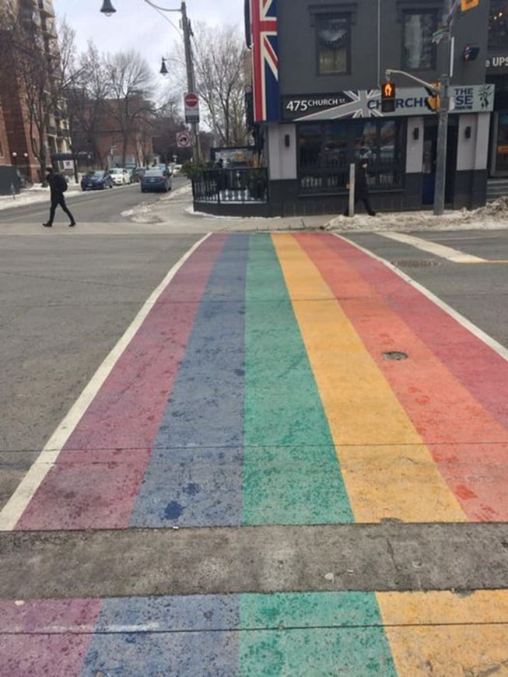
^{W1} Out of the depths I cry to you, O Lord.
² Lord, hear my voice!
Let your ears be attentive
to the voice of my supplications!
Photo: Church Street, Toronto taken by W Stiles
³ If you, O Lord, should mark iniquities,
Lord, who could stand?
⁴ But there is forgiveness with you,
so that you may be revered.
⁵ I wait for the Lord, my soul waits,
and in his word I hope;
⁶ my soul waits for the Lord
more than those who watch for the morning,
more than those who watch for the morning.
⁷ O Israel, hope in the Lord!
For with the Lord there is steadfast love,
and with him is great power to redeem.
⁸ It is he who will redeem Israel
from all its iniquities.
Contemplation and Conversation:
What do you long for?
From Brent Stiles:
Longing for Full Inclusion
About 10 percent of humanity scattered across the globe is LGBTQ2S+ (Lesbian, Gay, Bisexual, Transgender, Queer or Questioning, and Two-Spirit) in sexual orientation or gender identity. While some progress has been made in accepting this community, especially in countries like Canada, news stories from around the world are enough to make one shudder. In 2014, we saw disturbing views in Russia, imprisonment threats in Africa, and conservative backlash in the United States.
United Church Moderator Gary Paterson wrote in a 2014 blog post: “What is it about homosexuality that seems to rile up so many Christians, as if this were something that was about to destroy the world? Seems to stir up far more passion than issues of poverty, war or climate change. It turns out that playing the “homosexual card” and stoking the fears of a “gay agenda” … often leads to the most successful religious fundraisers in the United States; that troubles me!”
It should trouble us all. Why is anger so much easier than acceptance?"
Paterson continued: “I am so grateful to be a part of the United Church, where in August 2013, we celebrated 25 years of recognizing LGBTQ2S+ people as full members of the Body of Christ, of the church. Sure, our denomination is not perfect, and there are times and places where prejudice still rears its head; but it’s changing, and it continues to get better, more just, and inclusive. I want this news to make the headlines, at least on occasion, so that the world, the “spiritual but not religious,” the great and growing numbers of “unchurched” don’t think that what they hear and see in the headlines is the sum total of a Christian understanding of homosexuality. I want them to hear our message about acceptance and affirmation – There's a place for you!"
All people should feel a part of the larger whole, not displaced from the group; not scattered, alone and powerless. Full inclusion that’s our goal.
O God, turn my head to look for the scattered. Help me to listen for the footsteps of those who are left out. Inspire my mouth to call in those on the fringe who would like to enter. O God stretch my arms to include more within my embrace. Amen.
(From Longing for Home: Daily Reflections for Lent, United Church Publishing House.)
Whether you are at home trying to help slow the spread of the virus,
working to help care for those who are impacted most by COVID-19
or working to keep some normalcy in this time,
may you know God’s deep and abiding love in your life.
Know you are a valued part of our Rockwood and Stone United Church families.

Further Conversation … Would you like to talk more about today’s reflection? Email Heather at hleffler@rogers.com. Following worship next Sunday, she will invite others to join you in a Zoom break out room to share in further conversation.

From our Rockwood Stone Affirming Discernment Circle
Rev. Gord Dunbar of Kincardine United Church in his Fireside Chat this week https://www.youtube.com/watch?v=TmjlHreCzsA shares a very personal story of his daughter’s coming out and helps us understand the importance of being ally.

United Church of Canada – From Moderator Richard Bott
Posted on National Indigenous Peoples Day, June 21, 2021.
Created in 1996 – 25 years ago – this national day was declared as a symbolic time for Canadians to learn more about the many peoples Indigenous to this land.
Canadians were called on to learn more about the relationship between Canada and Indigenous peoples – to take part in learning and cultural events.
Can I tell you what I've learned over those 25 years? In short, there are many things that many Indigenous communities can take a lot of pride in – and there are a huge number of things that settler Canadians can't.
We could talk historically, but the problem with talking historically is that it makes people think the problems are all in the past. And, while there are a huge number of horrors that Canada has imposed on various Indigenous communities across the land in our past – Residential and Day Schools being just two examples – there are many that are happening today that so many Canadians want to stick our collective heads in the sand about.
Just a few to think about:
- the ongoing extraction of resources from unceded territory, without permission or participation of the Indigenous communities;
- continuing broken treaty agreements relating to safe housing, access to safe drinking water, access to medical and mental health, access to education;
- systemic racism of and in provincial child welfare systems that lead to the removal of Indigenous children from their families and communities at an overwhelmingly high rate;
- symbolic action after symbolic action by the governments that are our representatives, without substantive changes in the areas that our governments' own processes have shown need deep change (see the Calls to Justice from the report of the National Inquiry into Murdered and Missing Indigenous Women and Girls (2019), see the Calls to Action from the report of the Truth and Reconciliation Commission (2015), see the report of the Canada Royal Commission on Aboriginal Peoples (1996) ... and that is just what I can think of, off the top of my head.
As a Canadian who is a descendant of European colonizers of this land, I can say that I believe we have failed, miserably, in any kind of just relationship with the myriad peoples Indigenous to this land. As a participant and leader in The United Church of Canada, I can see much of our past and present broken relationships with Indigenous peoples both within the church and in the wider Indigenous communities. As someone called by Jesus to "seek justice and resist evil" I cannot be complacent, but must be in this work of truth, justice, healing, and building right relations.
The Indigenous peoples - from various cultures, languages, and teachings; on reserve and urban; in community and distanced from it - have been telling the rest of us what needs to happen for a very, very long time. There are pages upon pages written as a place to start.
It's time - and past time - to listen.
It's time - and past time - to act.
It's National Indigenous Peoples Day, 2021 - 25 years since it was declared.
I wonder what it'll look like in 2046 - 25 years from now?
(Image: Screenshot from the "Whose Land" app)
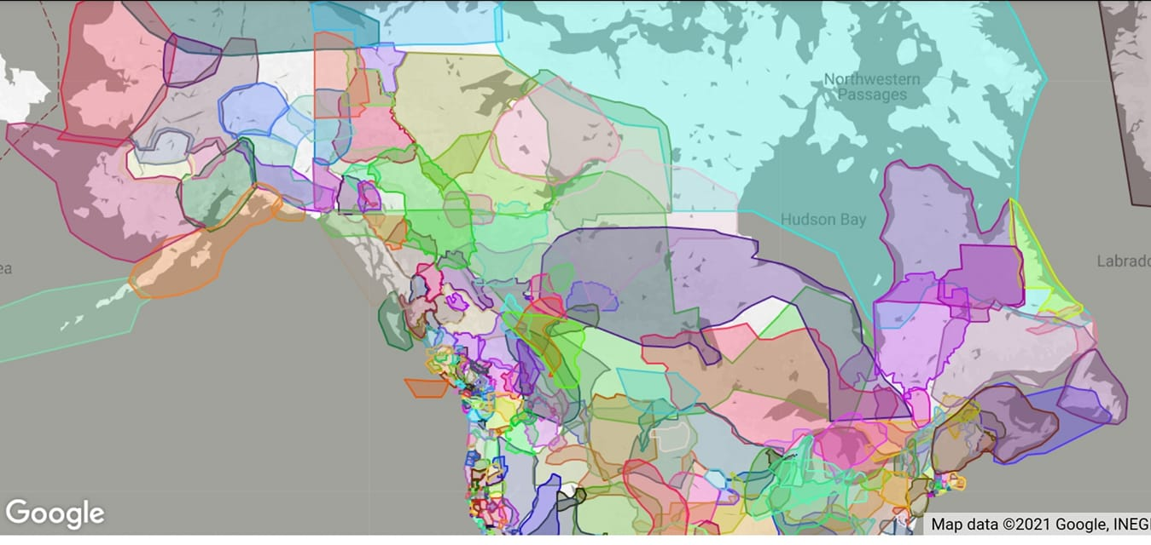
A gift of belonging to a church is that the practice of gathering together for worship … to pray, sing, listen to scripture and share how God touches our lives – helps us grow in deeper relationship to God and each other. With COVID-19 keeping us at home and physically distant from our Stone or Rockwood families, we are missing each other. We are offering this practice of sharing beyond Sunday morning to deepen our connection. Each week you will be offered a picture, a scripture and a question for contemplation, as well as a short reflection for you to contemplate, have conversation with people in your life and/or join an online conversation on our Rockwood Stone Facebook page.

