Contemplation and Conversation: 8th Sunday after Pentecost, July 18, 2021
A Psalm of Rockwood-Stone
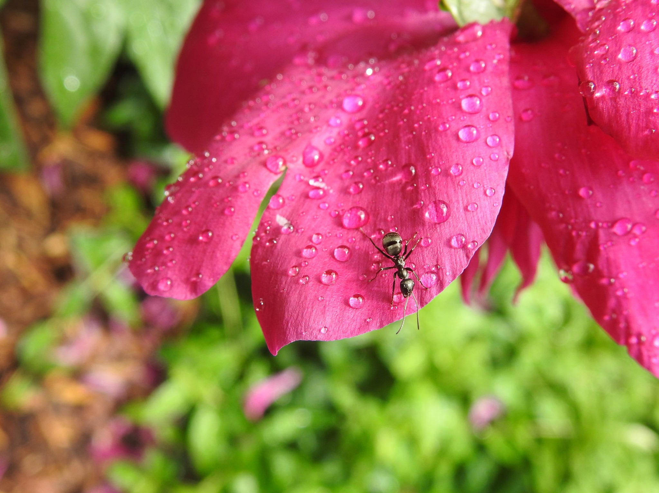
Thanks to everyone who participated in writing our “Psalm 151” on July 11 and Lisa Leffler for her leadership.
God, your scriptures tell us that you are with always us,
yet at times we still find ourselves searching for you.
Do you hear us when you call out to you?
God, do you hear us calling out for you?
I lift up my eyes to the Lord.
I praise the Lord, day by day, to keep us strong when troubles are all around us.
God, do you hear us calling out praises for your creation?
Thank you, God, for the beauty of creation and may it lift the spirits of all those needing your care.
Praise God for the beauty of nature!
The glory of God is reflected in the natural world,
in the sunshine,
the bird song,
the cool blue water,
the stretching shorelines,
the breeze on my cheek.
Music brings rhythm and enchantment and pulls you into the dance.
All gifts bring calm to my heart and joy of appreciation for all that is good in the world.
God of all creation,
You guide the birds on the wing.
You guide the tiniest creatures in their burrows.
Thank you for guiding me too, Holy One.
God, do you hear us calling out thanks for the gifts you have given us?
Your graces are ever present, O God, through the struggles and successes in our life.
In the ability to free our struggles and turning them over to You O Lord.
In giving strength to overcome insurmountable obstacles.
In rewarding us in the celebration of achievement. Thank you, O God, for your graces.
We give thanks for…
the joy of music
the gift of community
the support of friends and family.
Lord, we appreciate your help when we need patience.
Patience in our homes and patience with this world.
Bless us, Lord, and we will be your loyal servants.
Love us, Lord, as we try to be faithful servants to the Mighty One.
God, do you hear us calling out for guidance and support?
Lord help us to understand mother earth and assist us in cleaning up our environment.
Lord, like the lilies of the field, you will take care of us,
but we worry that the droughts or rains seem to come more and more excessively.
The Lord teaches us to look at the best ways to look after ourselves;
from learning to make vaccines to fighting forest fires.
We pray for people to not be so wasteful with our forests
And to stop clearcutting 1 million acres a year in Canada.
God, do you hear us calling out for connection?
I try to follow your path of love
but so often I still feel lost and alone.
But you are still with me God.
I see you each day in those I love.
We praise God for Loving caring friends, neighbours, family to be praying for us during these trying times.
Restore to me, O Lord, the joys of missed embraces.
Lord, you show us the way in teaching people worldwide to see how their choices affect others’ health and for people to be less self-serving.
God, do you hear us calling out for healing?
You, O God, know what it is to watch the suffering of your only son.
Give me strength as I do too.
We praise God for giving us strength and patience to wait for healing.
Praise God for the beauty of nature that heals our struggling souls.
Open your gates to see the troubles of our world, open our hearts for healing.
God, we know that you hear our prayers.
You hear us when share words aloud
and you hear the words trapped in the silence our hearts.
You are with us always,
and for that we are truly grateful.
Amen.

Contemplation and Conversation: What are you praying for today?
From Rev. Heather Leffler:
As I begin a year of preaching on the Psalms, it seems good to reflect on the Psalm you wrote as two congregations when I was on vacation. It is with gratitude that I read your heartfelt prayer.
You remind me to be grateful for God’s love and faithfulness and the bounty we enjoy – for the wonder and beauty of creation and the love of friends, neighbours and families.
You raise up longing in me for those embraces we have been missing in this time and for God’s intervention in the places of deepest suffering in our world.
Your heartfelt prayers for personal healing and healing of the earth nudge me to find new ways to care for the earth and all God’s creatures.
I give thanks to God for the prayers of our church family for our families, churches and the world.
Whether you are at home trying to help slow the spread of the virus,
working to help care for those who are impacted most by COVID-19
or working to keep some normalcy in this time,
may you know God’s deep and abiding love in your life.
Know you are a valued part of our Rockwood and Stone United Church families.

Further Conversation … Would you like to talk more about today’s reflection? Email Heather at hleffler@rogers.com. Following worship next Sunday, she will invite others to join you in a Zoom break out room to share in further conversation.


United Church of Canada from Moderator Richard Bott
It's Another Online Gathering!
It's time to tap the icon,
It's time to light the lights,
It's time to meet for worship on the Zoom platform tonight!
It's time to find my bible,
It's time to change camera height,
It's time to say a short prayer 'for the livestream tonight.
Why do we always come here?
I guess God only knows!
It's like a kind of family,
In all its ebb and flow!
But now let's get things started.
(Why won't this thing get started?)
It's time to get things started
On the most sensational, inspirational, celebrational, Jesustational
Oh dear God, it's working, now let's go!!!!
(With apologies to Jim Henson, this can be sung to the tune of the theme song from The Muppet Show. Image: The Muppets)

A gift of belonging to a church is that the practice of gathering together for worship … to pray, sing, listen to scripture and share how God touches our lives – helps us grow in deeper relationship to God and each other. With COVID-19 keeping us at home and physically distant from our Stone or Rockwood families, we are missing each other. We are offering this practice of sharing beyond Sunday morning to deepen our connection. Each week you will be offered a picture, a scripture and a question for contemplation, as well as a short reflection for you to contemplate, have conversation with people in your life and/or join an online conversation on our Rockwood Stone Facebook page.

