Contemplation and Conversation: 12th Sunday after Pentecost, August 15, 2021
Scripture: Ephesians 5:15-20 https://www.biblegateway.com/passage/?search=Ephesians%205%3A15-20&version=NRSV
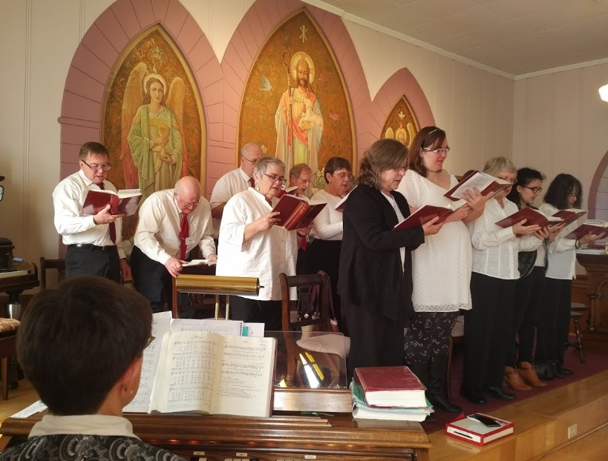
¹⁵ Be careful then how you live, not as unwise people but as wise, ¹⁶ making the most of the time, because the days are evil. ¹⁷ So do not be foolish, but understand what the will of the Lord is. ¹⁸ Do not get drunk with wine, for that is debauchery; but be filled with the Spirit, ¹⁹ as you sing psalms and hymns and spiritual songs among yourselves, singing and making melody to the Lord in your hearts, ²⁰ giving thanks to God the Father at all times and for everything in the name of our Lord Jesus Christ.
Contemplation and Conversation: What song would you sing to God today?
From Rev. Heather Leffler:
The writer of Ephesians urges us to be careful how we live with particular cautions around drinking, and I am sure he would add taking substances that cloud our minds and judgments. Often people use substances to relax and enjoy themselves, but the writer assures us there is another way.
Singing songs and making music together brings joy. This has never been so evident to us as in this time when we are urged not to sing together to halt the spread of COVID-19. There is nothing to stop us from singing when we are by ourselves or with the people we live with. I am grateful to those of you who have recorded your songs and shared them with us for our worship on Zoom.
We long to sing and make music together again. This reading from Ephesians encourages us to sing to God, to keep God at the centre of our lives and do everything we do in the name of Jesus. Whenever and whatever we sing, may it be to God’s glory and bring us joy, and may time pass quickly so we can praise God together in our churches.
Whether you are at home trying to help slow the spread of the virus,
working to help care for those who are impacted most by COVID-19
or working to keep some normalcy in this time,
may you know God’s deep and abiding love in your life.
Know you are a valued part of our Rockwood and Stone United Church families.

Further Conversation … Would you like to talk more about today’s reflection? Email Heather at hleffler@rogers.com. Following worship next Sunday, she will invite others to join you in a Zoom break out room to share in further conversation.

Our Rockwood Stone Family
Have you seen the great pumpkin and giant sunflower at Stone? Stop buy and take a picture of your family or friends. Learn about the work of the Canadian Foodgrains Bank and consider sending a donation to Stone United’s Foodgrains Project.

United Church of Canada Published On: July 26, 2021
COVID-19 Won’t End until It Ends for Everyone: Here’s how you can help
“Visible minority” is the term often used to refer to non-Indigenous racialized people. Think about it for a minute. In reality, 80 percent of people around the world are of African, Asian, Latin American, and Arab descent. They are not the minority―they are the global majority.
And only 1 percent of this global majority has been vaccinated against COVID-19. In fact, most won’t be vaccinated until 2023/24.
We need to take action now to ensure that everyone around the globe has access to vaccines. Because the COVID-19 crisis won’t end for anyone until it ends for everyone.
There is something you can do to help. Many things, actually.
First, you can join our Moderator in calling on the Canadian government to share excess vaccines, allocate more funds to COVAX, increase Official Development Assistance, and suspend the international agreement on property rights to allow vaccines to be produced more quickly and affordably around the world. You might use the e-mail template on our Call for Global Vaccine Access for All page. Check out the Moderator’s video message(opens in a new tab) too.
Second, you can support Mission & Service partners working hard to contribute to food and relief, distribute personal protective equipment, and host programs to prevent and control the spread of the disease.
Third, for just $25 dollars, you can give the gift of a two-dose vaccine. Pay it forward through the special gift of a vaccine through our United Church’s Gifts with Vision(opens in a new tab).
Fourth, you can join the whole of the church as we pray for the world together:
Loving and caring God,
We have done everything we’ve been told:
Worn masks, stayed home, gotten our shots―
Isn’t it about time all this is over?
Let us remember always that no, it’s not over;
It’s not over for people in so many places we never think about:
People whose lives were already a struggle
Now overflowing with illness and loss and grief,
And often with no masks, no shots, no way to stay safe at home.
Remind us, God of the whole world,
That the whole world is our family.
That this won’t be all over until it is over for all.
And let us do all we can
To give our whole-world family what we take for granted:
Hope for a future.
Amen.
https://united-church.ca/stories/covid-19-wont-end-until-it-ends-everyone

A gift of belonging to a church is that the practice of gathering together for worship … to pray, sing, listen to scripture and share how God touches our lives – helps us grow in deeper relationship to God and each other. With COVID-19 keeping us at home and physically distant from our Stone or Rockwood families, we are missing each other. We are offering this practice of sharing beyond Sunday morning to deepen our connection. Each week you will be offered a picture, a scripture and a question for contemplation, as well as a short reflection for you to contemplate, have conversation with people in your life and/or join an online conversation on our Rockwood Stone Facebook page.

