Contemplation and Conversation: 13th Sunday after Pentecost, August 22, 2021
Scripture: Psalm 84 https://www.biblegateway.com/passage/?search=Psalm+84&version=NRSV
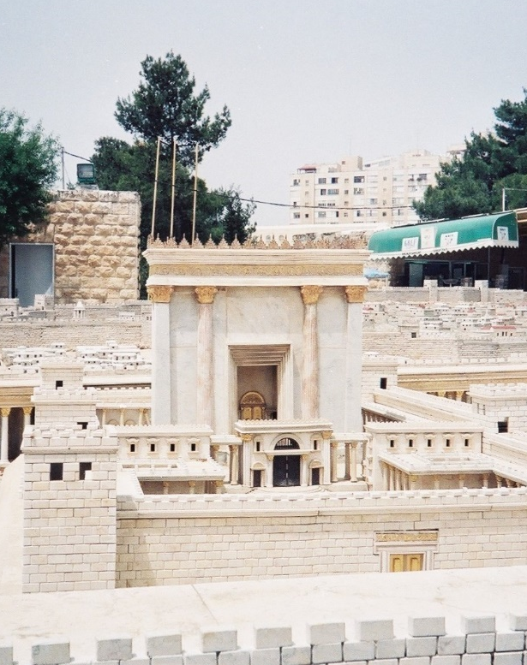
Contemplation and Conversation: How are you feeling about returning to our church buildings?
From Rev. Heather Leffler:
Preparing for or remembering a pilgrimage to Jerusalem the Psalmist is filled with longing and wonder. The writer sees in his mind’s eye the white and gold of the temple sparkling in the sunlight, birds making their homes between the pillars and the air filled with joy and singing and can’t imagine anything more precious than being in God’s house. He would rather stand at the door and wait than have all the riches and activities the world could offer.
We too know the Psalmist’s longing to return to our churches, to sit in familiar pews, be surround by images of Jesus, connect with our church family, sing, share in communion, eat together and maybe even enjoy a Country Breakfast. Caught between some relaxing of rules and a high number of vaccinated people, and the knowledge that vaccines can’t completely protect us from new variants of the COVID virus, I am left wondering how we can be together while managing the risks. I am anxious that we will forget that children and others aren’t able to be vaccinated and we all have people in our lives we want to protect.
As I struggle with what church inside Rockwood and Stone will look like, I am drawn back to the Psalm. The Psalmist knows that being in relationship with God enriches our lives whether we are in our church buildings, outside the door, on Zoom or connecting by phone. Our relationships with each other and God will sustain us until we can worship together again. Thanks be to God.
Whether you are at home trying to help slow the spread of the virus,
working to help care for those who are impacted most by COVID-19
or working to keep some normalcy in this time,
may you know God’s deep and abiding love in your life.
Know you are a valued part of our Rockwood and Stone United Church families.

Further Conversation … Would you like to talk more about today’s reflection? Email Heather at hleffler@rogers.com. Following worship next Sunday, she will invite others to join you in a Zoom break out room to share in further conversation.

United Church of Canada
Western Ontario Waterways has gathered information about the pandemic from a number of sources to help congregations decide when and how to safely re-enter our church buildings. Go to https://mailchi.mp/united-church/reopeningchurchbuildings-wowrc?e=24fb8ec670 to learn more.

A gift of belonging to a church is that the practice of gathering together for worship … to pray, sing, listen to scripture and share how God touches our lives – helps us grow in deeper relationship to God and each other. With COVID-19 keeping us at home and physically distant from our Stone or Rockwood families, we are missing each other. We are offering this practice of sharing beyond Sunday morning to deepen our connection. Each week you will be offered a picture, a scripture and a question for contemplation, as well as a short reflection for you to contemplate, have conversation with people in your life and/or join an online conversation on our Rockwood Stone Facebook page.

