Contemplation and Conversation: 4th Sunday of Creation Time, October 3, 2021
Scripture: Genesis 1:14-19 NRSV https://www.biblegateway.com/passage/?search=Genesis%201%3A14-19&version=NRSV
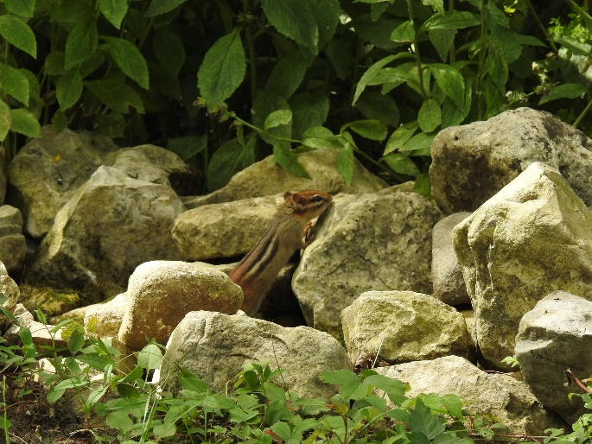
From Rev. Heather Leffler:
Sitting outside enjoying the garden, walking in the woods, playing in the park or gathering around the campfire, spring, summer, fall or winter, fresh air nurtures us physically and lifts our spirits. Summertime brings with it the impacts of our overuse of the resources God made to sustain life. Smog and wildfires, extreme storms, flooding and drought, like we have never known before, show us what happens when we put ourselves ahead of creation. Even the life-giving air we breathe is impacted by our excesses.
Yet our Creator has given us scientists, teachers, leaders and concerned people to call us to examine our actions and change our behaviours. Our Biblical stories remind us again and again that when we change, creation will respond.
Ponder and Pray:
Where does the beauty of creation take your breath away?
Life giving God, you are in the very air we breathe.
As we breathe in your love may we be inspired
to make the changes that will lead to healing the air
and the earth for all your creation. Amen.

Whether you are at home trying to help slow the spread of the virus,
working to help care for those who are impacted most by COVID-19
or working to keep some normalcy in this time,
may you know God’s deep and abiding love in your life.
Know you are a valued part of our Rockwood and Stone United Church families.

Further Conversation … Would you like to talk more about today’s reflection? Email Heather at hleffler@rogers.com. Following worship next Sunday, she will invite others to join you in a Zoom break out room to share in further conversation.

Our Rockwood Stone Family
Thank you to everyone who helped Celebrate Lou Darcie’s life with your words, music, thoughts, prayers, presence, food, setting up and cleaning up. Thanks to Chris Barlow, you can view the Celebration of Lou's Life by clicking this link https://youtu.be/6UgzIccZOq0 . The link can be shared with family, friends and neighbours who knew Lou.

United Church of Canada from Moderator Richard Bott published on World Communion Sunday, October 3, 2021
Bread; blessed, broken, and shared -
for all who are hungry,
eat and be filled!
Wine; a life's-blood promise -
sin *is* forgiven.
Christ's bread of Life,
Christ's cup of Blessing.
The gifts of God for all creation.
Eat. Drink. Remember.
And live!
A gift of belonging to a church is that the practice of gathering together for worship … to pray, sing, listen to scripture and share how God touches our lives – helps us grow in deeper relationship to God and each other. With COVID-19 keeping us at home and physically distant from our Stone or Rockwood families, we are missing each other. We are offering this practice of sharing beyond Sunday morning to deepen our connection. Each week you will be offered a picture, a scripture and a question for contemplation, as well as a short reflection for you to contemplate, have conversation with people in your life and/or join an online conversation on our Rockwood Stone Facebook page.

