Contemplation and Conversation: Thanksgiving Sunday, October 10, 2021
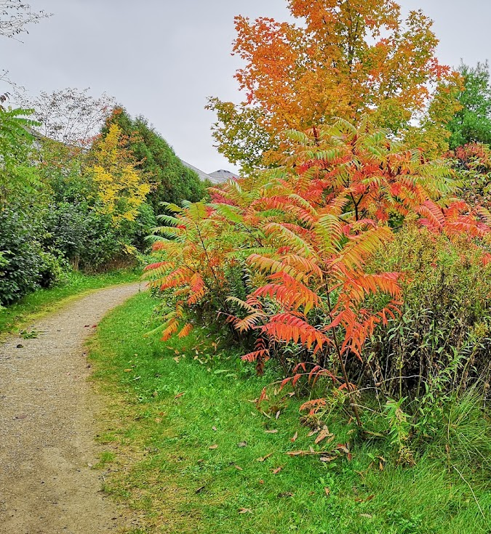
Scripture: Genesis 1: 20-26 NRSV https://www.biblegateway.com/passage/?search=Genesis+1%3A20-26&version=NRSV
And God said, “Let the waters bring forth swarms of living creatures, and let birds fly above the earth across the dome of the sky.” ²¹ So God created the great sea monsters and every living creature that moves, of every kind, with which the waters swarm, and every winged bird of every kind. And God saw that it was good. ²² God blessed them, saying, “Be fruitful and multiply and fill the waters in the seas, and let birds multiply on the earth.” ²³ And there was evening and there was morning, the fifth day.
²⁴ And God said, “Let the earth bring forth living creatures of every kind: cattle and creeping things and wild animals of the earth of every kind.” And it was so. ²⁵ God made the wild animals of the earth of every kind, and the cattle of every kind, and everything that creeps upon the ground of every kind. And God saw that it was good.
²⁶ Then God said, “Let us make humankind in our image, according to our likeness; and let them have dominion over the fish of the sea, and over the birds of the air, and over the cattle, and over all the wild animals of the earth, and over every creeping thing that creeps upon the earth.”
From Rev. Heather Leffler:
Contemplating creation leaves me knowing God is truly Holy Mystery and Wholly Love. Every plant, animal, element and person has a place in the cycle of life. When we put our own wants and needs first, we do serious harm. When we recognize our interdependence and care for one another we can all thrive.
On this Thanksgiving weekend the colours of fall, the delicious fruits and vegetables, the rain and the sun remind me again of the words from our New Creed. We worship God who has created and is creating … and works in us and others by the Spirit. May seeing God’s work in the world inspire is to give thanks and care for not only our human siblings but for all God’s creatures.
Ponder and Pray
Where are you inspired by creation?
Holy One, may we who have so much
respond in gratitude to you by sharing our resources
and caring for the earth so all can have enough. Amen.

Whether you are at home trying to help slow the spread of the virus,
working to help care for those who are impacted most by COVID-19
or working to keep some normalcy in this time,
may you know God’s deep and abiding love in your life.
Know you are a valued part of our Rockwood and Stone United Church families.

Further Conversation … Would you like to talk more about today’s reflection? Email Heather at hleffler@rogers.com. Following worship next Sunday, she will invite others to join you in a Zoom break out room to share in further conversation.

Our Rockwood Stone Family
Congratulations to Patty and Larry Lancaster who celebrated their 50th Anniversary on October 9, 2021.
On Reopening our Churches
Just a reminder the Reopening Commission was put in place by our Rockwood Stone Board with all the decision-making power of the Board. There mandate is to guide our churches by setting protocols in the hope of keeping everyone safe through the pandemic. As you will see in the announcement below, we are planning to continue to hold worship on Zoom and in one of our sanctuaries every other week beginning October 24, (except for Remembrance Sunday). You will be asked to register for worship, self screen for COVID symptoms, wear a mask, remain seated in social distanced seats through worship and visit people outside masked and/or at a safe distance after worship.thank While other venues and churches are allowing only double vaccinated people and relaxing some of these rules, our congregations include people who are not able to be vaccinated at this time and people who though vaccinated are vulnerable to the virus. Out of an abundance of caution we want to keep everyone safe.
In the coming week you will be contacted by phone or email by a member of Pastoral Care from Rockwood or Stone to ask you the following questions:
- Will you attend in-person worship at your church in the coming weeks? yes / no
- Will you register on the website or by leaving a message at the church? website / phone
- Is there anything you need to know before returning to in-person worship?
- Is there anything you would like to share with Heather or the commission about worship.
The Commission would really appreciate your responses to help guide our decision making.
Blessings,
Heather
From the Announcements:
Worship at Rockwood and Stone United Churches
Zoom – In the coming weeks we will continue to worship on Zoom each Sunday from 10 to 11 am.
In-person Worship – Most weeks beginning on October 24 there will be an in-person service in one of our churches from 11:30 am to 12:15 pm. Worship may not look the same as before COVID, but our ability to adapt and abide by restrictions will govern our success in continuing in person worship.
Registration – Space is limited in our churches so if you plan to attend you will need to register online or by leaving a message on the office phone. More details will follow next week. You will receive confirmation when there is space for you. Please only plan to register for worship in your church and continue to connect with your sister congregation online while space is limited.
Worship Schedule
Rockwood – October 24, November 14, 28, December 12
Stone – October 31, November 21, December 5, 19

United Church of Canada from Moderator Richard Bott on October 7
While I've had the chance to meet some of you who are reading this post, many of you I haven't had the chance to meet, and many of you I will never have the chance to meet.
But I want to tell you something.
I am thankful that *you* are in the world.
I am thankful for the differences you make, big and small, as you go through your life.
I am thankful for the concatenation of wonders, and hopes, and dreams; of tears, of grumbles, of laughter; the ideas, the quiet, and the chaos, that makes you, you.
One of my favourite characters in all of the fictions that I've experienced once said, "Nobody important? Blimey, that's amazing. You know that in nine hundred years of time and space and I've never met anybody who wasn't important before."
I'm much younger that that, but I can honestly say, "Same for me."
I am thankful that you are you.

A gift of belonging to a church is that the practice of gathering together for worship … to pray, sing, listen to scripture and share how God touches our lives – helps us grow in deeper relationship to God and each other. With COVID-19 keeping us at home and physically distant from our Stone or Rockwood families, we are missing each other. We are offering this practice of sharing beyond Sunday morning to deepen our connection. Each week you will be offered a picture, a scripture and a question for contemplation, as well as a short reflection for you to contemplate, have conversation with people in your life and/or join an online conversation on our Rockwood Stone Facebook page.

