Contemplation and Conversation: 21st Sunday after Pentecost, October 17, 2021
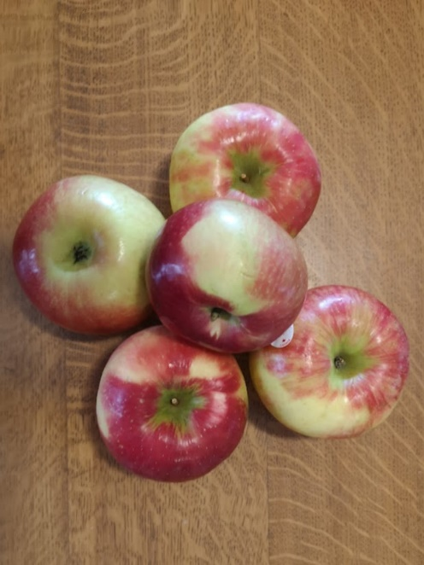
Scripture: Psalm 104:24-30 https://www.biblegateway.com/passage/?search=Psalm+104%3A24-30&version=NRSV
Contemplation and Conversation: What is your prayer this World Food Day?
From Rev. Heather Leffler:
Today is World Food Day. We have so many wonderful foods to choose from, it is hard for me to pick just one favourite. In this harvest season, biting into a sweet, juicy apple, enjoying apples in pie or fritters, in crisp or as apple sauce with roast park, or as warm cider seasoned with delicious spices, I am so grateful.
Then I remember the news –
the people who live on the streets or those who can barely make their mortgage or rent,
refugees on the road or in camps who wonder where their next meal will come from,
farmers who have lost their crop to drought or floods and wonder where they will find money for seed for a new crop, people caught in the midst of war, violence, injustice or abuse who must put safety of their family over food. How can we make a difference, even as we give thanks for what we have?
The Psalmist’s words about God’s wonderful creation, remind me that not only was the world created so that all people and all creatures would have enough, God’s Spirit continues to renew the earth and work with us to make a difference. Thank you for supporting our outreach to Mission and Service, Anishnabeg Outreach, Canadian Foodgrains Bank, East Wellington Community Service and the Rural Women’s Support Program and all the other organizations and people you support to help bring about a world where everyone has enough.
Generous God, thank you for the delicious foods we enjoy each day.
Teach us to be generous as you are generous.
Help us reach out in ways that share your bounty with those who are hungry
and hunger for justice. Amen.
Whether you are at home trying to help slow the spread of the virus,
working to help care for those who are impacted most by COVID-19
or working to keep some normalcy in this time,
may you know God’s deep and abiding love in your life.
Know you are a valued part of our Rockwood and Stone United Church families.

Further Conversation … Would you like to talk more about today’s reflection? Email Heather at hleffler@rogers.com. Following worship next Sunday, she will invite others to join you in a Zoom break out room to share in further conversation.

From Worship
We are so grateful to Stone’s 159th Anniversary speaker Vicki Olantundun, Executive Director of Chalmers Community Services Guelph. Chalmers has two locations:
Downtown Location: 41 Macdonell St. Guelph, ON N1H 2Z4
West Location: 577 Willow Rd. Guelph, ON N1H 7H3
If you would like to drop off food especially produce or volunteer, contact Chalmers:
Phone: 519 822 8778 Email: community@chalmerscentre.ca
Watch our Rockwood Stone YouTube channel later this week to hear Vicki’s message about the colour of hunger.

Rockwood Stone Family
Sunday, October 24 from 11:30 am to 12:15 pm, join Heather for In-person Worship at Rockwood. Please register between October 20 at noon and October 22 at noon at rockwoodstoneuc@gmail.com or by leaving a message at 519-856-4160 as space is limited.
Worship at Rockwood and Stone United Churches
Zoom – In the coming weeks we will continue to worship on Zoom each Sunday from 10 to 11 am.
In-person Worship – Most weeks beginning on October 24 there will be an in-person service in one of our churches from 11:30 am to 12:15 pm. Worship may not look the same as before COVID, but our ability to adapt and abide by restrictions will govern our success in continuing in person worship.
Registration – Space is limited in our churches so if you plan to attend you will need to register online or by leaving a message on the office phone. More details will follow next week. You will receive confirmation when there is space for you. Please only plan to register for worship in your church and continue to connect with your sister congregation online while space is limited.
Worship Schedule
Rockwood – October 24, November 14, 28, December 12
Stone – October 31, November 21, December 5, 19

United Church of Canada from Moderator Richard Bott October 11, 2021
In the midst of the community,
gathered in many ways,
through travel of bodies or electrons,
I celebrate your Being,
your Presence,
your Spirit-Alive,
Progenitor of Creation.
In you we live,
and move,
and are;
surrounded and suffused,
drawn outward and inward,
by Love's lure -
drawing us into the next moment,
and the next,
and the next -
full of possibility,
full of choices,
full of life - in all its abundance!
And so my heart murmurs, "Alleluia,"
while my hands reach out,
to lift up and hold on,
and my soul dances
on these waves
of thanks giving.
Alleluia, loving God!

A gift of belonging to a church is that the practice of gathering together for worship … to pray, sing, listen to scripture and share how God touches our lives – helps us grow in deeper relationship to God and each other. With COVID-19 keeping us at home and physically distant from our Stone or Rockwood families, we are missing each other. We are offering this practice of sharing beyond Sunday morning to deepen our connection. Each week you will be offered a picture, a scripture and a question for contemplation, as well as a short reflection for you to contemplate, have conversation with people in your life and/or join an online conversation on our Rockwood Stone Facebook page.

