Contemplation and Conversation: 22nd Sunday after Pentecost, October 24, 2021
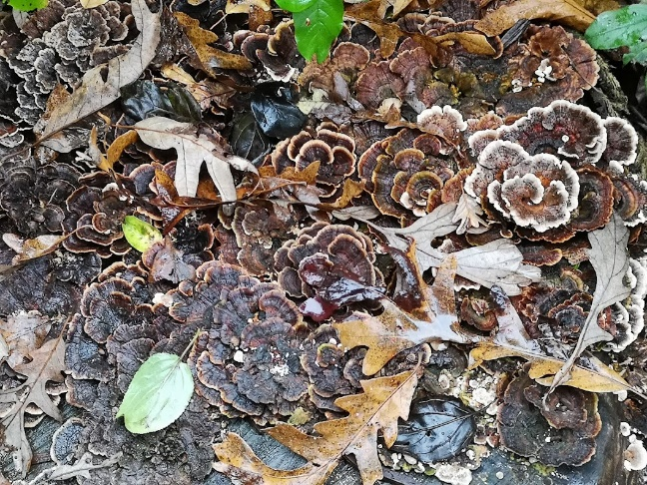
Scripture: Mark 10:46-52 https://www.biblegateway.com/passage/?search=mark+10%3A46-52&version=NRSV
Contemplation and Conversation: What do you need to feel included in community?
From Rev. Heather Leffler:
I find myself reading healing stories in a new way. They used to be wonderfully simple. There was a blind man, Jesus restored his sight and he lived happily ever after.
More than his sight, I now realize, Bartimaeus needed the love and support of a community that was afraid of him because of his disability. Even in a time when we have learned to speak of the man who is blind instead of the blindman in order to see the individual as a person first; where we legislate accommodations for people with different abilities, we still often fail to see and follow Jesus’ example.
Jesus didn’t see that Bartimaeus was blind and restore his sight. He asked what Bartimaeus needed Jesus to do for him. We all have weaknesses that make life challenging. Jesus invites us to ask for what we need so that we can be a part of our community and share our unique gifts with one another.
Whether you are at home trying to help slow the spread of the virus,
working to help care for those who are impacted most by COVID-19
or working to keep some normalcy in this time,
may you know God’s deep and abiding love in your life.
Know you are a valued part of our Rockwood and Stone United Church families.

Further Conversation … Would you like to talk more about today’s reflection? Email Heather at hleffler@rogers.com. Following worship next Sunday, she will invite others to join you in a Zoom break out room to share in further conversation.

Our Rockwood Stone Family
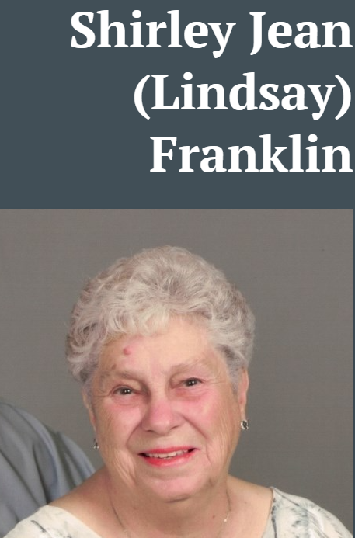
Our thoughts and prayers are with Joyce Duffield and her family as they mourn the death of her sister Shirley Jean (Linsay) Franklin who died Wednesday, October 20, 2021 in her 82nd year. https://www.legacy.com/obituaries/torstar/obituary.aspx?n=shirley-jean-franklin-lindsay&pid=200455698

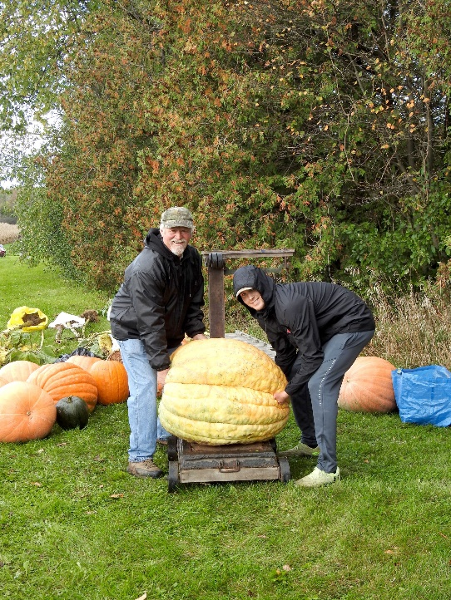
From Wellington Advertiser Saturday, October 23, 2021 Vol 54 Issue 42
Foodgrains Bank Growing Project wraps up
Growing project - Tom Parker, left, and Andy May weighing the winning pumpkin grown by Liam Anthony. Submitted photo
GUELPH/ERAMOSA – In spite of the inclement weather on Oct. 17, an enthusiastic crowd joined Stone United Church to wrap up its 2021 Foodgrains Growing Project.
The event marks the third year Stone United Church, with cooperation from area churches, has raised money for the Canadian Foodgrains Bank.
The project over the last two years has featured a friendly competition among church members to grow the heaviest pumpkin. This year sunflowers were added as a growing option with the challenge to grow the tallest sunflower.
The winner of the heaviest pumpkin this year was Liam Anthony, with a 275-pound entry.
Laurel and Alec Parker grew the tallest sunflower, topping out at 14 feet.
The best carved pumpkin was entered by the Leffler family and the best decorated by Pat Weir.
The Stone Project is one of many growing projects to raise money to combat global hunger.
“Last year in the face of the pandemic, $49 million was raised to help feed almost one million people suffering from hunger and malnutrition in 33 countries,” said Henry Reinder, Ontario regional representative for the Canadian Foodgrains Bank.
“This was the Canadian Foodgrains Bank’s best fundraising year ever.”
Reinder went on to thank project participants, noting, “This project is one of the more unique fundraising initiatives in Ontario.”
Tom Parker, one of the project organizers, thanked participants from Barrie Hill, Speedside, Erin/Ballinafad, Ebenezer, Arkell, Rockwood and Stone Churches.
This year, the hope is to surpass last year’s total of $7,500. Donations are still being accepted either by e-transfer to stoneuc.treasurer@gmail.com or by mail to Stone United Church, Box 57, Rockwood, N0B 2K0.
To-date we have raised $6,050 for our 2021 Foodgrains Project.
Go to https://www.youtube.com/watch?v=7Dib4iBw6yM to see our Wrap Up Video.

United Church of Canada from Moderator Richard Bott
The Mission of The United Church of Canada, as approved by the 43rd General Council:
Deep spirituality
Bold discipleship
Daring justice
The Vision of The United Church of Canada as approved by the 43rd General Council:
"Called by God, as disciples of Jesus, the United Church of Canada seeks to be a bold, connected, evolving church of diverse, courageous, hope-filled communities united in deep spirituality, inspiring worship, and daring justice."

A gift of belonging to a church is that the practice of gathering together for worship … to pray, sing, listen to scripture and share how God touches our lives – helps us grow in deeper relationship to God and each other. With COVID-19 keeping us at home and physically distant from our Stone or Rockwood families, we are missing each other. We are offering this practice of sharing beyond Sunday morning to deepen our connection. Each week you will be offered a picture, a scripture and a question for contemplation, as well as a short reflection for you to contemplate, have conversation with people in your life and/or join an online conversation on our Rockwood Stone Facebook page.

