Contemplation and Conversation: 23rd Sunday after Pentecost, October 31, 2021
Scripture: Ruth 1:1-18 https://www.biblegateway.com/passage/?search=Ruth%201%3A1-18&version=NRSV
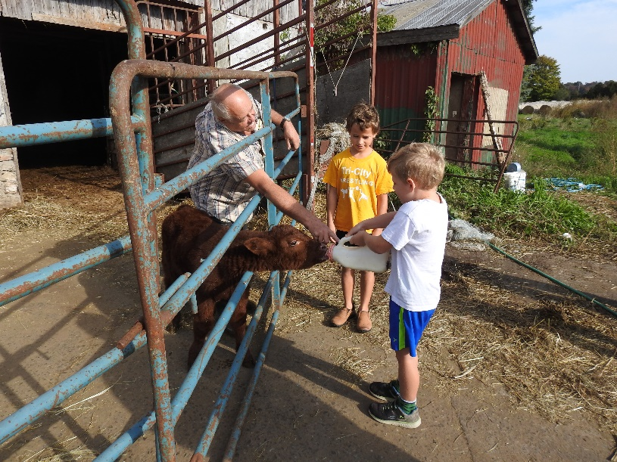
Contemplation and Conversation:
How can you create space to hear what others in our church family need?
How can you reach out so that others know what you need?
From Lisa Leffler:
Naomi’s life was marked by great tragedy. She and her family had to leave their home because of a time of famine. Eventually she rebuilt her life in a new land with her husband and two sons. For time her life was settled (or as settled as life ever is). Her sons were both married and presumably about to start their own families when another great tragedy befalls on Naomi. She loses both her husband and her sons and needs to return to her homeland to find support with her family.
In the midst of her grief Naomi tells her two daughters-in-law to return to their homes so they can rebuild their lives. Her first thought is of the well-being of her daughters-in-law but for Ruth leaving Naomi is not what is best for her. She decides to continue her journey with her mother-in-law.
We find ourselves in another time of great change in the midst of this pandemic that has consumed our lives for so long. Things are slowly opening back up for people who are fully vaccinated. For some this is a great joy as they see it as sign that things may finally be getting back to “normal”. Others find themselves anxious that we are perhaps moving too fast and will need more time to feel comfortable in public spaces. I pray that as we navigate this time of change, we remember and learn from Naomi who had the best intentions but was projecting her own needs on her daughters-in-law. The story of Ruth and Naomi invites us to name our needs and desires but not to let them overpower the needs and desires of those we love. This is not always an easy path to walk and so, I give thanks for the Re-Opening Commission who have spent many long hours prayerfully discerning how to keep our congregations safe and connected. As we journey forward together may their Spirit granted wisdom guide us so that no one is left behind.
Whether you are at home trying to help slow the spread of the virus,
working to help care for those who are impacted most by COVID-19
or working to keep some normalcy in this time,
may you know God’s deep and abiding love in your life.
Know you are a valued part of our Rockwood and Stone United Church families.

From Our Affirming Discernment Circle from Brian Mack
"For the Bible Tells Me So" on Kanopy (which can be accessed through your public library card) although produced in 2007, rings so true in 2021. 100 min in length.
Movie Promo – Does God really condemn loving homosexual relationships? Is the chasm separating Christianity from gays and lesbians too wide to cross? Is the Bible an excuse to hate? These questions and more are answered in this award-winning documentary, which brilliantly reconciles homosexuality and Biblical scripture - and reveals that religious anti-gay bias is based almost solely upon a misinterpretation of the Bible.
Through the experiences of five very normal, Christian, American families - including those of former House Majority Leader Richard Gephardt and Episcopal Bishop Gene Robinson - we discover how people of faith handle the realization of having a gay child or family member.
Our Rockwood Stone Family
Evelyn Farr is in hospital. Please keep her in your thoughts and prayers.

United Church of Canada From Moderator Richard Bott
I will never be able
to finish the all work
to which I have been called -
but, in all truth, I am not obliged to.
My task, however,
is to finish what my grandparents started,
and to begin what I can,
trusting that my justice-seeking,
my love-of-neighbour,
my care-of-creation,
will be completed
by my great-grandchildren,
as they begin
theirs.

A gift of belonging to a church is that the practice of gathering together for worship … to pray, sing, listen to scripture and share how God touches our lives – helps us grow in deeper relationship to God and each other. With COVID-19 keeping us at home and physically distant from our Stone or Rockwood families, we are missing each other. We are offering this practice of sharing beyond Sunday morning to deepen our connection. Each week you will be offered a picture, a scripture and a question for contemplation, as well as a short reflection for you to contemplate, have conversation with people in your life and/or join an online conversation on our Rockwood Stone Facebook page.

