Contemplation and Conversation: 2nd Sunday of Advent, December 21, 2021
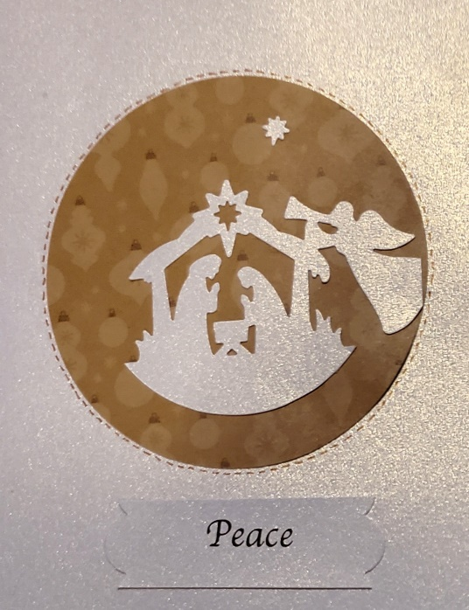
Scripture: Luke 1:68-79 CEV https://www.biblegateway.com/passage/?search=Luke+1%3A68-79+&version=CEV
From Rev. Heather Leffler:
One of the unexpected results of the pandemic has been that people from all intersections of life have joined together to address injustices. Perhaps our global experience in lockdown helped us focus on our shared humanity. We have been invited to open ourselves to others in a new way.
BIPOC – Black, Indigenous and People of Colour and LGBTQ2SI+ are speaking up, allies are standing with them, and people are listening. We are recognizing our privilege and biases and having the challenging conversations needed to reimagine our societies and institutions.
Whatever we are facing we are not alone. Zechariah assures us that God’s love and kindness shines in our lives like the sun that rises every day in the sky. In our homes and in the world, the Holy One guides us to see all people as our siblings so that together we can find a life of peace.
Contemplation and Conversation: Where do you long for peace in your life or the world?
Prayer
Jesus, Prince of Peace, you more than anyone can understand those who suffer because they are different. Help us learn to love and respect all people as they are so we can live in peace. Amen.

Whether you are at home trying to help slow the spread of the virus,
working to help care for those who are impacted most by COVID-19
or working to keep some normalcy in this time,
may you know God’s deep and abiding love in your life.
Know you are a valued part of our Rockwood and Stone United Church families.

Further Conversation … Would you like to talk more about today’s reflection? Email Heather at hleffler@rogers.com. Following worship next Sunday, she will invite others to join you in a Zoom break out room to share in further conversation.

From our Rockwood Stone Affirming Discernment Circle
Thank you to Brent Stiles for sharing his story that helped to deeper our understanding of why it is so important to be an affirming church. Brent shared with us at both churches and on Zoom. He shared a transcript that is attached to this email for anyone who missed it.

In a response to a headline from CNN Business that stated “2% of Elon Musk’s wealth could solve world hunger, says director of UN food scarcity organization” Elon Musk tweeted “If [UN World Food Program] can describe on this Twitter thread exactly how $6B will solve world hunger, I will sell Tesla stock right now and do it.” Musk was pointing out that it takes more than money to solve world hunger. Any organization working to solve world hunger knows there are political, social and economic challenges that need to be overcome. The Canadian Foodgrains Bank wrote an excellent response to his tweet describing some of the complexities they have faced working towards global food security and the actual estimated cost of solving world hunger (see link below).
For those of us who cannot casually offer to give six billion dollars, addressing food insecurity can be overwhelming. The good news is that we are not facing this problem alone. There are many organizations that work locally and globally to make a difference. Thank you for your continued support of East Wellington Community Services, Anishnabeg Outreach, Mission and Service, the Canadian Foodgrains Bank, and all the other organizations that work to help make sure everyone has all they need!
Response from the Canadian Foodgrains Bank: https://foodgrainsbank.ca/news/elon-musk-response/

United Church of Canada From Moderator Richard Bott December 2, 2021
I think I was arguing with my inner Grinch today...
an Advent poem (with apologies to Dr. Seuss!)
‘Twas the month before Christmas,
and all through God’s place,
the people were running –
not a moment for grace!
There was much to be done,
oh, yes, so much to do –
Carols to be sung,
Christmas cookies chewed through!
One: The wreath it was ready,
candles purple and white,
with the touch of match,
to blaze out the Christ-light!
But something was missing,
in all of our rush –
what was it I wondered,
what was it –
Oh, hush!
In the silence that fell,
I knew what we’d miss,
in our great to-and-fro-ing,
if we didn’t desist…
Peace.
Peace in our hearts.
Peace in our lives.
Peace in our families.
Peace in the world.
So let this light shine,
for some moments, each day,
to quiet our hearts,
to enlighten our way.
As we join hands together,
this great Advent-tide,
let us look round the world,
let us look side-to-side,
and with all that we are,
and with all that we do,
let us be peace-bearers forever,
Christ’s people, right through.

A gift of belonging to a church is that the practice of gathering together for worship … to pray, sing, listen to scripture and share how God touches our lives – helps us grow in deeper relationship to God and each other. With COVID-19 keeping us at home and physically distant from our Stone or Rockwood families, we are missing each other. We are offering this practice of sharing beyond Sunday morning to deepen our connection. Each week you will be offered a picture, a scripture and a question for contemplation, as well as a short reflection for you to contemplate, have conversation with people in your life and/or join an online conversation on our Rockwood Stone Facebook page.

