Contemplation and Conversation: 1st Sunday of Advent, November 28, 2021
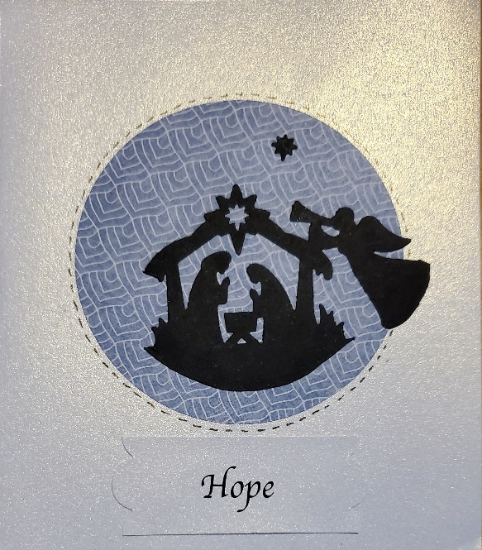
Scripture: Psalm 25:1-10 CEV https://www.biblegateway.com/passage/?search=Psalm+25%3A1-10&version=CEV
From Rev. Heather Leffler:
Journeying through the last 20 months has been filled with very real challenges, fears, loneliness, illness, sadness and grief for people around the world. No one has been untouched by the pandemic.
At the same time, the past months have opened us to the truth the Psalmist writes about. God is honest and merciful, kind and faithful to everyone. The path God lays out before us is one that urges us to look beyond ourselves.
Being together on Zoom or connecting by phone or email has grounded us in relationships. Hearing each others’ stories has helped us look beyond our struggles to be kind and faithful to one another. These connections help us find hope.
Contemplation and Conversation: What gives you hope in this time?
Prayer
God of hope, through the challenges life brings may the connection to you through our church family continue to bring us hope, so that we can in turn be kind and faithful to all. Amen.
Whether you are at home trying to help slow the spread of the virus,
working to help care for those who are impacted most by COVID-19
or working to keep some normalcy in this time,
may you know God’s deep and abiding love in your life.
Know you are a valued part of our Rockwood and Stone United Church families.

Further Conversation … Would you like to talk more about today’s reflection? Email Heather at hleffler@rogers.com. Following worship next Sunday, she will invite others to join you in a Zoom break out room to share in further conversation.

From our Rockwood Stone Affirming Discernment Circle
The Tri (Antler River Watershed, Horseshoe Falls and Western Ontario Waterways) UCW hosted a Zoom meeting entitled “A Step Towards Affirming”
Thea Sheridan-Jonah, presently a first year university student in Vancouver, set the wheels in motion for her home church, St Paul’s, Oakville, to become affirming.
She said that it is the little things that determine if we are welcoming or affirming. Do we shake hands/greet people outside or inside the front door? What does the sign on our washroom doors say? What words are we using in worship that might exclude people? Are we addressing people by their appropriate pronouns? How do we accommodate those with disabilities? What are the gifts of each person entering our churches? Are they allowed to be part of decision making?
Thea suggested that we reach outside our walls to community schools and organizations and let them know that our churches are safe places.
One participant asked if we should be called United Church” Women”. Another asked, “Would your community be willing to fly a Pride flag for the month of June?”
Our affirming journey is a time to examine ourselves, our churches and our community. Are we ready to “come out” as an affirming church? If you have questions, please contact Brent, Barb, Marion, Brian, Lisa or Liz.
Our Rockwood Stone Family
Advent Gifts in the Spirit of Christmas help us support Anishnabeg Outreach …
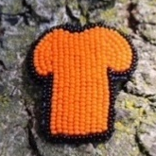
Anishnabeg Outreach’s Orange Shirt Sponsorship Program symbolizes a unified step towards reconciliation and the building of relationships between Indigenous and non-Indigenous peoples. Make a donation to Rockwood or Stone for Anishnabeg Outreach to help sponsor a bead making microbusiness. $150 sponsorship will provide Indigenous Artists with beading kits, a workshop and mentor so they can start their own micro business. AO will buy their pins and hope to expand the program to launch an online selling platform for Indigenous artists. https://aocan.org/orange-shirt-sponsorship/
East Wellington Community Services …
Make a donation to Rockwood or Stone to help fill Foodbank Christmas hampers for families who are food insecure. You can also donate 1 litre tetra packs of orange or apple juice, peanut butter, jam, boxes of chocolate, toothpaste at our churches.
Drop your gifts on the porch at Eva and Murray Olivers 5401 Eramosa 4th Line, Rockwood or Chris and Marcia Haworth’s 250 MacKenzie St, or bring them to worship at Rockwood or Stone. You can also donate towards gift cards for families.
Etransfers can be sent to stoneuc.treasurer@gmail.com or rockwooduc.treasurer@gmail.com
Cheques can be sent to Stone United Church, PO Box 57 Rockwood, ON N0B 2K0 or
Rockwood United Church, 119 Harris St., Rockwood, ON N0B 2K0.
Please designate what your donation is for.

United Church of Canada From Moderator Richard Bott November 27, 2021
It's almost Advent 1 (when the sun goes down!)
Come and sing with me!
(To the tune of "Winter Wonderland")
Advent's here - are you ready?
Every year (Yes, already!)
the cycle comes round,
the Christ to be found -
join us in the walk to Bethlehem!
Hope's alive, in our living!
Mistakes are made, but there's forgiving!
This Christmas we'll share
the Good News everywhere -
join us in the walk to Bethlehem!
In our lives there can be gloom and sorrow,
fears, frustrations - yes - they can abound,
but the Christ-child 's coming! (Not tomorrow!)
In this little one our hopes are found!
Advent's here - are you ready?
Every year! (Yes, already!)
This first candle we light,
to guide through the night -
join us in the walk to Bethlehem!
(Blessed Advent, all!)

A gift of belonging to a church is that the practice of gathering together for worship … to pray, sing, listen to scripture and share how God touches our lives – helps us grow in deeper relationship to God and each other. With COVID-19 keeping us at home and physically distant from our Stone or Rockwood families, we are missing each other. We are offering this practice of sharing beyond Sunday morning to deepen our connection. Each week you will be offered a picture, a scripture and a question for contemplation, as well as a short reflection for you to contemplate, have conversation with people in your life and/or join an online conversation on our Rockwood Stone Facebook page.

