Contemplation and Conversation: 3rd Sunday after Epiphany, January 23, 2022
Scripture: 1 Corinthians 12:12-31 https://www.biblegateway.com/passage/?search=1+Corinthians+12%3A12-31a&version=NRSV
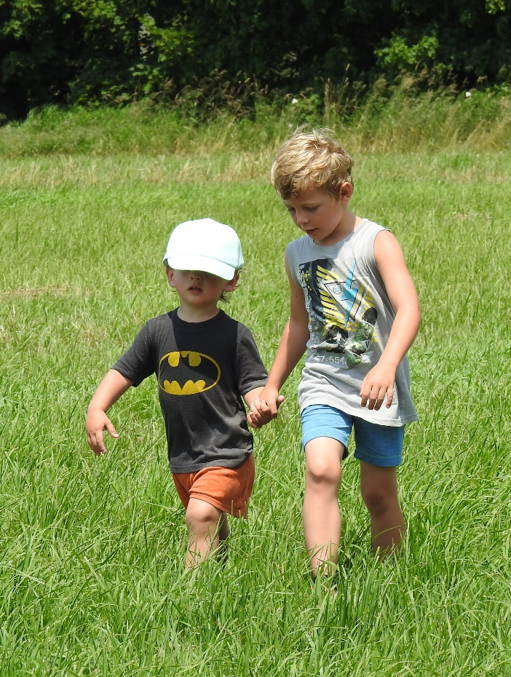
Contemplation and Conversation: Where have you found hope in this time?
From Rev. Heather Leffler:
If ever there was a time that reminds us, we are one body, Covid-19 is it. Actions or inactions of individuals and governments around the world have impact not only people but all of creation. We have seen leaders who denied the existence of Covid-19 or the efficacy of the vaccine that have left others confused, angry and refusing to get vaccinated. We cannot say what we do doesn’t affect our neighbours just as ²¹ The eye cannot say to the hand, “I have no need of you,” nor again the head to the feet, “I have no need of you.”
At our best as humanity in this time, we have seen scientist, corporations and governments work together to produce vaccines, medical equipment and essential goods much faster than we could ever imagine. We have seen countries with vaccines share them. People reached out in gratitude to health care and essential workers and to help out neighbours and people they have never met.
I find hope in these acts and the recognition that we are in this together. I pray that people will continue to find ways to care for others and that when we look back on this time, we will all be reminded that when we work together as one body the world is a better place. May it be so.
Whether you are at home trying to help slow the spread of the virus,
working to help care for those who are impacted most by COVID-19
or working to keep some normalcy in this time,
may you know God’s deep and abiding love in your life.
Know you are a valued part of our Rockwood and Stone United Church families.

Further Conversation … Would you like to talk more about today’s reflection? Email Heather at hleffler@rogers.com. Following worship next Sunday, she will invite others to join you in a Zoom break out room to share in further conversation.

Our Rockwood Stone Family
If you missed today’s worship service, email hleffler@rogers.com for the link.
United Church of Canada From Moderator Richard Bott, January 17, 2022
When I was a child,
I would throw myself
into the snow,
laughing as I was caught
with a "thud",
and billows around me,
a shiver of delicious cold
powdering down my neck,
as just a bit of the iciness
would get past my hood,
and drip down my back,
shrieks of joy pushing me up again,
only to find another spot
to fly and flop and flounder!
As the snow comes down this morning
I realize,
that's a pretty good description
of my faith-life, too.
Alleluia!

A gift of belonging to a church is that the practice of gathering together for worship … to pray, sing, listen to scripture and share how God touches our lives – helps us grow in deeper relationship to God and each other. With COVID-19 keeping us at home and physically distant from our Stone or Rockwood families, we are missing each other. We are offering this practice of sharing beyond Sunday morning to deepen our connection. Each week you will be offered a picture, a scripture and a question for contemplation, as well as a short reflection for you to contemplate, have conversation with people in your life and/or join an online conversation on our Rockwood Stone Facebook page.

