Contemplation and Conversation: 2nd Sunday after Christmas, January 2, 2022

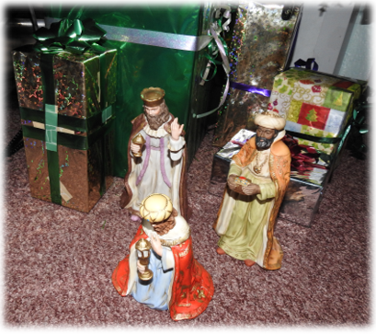
Scripture: Psalm 147:12-20 https://www.biblegateway.com/passage/?search=Psalm+147%3A12-20&version=NRSV
Contemplation and Conversation: How have you experienced giving as an expression of love in your own life? How might this work in your relationship with God?
From Brian Mack:
My favourite part of the Christmas story is found in the gospel of Matthew when the Magi offer gifts of gold, frankincense, and myrrh as they celebrate the birth of the baby Jesus. When they kneel down before the Christ child, no one calculates the monetary worth of the gifts. No one records what Mary and Joseph did with the offerings. We are only told that the Magi travelled a great distance, acknowledged the birth of the Messiah, and departed. Their gifts were given freely in love.
Like the gifts of the Magi that were given out of pure love, Psalm 147 reminds me that from the very beginning of the Biblical story, the Holy One has also given us gifts with no strings attached. The gift of creation was given freely to us in love. We have been blessed with rich soil, adequate sunshine, and sufficient rain to nurture our crops. We have been given snow in sufficient quantities to blanket the earth to allow for dormancy to occur and for the re-birth of plants to follow. We are privileged to see frost that is scattered like ashes on a January morning. We know the comfort of a gentle breeze on a hot summer day, or the surprise associated with a March thaw which causes water to flow freely.
In his book, The Meaning of Gifts, Paul Tournier states: “There comes a day when we understand that all is of grace, that the whole world is a gift of God, a completely generous gift. We see each flower, each drop of water, each minute of our life as a gift of God. He gives them to all, both to those who know him and to those who are ignorant of him.” God gives because God loves us. When we reciprocate by giving our time, our monetary offerings, and our talents to God, we love our Creator in return. As we embark on 2022 and make our stewardship resolutions, may we be reminded of all the ways on our life journey that we have been touched by the One who is both Holy Mystery and Wholly Love. Thanks be to God.
Whether you are at home trying to help slow the spread of the virus,
working to help care for those who are impacted most by COVID-19
or working to keep some normalcy in this time,
may you know God’s deep and abiding love in your life.
Know you are a valued part of our Rockwood and Stone United Church families.

Further Conversation … Would you like to talk more about today’s reflection? Email Heather at hleffler@rogers.com. Following worship next Sunday, she will invite others to join you in a Zoom break out room to share in further conversation.

Our Rockwood Stone Family
If you missed today’s worship service, email hleffler@rogers.com for the link.
Thank you to Chris Arbuckle for sharing information about an app that does live transcription on your phone, tablet, or computer. The app is called Live Transcribe & Notification and can be found here: https://play.google.com/store/apps/details?id=com.google.audio.hearing.visualization.accessibility.scribe
Please hold Jean Jackson, Liz Guthrie and their families in your thoughts and prayers as they mourn the death of Jean’s sister, Margaret Parkinson.
https://www.guelphtoday.com/obituaries/parkinson-margaret-nee-major-4906332

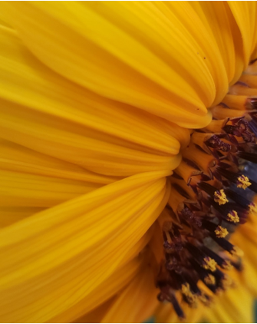
United Church of Canada Published On: December 31, 2021
From Moderator Richard Bott
In the year that is coming,
let's plant some seeds.
Seeds of hope.
Seeds of equity.
Seeds of justice.
Seeds of love.
Let's plant seeds that will germinate
and grow,
and produce beautiful flowers,
in this season, this year.
Let's plant seeds that will start,
this season,
but will need a year or two to grow,
before they produce their fruit.
Let's plant seeds that will germinate,
and break through the ground,
seeds of trees that will grow,
tall to the sun,
but not in our lifetime -
these are seeds for the generations
to come.
This year, let us bear witness
to the seeds of past plantings -
the ones we planted
that are just bearing fruit;
and the ones our grandparents sowed,
so many years ago.
And as we sow,
as we harvest,
as we simply sit in the shade,
let us give thanks...
for what was,
for what is,
for what is yet to come.
(Image: rb)

A gift of belonging to a church is that the practice of gathering together for worship … to pray, sing, listen to scripture and share how God touches our lives – helps us grow in deeper relationship to God and each other. With COVID-19 keeping us at home and physically distant from our Stone or Rockwood families, we are missing each other. We are offering this practice of sharing beyond Sunday morning to deepen our connection. Each week you will be offered a picture, a scripture and a question for contemplation, as well as a short reflection for you to contemplate, have conversation with people in your life and/or join an online conversation on our Rockwood Stone Facebook page.

