Contemplation and Conversation: 1st Sunday after Christmas, December 26, 2021
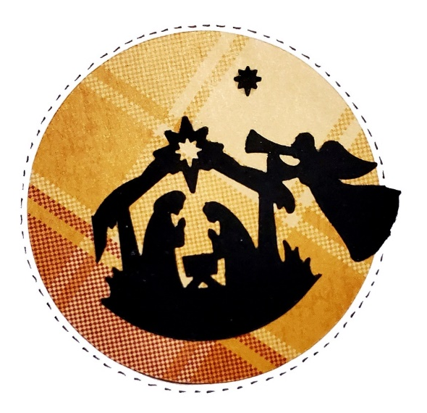
Scripture: Luke 2:1-14 https://www.biblegateway.com/passage/?search=Luke+2%3A1-14&version=CEV
Contemplation and Conversation: What fills your life with hope, peace, joy and love?
From Rev. Heather Leffler:
The shepherds were filled with fear when the angels first appeared. Could it be true? Was there a newborn saviour in a manger? Their fear transformed from curiosity to wonder when they knelt at the manger. For over 2,000 years, the babe in the manger has transformed people’s lives.
This Christmas season is not the same as Christmas’ past. We long for large lively gatherings, sharing delicious feasts, singing without masks and hugging those we love. And yet, even amidst the cautions there are so many things to be thankful for, so many ways creative ways to show our love and care.
Precious Jesus, fill us with the wonder of those who gathered at your birth and inspire us to love. Amen.
Whether you are at home trying to help slow the spread of the virus,
working to help care for those who are impacted most by COVID-19
or working to keep some normalcy in this time,
may you know God’s deep and abiding love in your life.
Know you are a valued part of our Rockwood and Stone United Church families.

Further Conversation … Would you like to talk more about today’s reflection? Email Heather at hleffler@rogers.com. Following worship next Sunday, she will invite others to join you in a Zoom break out room to share in further conversation.

Our Rockwood Stone Family
If you missed today’s worship service, email hleffler@rogers.com for the link.
Our Christmas Eve services can be found at https://www.youtube.com/channel/UCzo3XS-Ko7xb2b-bqogjyYg .

United Church of Canada From Moderator Richard Bott, December 26, 2021
There are people in this world who, by the strength of their faith and the conviction of their character, change the world for the better. Some do it on a smaller scale, while others find themselves in moments that are experienced around the world.
This was a man who faithfully lived out his call as pastor, priest, and prophet - and, in doing so, helped the world to be more hopeful, more loving, more just.
Archbishop Desmond Tutu - thank you for your ministry to a hurting and healing nation, and a hurting and healing world.
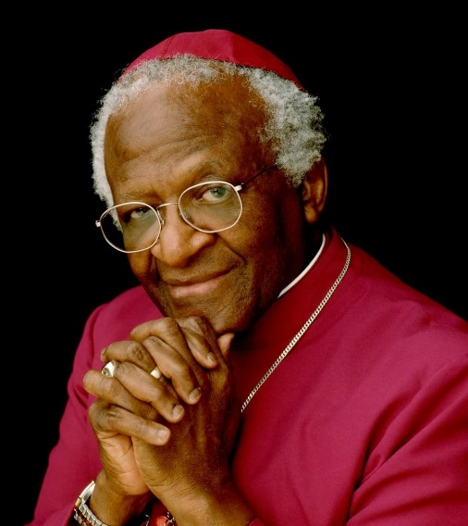
I'd invite these reading to join me in prayers of thanks to God, for the grace in his life and his ministry, and in prayers of compassion for his family, friends, community, and all others grieving in this time of goodbye.
"They will hunger no more,
or thirst any more.
The sun will not strike them by day,
nor any scorching heat.
For the Lamb at the center of the throne
will be their shepherd,
and will guide them to springs
of the water of life,
and God will wipe away every tear
from their eyes." (Rev. 7.16-17)
Archbishop Desmond Mpilo Tutu
1931 - 2021

A gift of belonging to a church is that the practice of gathering together for worship … to pray, sing, listen to scripture and share how God touches our lives – helps us grow in deeper relationship to God and each other. With COVID-19 keeping us at home and physically distant from our Stone or Rockwood families, we are missing each other. We are offering this practice of sharing beyond Sunday morning to deepen our connection. Each week you will be offered a picture, a scripture and a question for contemplation, as well as a short reflection for you to contemplate, have conversation with people in your life and/or join an online conversation on our Rockwood Stone Facebook page.

