Contemplation and Conversation: 1st Sunday of Lent, March 6, 2022
From the Lent and Easter Package
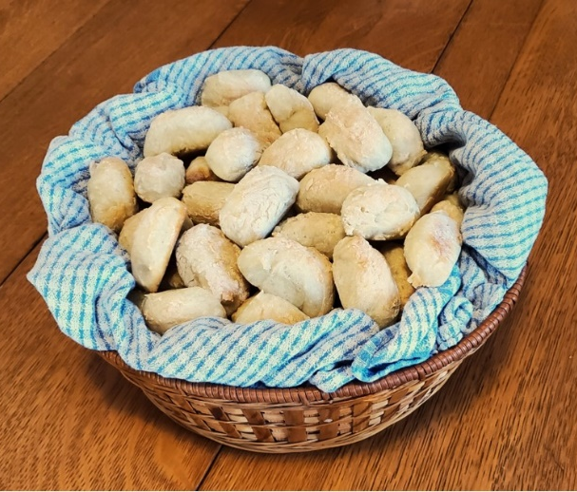
Scripture: John 6:28-40 CEV https://www.biblegateway.com/passage/?search=John+6%3A28-40&version=CEV
From Lisa Leffler:
Bread seems like such an ordinary, everyday food. It is something you may grab for a quick meal without giving it much thought, but when you pause to think about bread, it is the very ordinary nature that makes it so extraordinary. Imagine the smell of bread baking in the kitchen or taking a bite of bread still warm from the oven. If you take time to pause and appreciate what you are eating, there is a feeling of comfort and sustenance that goes far beyond the basic nutrition of the bread.
In the same way Jesus feeds our souls in a way that at times is beyond description. By inviting Jesus into our hearts, we are inviting in deep meaningful connections that exist beyond what we can see on the surface. The Spirit invites us into relationship that sustains us through the joys and sorrows of life.
When you make bread, it takes time to prepare the ingredients, let it rise and then bake it. Once it is consumed, you start the process all over again – sometimes in the same way and other times making little adjustments or trying something completely new.
On our faith journeys we are invited to ask questions as we engage in a spiritual practice, take the time to settle into a new spiritual space and then discern whether we are being invited to go deeper into our current practices or to try something new.
Just as there are many kinds of bread, there are many ways to know God through Jesus. At times life may be full and chaotic and we may need to engage in "quick-rise" explorations of faith. At other times we may have the time and space to take a more slow, methodical approach to our faith. There are gifts and challenges in whatever approach we take, and God will be there with us through it all. As we reflect on Jesus, the bread of life, we can take comfort in the way that Jesus is present and a part of our everyday lives, while looking forward to the potential of new and possibly challenging ways that following Jesus will shape us.
Contemplation and Conversation:
What practices bring comfort through familiarity in your faith?
Where might God be inviting you to try something new?
Prayer
Ever-present God, thank you for the gift of sustenance
that knowing you through Jesus offers in my life.
Through your Spirit help me discern when you are inviting me
to try something new and when to simply take comfort
in doing what is familiar.
In the times of comforting familiarity
and in the times of questioning and new possibilities
I know you are here with me. Thanks be to God! Amen.
Whether you are at home trying to help slow the spread of the virus,
working to help care for those who are impacted most by COVID-19
or working to keep some normalcy in this time,
may you know God’s deep and abiding love in your life.
Know you are a valued part of our Rockwood and Stone United Church families.

Further Conversation … Would you like to talk more about today’s reflection? Email Heather at hleffler@rogers.com. Following worship next Sunday, she will invite others to join you in a Zoom break out room to share in further conversation.

Our Rockwood Stone Family
If you missed today’s worship service, email rockwoodstoneuc@gmail.com for a YouTube link.

Attached are the pictures from the Lent and Easter package. If you would like an electronic copy of the whole package email hleffler@rogers.com.
Ukraine Crisis – CFGB and Mission and Service

Several of Canadian Foodgrains Bank member organizations have a presence in Ukraine. The Foodgrains Bank, together with the Humanitarian Coalition, has launched an appeal to help participating members and their locally-based partners provide emergency food assistance and support.
Please consider donating to help these efforts. Any donation you can make is appreciated. Visit www.foodgrainsbank.ca/donate/ukraine to find out more about the crisis and to give.
Donations can also be made through Stone’s CFGB Project by etransfer to stoneuc.treasurer@gmail.com or Stone United Church, PO Box 57 Rockwood, ON N0B 2K0.
Mission and Service is also supporting the people of Ukraine. Donations can be made at https://united-church.ca/social-action/act-now/conflict-ukraine or through an etransfer to Rockwood rockwooduc.treasurer@gmail.com Rockwood United Church, 119 Harris St., Rockwood, ON N0B 2K0.
Mark your etransfers and cheques for Ukraine.

World Day of Prayer
More than ever our world needs prayer. Friday, March 4, 2022 was the World Day of Prayer. The materials were written by the Women of England, Wales and Northern Ireland. The Women’s Inter-Church Council of Canada (WICC) virtual service can be found at https://wicc.org/world-day-of-prayer-2022-service-video/
Attached is information about England, Wales and Northern Ireland. Donations in support of the Women’s Inter-Church Council of Canada’s work can be made at www.wicc.org/donate .

United Church of Canada from Moderator Richard Bott, February 23, 2022
God - Creator, Christ, and Holy Spirit -
Trinity Divine, hear the words of my soul.
Peace. Peace!
Peace in Ukraine.
Peace in Russia.
Peace in the hearts of all
who manouver for war.
Peace for the children.
Peace for those of many years.
Peace, my God,
peace,
peace,
peace for the world, I pray.
Help us to pull back
from the games, greeds, and fears,
that lead us to brinkmanship -
to, at best, a place of chaos;
or, so much worse, to war's atrocities.
Peace, I pray.
Peace for all your children,
the world around.
Amen and amen.

A gift of belonging to a church is that the practice of gathering together for worship … to pray, sing, listen to scripture and share how God touches our lives – helps us grow in deeper relationship to God and each other. With COVID-19 keeping us at home and physically distant from our Stone or Rockwood families, we are missing each other. We are offering this practice of sharing beyond Sunday morning to deepen our connection. Each week you will be offered a picture, a scripture and a question for contemplation, as well as a short reflection for you to contemplate, have conversation with people in your life and/or join an online conversation on our Rockwood Stone Facebook page.

