Contemplation and Conversation: Palm Sunday, April 10, 2022
Scripture: John 15:1-6 CEV https://www.biblegateway.com/passage/?search=John+15%3A1-6&version=CEV
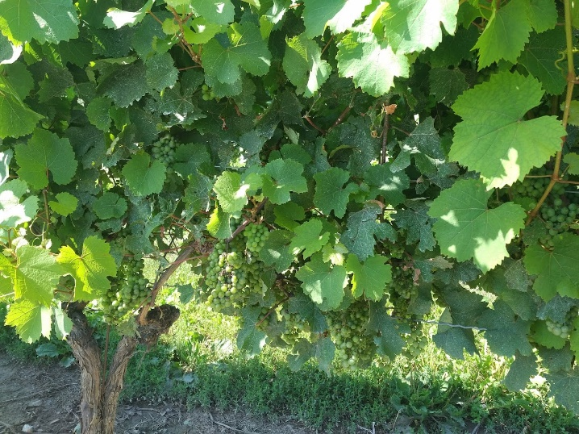
Reflection from Heather Leffler
William Barclay writes that vines grew all over Palestine. They were often grown on terraces and needed a great deal of attention to bear the best fruit. The soil was carefully prepared, slips were planted at least twelve feet apart and not allowed to bear fruit for three years. Branches were pruned drastically so the plant’s energy could go into bearing fruit. It was the vine that supported the branches and carried the nutrients from the roots through the branches to the fruit.
Having Jesus in my life means that sometimes I am called to cut things out of my life to make room for new possibilities. As we become more conscious of the impact we have on the earth, I find myself looking for ways to conserve energy and other resources, to reduce, reuse and recycle. This could feel like losing something, but my faith assures me that making choices that care for the earth and God’s creatures will open new possibilities I never imagined.
Contemplation and Conversation
What might Jesus be asking me to prune
to help care for creation or the people in my life?
Prayer
Jesus, thank you for providing for all my needs,
help me bear fruit that cares for your creation and creatures. Amen.
Whether you are at home trying to help slow the spread of the virus,
working to help care for those who are impacted most by COVID-19
or working to keep some normalcy in this time,
may you know God’s deep and abiding love in your life.
Know you are a valued part of our Rockwood and Stone United Church families.

Further Conversation … Would you like to talk more about today’s reflection? Email Heather at hleffler@rogers.com. Following worship next Sunday, she will invite others to join you in a Zoom break out room to share in further conversation.

Our Rockwood Stone Family
If you missed today’s worship service, email rockwoodstoneuc@gmail.com for a YouTube link.

United Church of Canada
I am sharing this prayer from Moderator Richard Bott again. With many people we care about infected with Covid-19, we continue to face challenging decisions each day.
I pray you and those you love will be well. – Heather Leffler
In this time of COVID-19, we pray:
When we aren't sure, God,
help us be calm;
when information comes
from all sides, correct and not,
help us to discern;
when fear makes it hard to breathe,
and anxiety seems to be the order of the day,
slow us down, God;
help us to reach out with our hearts,
when we can't touch with our hands;
help us to be socially connected,
when we have to be socially distant;
help us to love as perfectly as we can,
knowing that "perfect love casts out all fear."
For the doctors, we pray,
for the nurses, we pray,
for the technicians and the janitors and the
aides and the caregivers, we pray,
for the researchers and theorists,
the epidemiologists and investigators,
for those who are sick,
and those who are grieving, we pray,
for all who are affected,
all around the world...
we pray
for safety,
for health,
for wholeness.
May we feed the hungry,
give drink to the thirsty,
clothe the naked and house those without homes;
may we walk with those who feel they are alone,
and may we do all that we can to heal
the sick—
in spite of the epidemic,
in spite of the fear.
Help us, O God,
that we might help each other.
In the love of the Creator,
in the name of the Healer,
in the life of the Holy Spirit that is in all and with all,
we pray.
May it be so.

A gift of belonging to a church is that the practice of gathering together for worship … to pray, sing, listen to scripture and share how God touches our lives – helps us grow in deeper relationship to God and each other. With COVID-19 keeping us at home and physically distant from our Stone or Rockwood families, we are missing each other. We are offering this practice of sharing beyond Sunday morning to deepen our connection. Each week you will be offered a picture, a scripture and a question for contemplation, as well as a short reflection for you to contemplate, have conversation with people in your life and/or join an online conversation on our Rockwood Stone Facebook page.

