Contemplation and Conversation: Easter Sunday, April 17, 2022
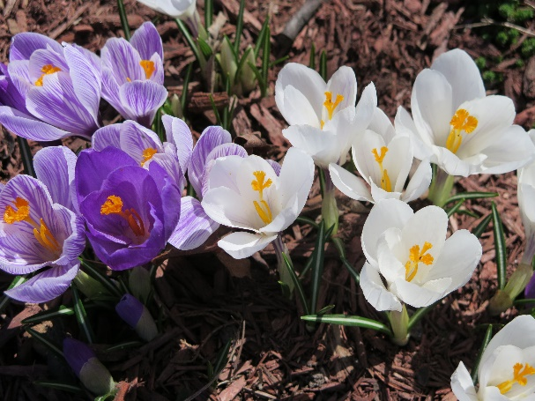
Scripture: John 11:17-27 CEV https://www.biblegateway.com/passage/?search=John+11%3A17-27&version=CEV
Photo by Marianne Poschung
Reflection from Rev. Heather Leffler
Martha’s heart was broken. Her beloved brother was dead. If only Jesus had come earlier, she was sure he could have saved Lazarus. But what was Jesus saying, he is the one who raises people from the death to life?
What joy when Jesus, raised Lazarus and restored him to his sisters and the community. Did Martha remember his words when Jesus died on the cross or was she plunged into a new despair with his disciples on Good Friday?
On Easter the tomb was empty, but it took time for his followers to take in that Jesus had risen from the dead. This may be one of the most challenging events for us to explain and accept as Christians. Yet all of creation points to the hope of resurrection.
In Confirmation we talked about symbols of Easter – bunnies, eggs, butterflies and flowers. What do they have to do with resurrection – rising from death to life?
In truth, many pre-Christian faiths and traditions celebrated spring and new life with bunnies, cocoons, seeds and eggs. When Christians came to explain the new life that we find in Jesus’ resurrection, we embraced these familiar symbols of birth and transformation. They help us share the hope we have in Jesus who has risen from the dead.
Alleluia Christ has risen! Christ has risen indeed!
Contemplation and Conversation
What symbol brings you hope at Easter?
Prayer
Risen Lord, thank you for the way signs of spring and new life
help us live in the assurance that
you are with us in life, in death and life beyond death,
we are not alone. Amen.
Whether you are at home trying to help slow the spread of the virus,
working to help care for those who are impacted most by COVID-19
or working to keep some normalcy in this time,
may you know God’s deep and abiding love in your life.
Know you are a valued part of our Rockwood and Stone United Church families.

Further Conversation … Would you like to talk more about today’s reflection? Email Heather at hleffler@rogers.com. Following worship next Sunday, she will invite others to join you in a Zoom break out room to share in further conversation.

Our Rockwood Stone Family
If you missed today’s worship service, email rockwoodstoneuc@gmail.com for a YouTube link.

United Church of Canada From Moderator Richard Bott
The tomb is empty,
the wrappings of death lie there,
but his body is gone.
Christ is risen!
Risen, indeed!
Alleluia, Alleluia, ALLELUIA!
Oh, alleluia, Amen!

War is terrible but you find us, Loving God.
You find us anxious as conflict rages in the country of Ukraine.
You find us angry at the senseless loss of life,
you find us distressed as civilians are caught up in a terrible war,
you find us grieving over the death of innocent bystanders.
War is terrible but you listen to us carefully, Loving God.
You listen as we ask the politicians, “Can’t you work for a peaceful solution?”
You listen as we say to the aggressors, “Don’t put children or hospitals at risk.”
You listen as we give thanks for countries that welcome those displaced
with big hearts and open arms;
you listen as we fear for journalists who put themselves in danger
to report the truth.
War is terrible but you give us hope, Loving God.
Hope that leaders will patiently give peace a chance.
Hope that despite the heartache, the terror, and the loss,
places of sanctuary will be found and acts of kindness will take root and grow.
Hope that feelings of revenge for broken livelihoods and broken bodies
will be replaced by a willingness to restore community and to forgive.
We pray in the name of Jesus, crucified one. Amen
―David Sparks

A gift of belonging to a church is that the practice of gathering together for worship … to pray, sing, listen to scripture and share how God touches our lives – helps us grow in deeper relationship to God and each other. With COVID-19 keeping us at home and physically distant from our Stone or Rockwood families, we are missing each other. We are offering this practice of sharing beyond Sunday morning to deepen our connection. Each week you will be offered a picture, a scripture and a question for contemplation, as well as a short reflection for you to contemplate, have conversation with people in your life and/or join an online conversation on our Rockwood Stone Facebook page.

