Contemplation and Conversation: 5th Sunday of Easter, May 15, 2022
Scripture: John 13:31–35
https://www.biblegateway.com/passage/?search=John+13%3A31%E2%80%9335&version=NRSVA

From Lisa Leffler:
Today’s scripture talks of a time of transition for Jesus’s followers. Jesus is preparing them for a time when he will no longer be with them physically, but his teachings and wisdom would remain in their hearts. Jesus knew he would no longer be there to help them discern the right path so he reminded his disciples that the most important thing they could do is to act out of love.
As followers of Jesus, we may not have ever known the physical presence of Jesus, but we know his love when we gather in community. We see the love Jesus spoke of when we make meals to care for someone going through a hard time. We see the love Jesus spoke of when we share our joys and sorrows in worship and other small groups throughout the week. We see the love Jesus spoke of when we create deep and lasting friendships with people we have met at church.
As disciples of Jesus, we are called to share that love with the world. To look for the piece of God’s Holy Mystery in each person we meet, to celebrate them for the unique individuals God made them to be and to help break down systemic barriers that may be keeping them from their true path. Walking the path of love means making sure you see the whole person, encouraging each person you meet to be the best version of themselves, and listening to their stories to help you be the best version of yourself.
Contemplation and Conversation
How do you engage the world with loving action? What makes you feel loved?
Prayer
Holy Mystery who is Wholly Love,
Help us to meet each person we encounter with love.
Open our hearts to deeper relationship with one another
as we learn more about your Holy Mystery
through the unique ways you have made each one of us. Amen
Whether you are at home trying to help slow the spread of the virus,
working to help care for those who are impacted most by COVID-19
or working to keep some normalcy in this time,
may you know God’s deep and abiding love in your life.
Know you are a valued part of our Rockwood and Stone United Church families.

Further Conversation … Would you like to talk more about today’s reflection? Email Heather at hleffler@rogers.com. Following worship next Sunday, she will invite others to join you in a Zoom break out room to share in further conversation.

Our Rockwood Stone Family
If you missed today’s worship service, email rockwoodstoneuc@gmail.com for a YouTube link.
x

United Church of Canada From Moderator Richard Bott,
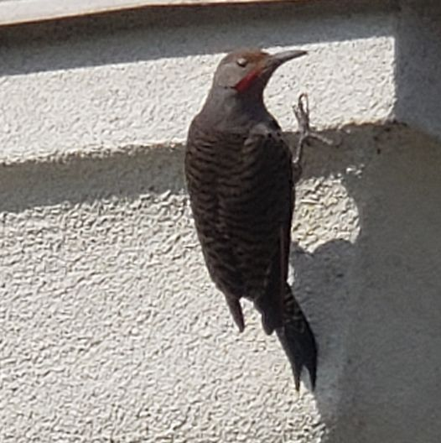
Holy Spirit's movin' round (here and now!)
Holy Spirit's movin' round,
in all Creation can be found!
(Oh, here and now, and every day,
oh, here and now, and every day!)
Holy Spirit's wings are strong (here and now!)
Holy Spirit's wings are strong,
gathers us under, carries along!
(Oh, here and now, and every day,
oh, here and now, and every day!)
Holy Spirit sings Christ's love (here and now!)
Holy Spirit sings Christ' love,
in gullsong, raven's cry, coo of the dove!
(Oh, here and now and every day,
oh, here and now, and every day!)
At Pentecost the Spirit sang (here and now!)
Pentecost the Spirit sang;
church, it started, with quite a bang!
(Oh, here and now and every day,
oh, here and now, and every day!)
Holy Spirit's movin' round (here and now!)
Holy Spirit's movin' round,
in all Creation can be found!
(Oh, here and now, and every day,
oh, here and now, and every day...
oh, here and now - and every day!)
(Tune: Lukey's Boat (Canadian folk song))

A gift of belonging to a church is that the practice of gathering together for worship … to pray, sing, listen to scripture and share how God touches our lives – helps us grow in deeper relationship to God and each other. With COVID-19 keeping us at home and physically distant from our Stone or Rockwood families, we are missing each other. We are offering this practice of sharing beyond Sunday morning to deepen our connection. Each week you will be offered a picture, a scripture and a question for contemplation, as well as a short reflection for you to contemplate, have conversation with people in your life and/or join an online conversation on our Rockwood Stone Facebook page.

