Contemplation and Conversation: 7th Sunday of Easter, May 29, 2022
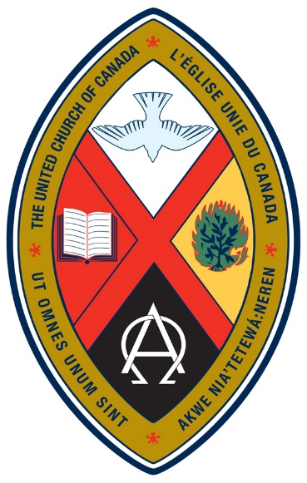
Scripture: John 17:20-26 NRSVUE https://www.biblegateway.com/passage/?search=John%2017%3A20-26&version=NRSVUE
From Rev. Heather Leffler:
In 1925 the Congregational, Methodist, Presbyterian and Union Churches came together to form our United Church of Canada. In 1944 when our crest was adopted the Latin phase “Ut omnes unum sint” “that they may be one” from John’s gospel was inscribed on it. Those of us of a certain age looked forward to the day when all Christian churches would come together as one. Almost 100 years later, we have had individuals, ministers and churches leave our United Church. We have recognized and apologised for our treatment of our First Nations siblings, women, diaconal ministers, Japanese Canadians, members of the LGBTQ2S+ community and most recently our Black and Asian siblings. We have forged some relationships with other denominations, but we find ourselves far from agreement with others.
How can we hear these words of Jesus in a new way for our time? For me, the answer is to look more closely at the motley crew of disciples that Jesus saw as one with him in God … deniers and doubters, fishermen and tax collectors, Greeks and Jews, men and women, prostitutes and people who had been possessed by demons. These were the people he saw as being one in God. Not because they were all believed the same doctrines or even understood scripture in the same way. Jesus saw them as one in him and God because he loved them, and they loved him. That didn’t make them perfect. I’m guessing there were days they didn’t even like each other that much. What was clear was that they all mattered because Jesus and God loved them. It isn’t easy to be with people who see the world from a different perspective than we do but if we are to be one family in God, we have to love one another despite our differences, maybe even because of them.
In 2012 the Mohawk phrase "Akwe Nia'Tetewá:neren" which means “all my relations” was added to our crest. It points to seeing all people and indeed all creatures as relations through our Creator. Instead of seeking to make us all the same it invites us to celebrate our differences.
Contemplation and Conversation
Who might God be inviting you to be one with, despite your differences?
Prayer
Holy Mystery, who is Wholly Love,
help us to truly listen to those who think differently than we do,
to respond in humility and love especially when it is challenging
so that we may all be one in your love. Amen.
Know you are a valued part of our Rockwood and Stone United Church families.

Further Conversation … Would you like to talk more about today’s reflection? Email Heather at hleffler@rogers.com. Following worship next Sunday, she will invite others to join you in a Zoom break out room to share in further conversation.

Our Rockwood Stone Family
If you missed today’s worship service, email rockwoodstoneuc@gmail.com for a YouTube link.
For more information about our United Church Crest, go to https://united-church.ca/community-and-faith/welcome-united-church-canada/united-church-crest

United Church of Canada from Moderator Richard Bott, May 25, 2022
I'm angry, God...
and there's nothing I can do with it.
My jaw is clenched,
and my hands keep grasping,
and my heart is pounding,
I want to do *something*...
but all I can do is offer prayerful support
for our neighbours to the south,
for our friends and our communion partners
in the U.S.A.
Somehow, it just doesn't feel like it's enough.
Less than two weeks ago, in Buffalo,
10 women and men, most of them Black,
were murdered by an 18-year-old youth
in a mass shooting fueled by racism and hatred.
Less than twenty-four hours ago,
19 children and one of their teachers
were murdered by an 18-year-old youth,
shot and killed at their school in Texas.
Over and over and over again,
the people who worship
the god of the trigger and barrel
sacrifice life after innocent life;
while others pass laws that protect
their "right" to bear arms
over others' right to live.
The numbers keep growing.
How can I help, God?
I'm a Canadian,
part of a different political and social system,
one with our own massive problems
of racism and poverty and brokenness,
but at least I have a voice and a vote and
the ability to act, here.
How can I help my neighbours,
the folks who are just across that invisible line?
What can I do that will build up,
rather than tear down?
What do I do with this rage, my God?
I pray for the families who are grieving.
I pray for the agents of change.
I pray that whatever powers and principalities
given strength by this insanity,
would be transformed by the actions
of those who truly live your love,
who believe in life, and life abundant,
for all your creation.
I pray, loving God.
Help me to understand how I can act.
Please...

A gift of belonging to a church is that the practice of gathering together for worship … to pray, sing, listen to scripture and share how God touches our lives – helps us grow in deeper relationship with God and each other. We are offering this practice of sharing beyond Sunday morning to deepen our connection. Each week you are offered a picture, a scripture and a question for contemplation, as well as a short reflection for you to contemplate, have conversation with people in your life and/or join an online conversation on our Rockwood Stone Facebook page.

