Contemplation and Conversation: Pentecost Sunday, June 5, 2022
Scripture: Acts 2:1–21
https://www.biblegateway.com/passage/?search=Acts+2%3A1%E2%80%9321&version=NRSVUE
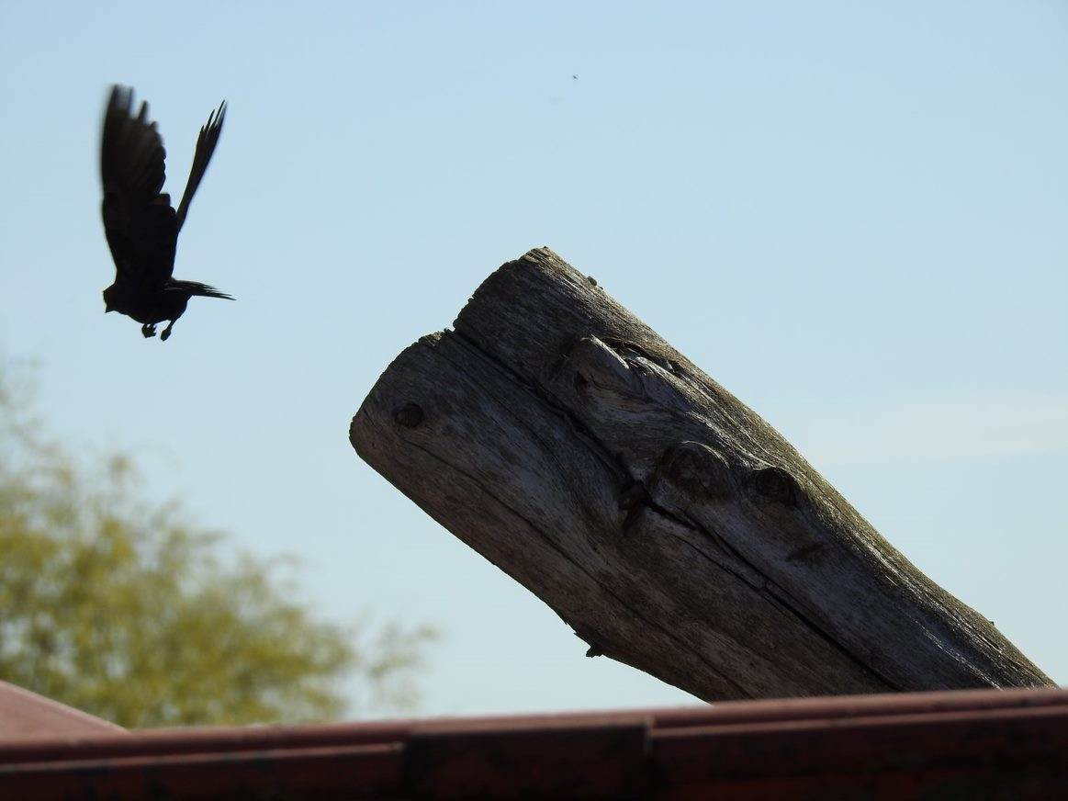
From Lisa Leffler:
On the day of Pentecost there were people gathered from many different regions with different languages and cultures. As they were gathering there was probably lots of miming and testing out different languages to find ways to communicate with one another. There were probably many misunderstandings and frustrations but when it was time to hear the word of God a miracle happened – everyone was able to hear the message in their own language!
This story reminds us that even when we all hear the same message it is impacted by our own experiences and interpretations. At times this can lead to frustration when someone is not getting something that seems so obvious to you. Over the years I have found myself thinking (and sometimes saying), “How can that person call themselves Christian and …?” The “ands” are always different but the feeling of anger and betrayal that “those people” are reading the same scriptures as me and using them to justify what I see as hatred and hurt remains the same.
That anger and judgement is something that I continue to work hard at letting go because as this scripture tells us we are all connected by one Spirit, and we all belong to God. That tells me that I don’t get to just write someone off because I don’t agree with them. Sometimes that is more challenging than others but a lecture I recently listened to by Brené Brown helped me to find a way to let go of some of that judgement. She described a really challenging situation to her therapist about having to share a room with someone on a retreat who was smoking in a non-smoking retreat centre and wiping her sticky icing covered fingers on their shared couch. The therapist’s response to this story was one simple question, “Do you think she was doing the best she can?”
When we approach people assuming that they are doing their best it is a lot easier to treat them with compassion. It invites us to ask, “How can I help that person?” instead of “What is wrong with that person?!” Looking for the best in one another leaves room for the Spirit to be at work in our lives and helps us to shift from simply “doing the best we can” to become the best versions of ourselves. The versions of ourselves that God is inviting us to as we join together in community bound by one Spirit.
Contemplation and Conversation
How do you recognize God’s Spirit in people that you find challenging?
Prayer
Holy Mystery who is Holy Love,
Help us to see beyond our differences
and recognize your Spirit in everyone we meet.
Help us to see the best in one another
so that we can live and work together in community
bound together by your love. Amen
Know you are a valued part of our Rockwood and Stone United Church families.

Further Conversation … Would you like to talk more about today’s reflection? Email Heather at hleffler@rogers.com. Following worship next Sunday, she will invite others to join you in a Zoom break out room to share in further conversation.

Our Rockwood Stone Family
If you missed today’s worship service, email rockwoodstoneuc@gmail.com for a YouTube link.
Thank you to the Rockwood-Stone Choir for sharing “Tell Me the Stories of Jesus”: https://www.youtube.com/watch?v=AcAcGn9IWIM

United Church of Canada From Moderator Richard Bott
Pentecost is Sunday, June 5. In his last Pentecost video message as Moderator, the Right Rev. Dr. Richard Bott reminds us that The United Church of Canada is part of the 2000-year community of Christ’s disciples―a worldwide communion that is not bound by geography, space, or time. We are people who change the world—with deep spirituality, with bold discipleship, with daring justice.
Watch it on YouTube here: https://www.youtube.com/watch?v=AiOIM4w-gKA

A gift of belonging to a church is that the practice of gathering together for worship … to pray, sing, listen to scripture and share how God touches our lives – helps us grow in deeper relationship with God and each other. We are offering this practice of sharing beyond Sunday morning to deepen our connection. Each week you are offered a picture, a scripture and a question for contemplation, as well as a short reflection for you to contemplate, have conversation with people in your life and/or join an online conversation on our Rockwood Stone Facebook page.

