Contemplation and Conversation: Baptism of Jesus 2020
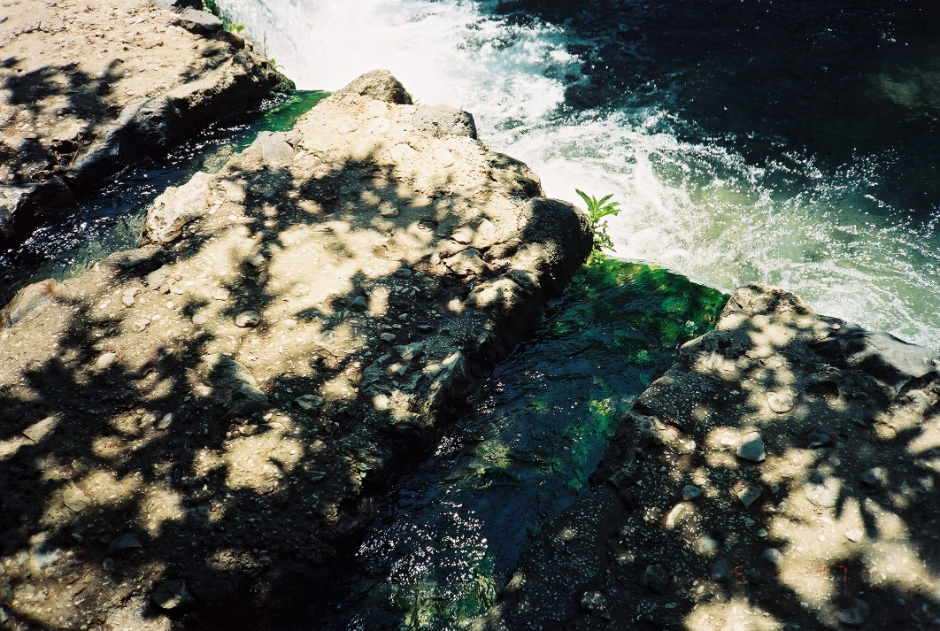
A gift of belonging to a church is that the practice of gathering together for worship … to pray, sing, listen to scripture and share how God touches our lives – helps us grow in deeper relationship to God and each other. When life keeps you from being physically present at Stone or Rockwood, you are missed. We are offering a practice of sharing beyond Sunday morning to deepen our connection. Each week you will be offered a picture, a scripture and a question for contemplation, as well as a short reflection for you to contemplate, have conversation with people in your life and/or join an online conversation on our Rockwood Stone Facebook page.
Source of the Jordan River, Israel
Matthew 3:13-17: https://www.biblegateway.com/passage/?search=Matthew+3%3A13-17&version=NRSV
Contemplation and Conversation: What does being baptized mean to you?
From Rev. Heather Leffler:
I have often found it hard to find the words to describe what being baptized means in my life. The more we share in conversation in worship, the more confident I become that being baptized has had a significant impact on my life. Being baptized assures me that I am a part of a community of believers who celebrate God's presence … live with respect in Creation, … love and serve others, … seek justice and resist evil … and proclaim Jesus, crucified and risen, our judge and our hope. I am so grateful to find that community at Rockwood and Stone at this time in my life.
May reflecting on your baptism remind you that you are a beloved child of God
and a valued part of our Rockwood and Stone United Church families.

