Contemplation and Conversation: 2nd Sunday after Epiphany, January 17, 2021
Scripture: 1 Corinthians 6:12-20 https://www.biblegateway.com/passage/?search=1+Corinthians+6%3A12-20+&version=NRSV
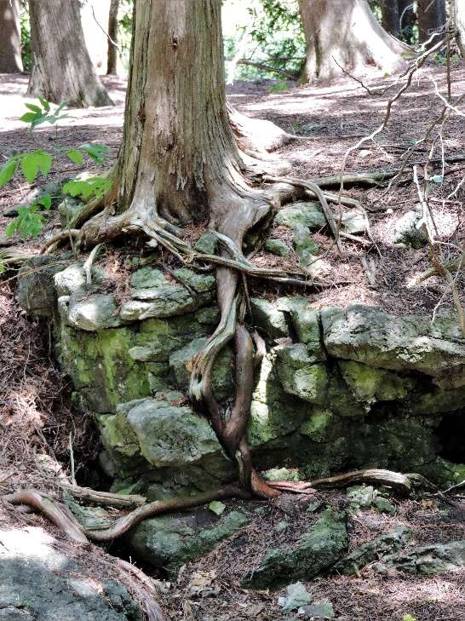
Contemplation and Conversation: How do your choices and actions impact others? How do you balance your needs with the needs of others?
From Lisa Leffler:
In Bible Study we have been reading the epistles (letters written to early churches by the apostle Paul). If you have attended Bible Study even once you will know I can be more than a little hard on Paul. I find at times he can be a little over critical and hyper-dramatic. Today’s passage is no exception. He is the full embodiment of a hellfire preacher as he calls for people to “shun fornication”. This is a style of preaching that I have a hard time with because too often I have seen it lead to a culture of shame and self-loathing, but if you can get passed the harsh tone of today’s scripture it holds an important message:
We are all connected to God and through God we are connected to each other and all creation!
This is an important message as we find ourselves in another lockdown and have been asked to only go out for the essentials. The government has tried to outline what is essential and what should be avoided but the challenge is that we all have unique and diverse needs. We all have different understandings of what is essential and what is not.
You do not have to spend long watching the news or on social media before you hear people complaining about the restrictions or refusing to follow guidelines. When you are doing your best to comply it is frustrating when others appear not to be. I think that frustration stems from knowing that the actions of people not following restrictions will impact everyone around them because we are all connected.
We live in a very individualistic society, so we don’t always think about how our actions impact those around us. I believe the reminder that we are all connected through creation and through God’s love is actually a gift of the pandemic. When I am trying to decide what is essential for me, I start by thinking how it will impact people around me. Doing a risk assessment every time I want to leave the house can be exhausting but it helps develop an important skill of being aware of the impact of my actions.
There is nothing that we do that does not impact the world around us. The choices we make about what products to buy impact the earth that we all share. How we react in different situations affects the emotional well-being of those arounds us. The information we choose to share (or not share) impacts how people learn and grow. Imagine the positive impact we can have when we make those choices with the knowledge that God’s Spirit connects us all!

Whether you are at home trying to help slow the spread of the virus,
working to help care for those who are impacted most by COVID-19
or working to keep some normalcy in this time,
may you know God’s deep and abiding love in your life.
Know you are a valued part of our Rockwood and Stone United Church families.

Further Conversation … Would you like to talk more about today’s reflection? Email Heather at hleffler@rogers.com. Following worship next Sunday, she will invite others to join you in a Zoom break out room to share in further conversation.

From our Rockwood Stone Affirming Discernment Circle
Paul’s scripture today made his opinions about a sexual ethic very clear but in today’s society that is not always an easy thing to navigate. Queer Theology offers an excellent resource on creating your own sexual ethic. Check it out here: https://www.queertheology.com/create-sexual-ethic/.

From East Wellington Community Services
Dear members of Stone United and Rockwood United Churches,
As we look back at another year, we want to take this opportunity to thank you for your support throughout 2020. Your contributions and efforts in support of EWCS Rockwood food bank have enabled us to provide food to those in our community who struggle during difficult times.
We could not do our work without the support of partners like you and we truly value your assistance. We are humbled by your generosity and grateful for all your help.
On behalf of our board of directors, volunteers, staff and the clients who receive your food, gifts and monetary contributions, we thank you for the impact you have made.
May 2021 bring us all good health and hope for a bright future.
Barb Carscadden

United Church of Canada – from Moderator Richard Bott
A prayer while being vaccinated against COVID-19:
(Note: I have not yet been vaccinated. I will probably have my chance in the fall. But I like having prayers in my back pocket. 😉 )
My God...
bless the hands that hold the needle,
as I give thanks for their care,
bless all those who have brought this vaccine into being,
and those who have gotten it
from there to here;
bless this body that begins the work,
and bless the antibodies it produces,
may they have long and lasting memory,
to protect me from COVID's harm.
Thank you for the science and the medicine,
thank you for the researchers, all;
thank you for the gifts that have been given,
may we make certain this gift is available
to *all* the world - the great and the small.
In the name of the Creator,
in the presence of the Healing Christ,
with the grace of the Holy Spirit, I pray.
May it be so.
A gift of belonging to a church is that the practice of gathering together for worship … to pray, sing, listen to scripture and share how God touches our lives – helps us grow in deeper relationship to God and each other. With COVID-19 keeping us at home and physically distant from our Stone or Rockwood families, we are missing each other. We are offering this practice of sharing beyond Sunday morning to deepen our connection. Each week you will be offered a picture, a scripture and a question for contemplation, as well as a short reflection for you to contemplate, have conversation with people in your life and/or join an online conversation on our Rockwood Stone Facebook page.

