Contemplation and Conversation: Transfiguration Sunday, February 27, 2022
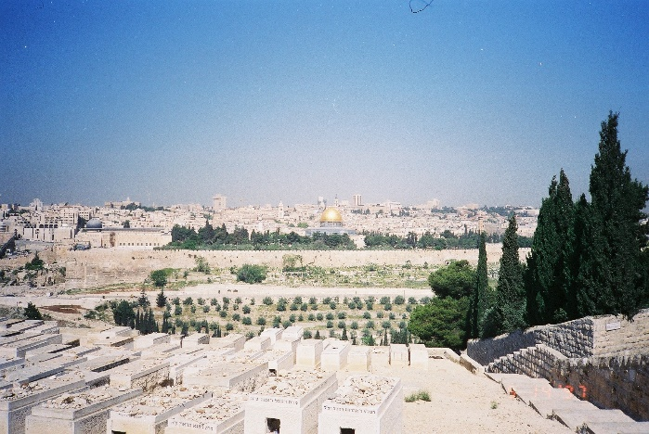
Scripture: Luke 9:28-36 NRSV https://www.biblegateway.com/passage/?search=Luke%209%3A28-36&version=NRSV
Contemplation and Conversation:
When have you experienced something that you only fully understood later?
From Rev. Heather Leffler:
What a gift for Peter, James and John to have time alone with Jesus! As he prayed, they started to doze off. Then Jesus transformed before their eyes and they were wide awake. Suddenly Moses, who led the children of Israel out of Egypt and through the wilderness, and Elijah, the great prophet, were with him. Peter wanting to hang on to the moment would have built shelters for them. As they left, the friends kept silent. What did it mean? Who could they tell? Who would believe them? They couldn’t talk about it then, but I have no doubt that experience shaped their lives and their ministry.
At the invitation of a beloved professor and with John’s encouragement, I took two courses in Israel. For someone who had rarely been out of Ontario and never traveled without family or friends, it was something I had never imagined doing. Setting out I had no idea that while I was walking from the Old City to the New City of Jerusalem, I would have my wallet stolen and would have to go back into the city by myself to report the theft. At the time I just did what I had to do. Looking back, it is one of the experiences of the trip that shaped me the most. It taught me that I could face the challenges life offers and gave me the courage to do things I would never have considered.
May you find gifts in the challenges you have faced, that open new possibilities for your life. Amen.
Whether you are at home trying to help slow the spread of the virus,
working to help care for those who are impacted most by COVID-19
or working to keep some normalcy in this time,
may you know God’s deep and abiding love in your life.
Know you are a valued part of our Rockwood and Stone United Church families.

Further Conversation … Would you like to talk more about today’s reflection? Email Heather at hleffler@rogers.com. Following worship next Sunday, she will invite others to join you in a Zoom break out room to share in further conversation.

Our Rockwood Stone Family
If you missed today’s worship service, email rockwoodstoneuc@gmail.com for a link
The video of Chimamanda Ngozi Adicie: The Danger of a Single Story shared in worship can be found at https://www.youtube.com/watch?v=D9Ihs241zeg .

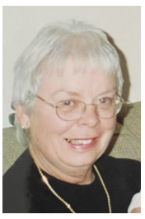
Stewart (Broderick), Frances Mae — Fran would like to let you know that as of February 22, 2022, at the age of 79, her work here is done. Fran received a call, a sort of an offer that you cannot refuse, for an appointment from which she will not be returning. This assignment comes with a huge sign-on bonus, a reunion with family and friends she has not seen in a long time. Job security is exactly 110 percent. Her new mission takes her to a wonderful place where she will be socializing, dancing, gardening, knitting and reading to her heart’s content. Music, laughter and love are guaranteed. Food is delicious and you never gain an ounce. Fran left detailed instructions for her husband and children to celebrate her mission here, which has now been completed. Low adherence to these instructions will not be tolerated. We want to let her know that she did a great job while she was here and wish her a safe journey. We will remember her smile, her warmth, her energy, her love for life, family and friends. She worked very hard all her life, up until the very end. She made a difference in the lives of many, and her life here will not be forgotten.
Fran is survived by her husband Kenneth and two daughters, Constance Cunningham (Stewart) and her husband Carey Cunningham of Oakville, Ontario, and April Vodden (Stewart) and her husband William (Bill) Vodden of Fergus, Ontario. Proud Grandma of Nicholas and Logan Cunningham and Morgan and Austin Vodden. Predeceased by Fran’s sister Florence Shortt (Broderick) and brother-in-Law Ronald Shortt and Mother and Father, Edith and Joseph Broderick.
Fran was born in Toronto, went to school in Toronto and was employed by NCR Canada Ltd. where she met the love of her life - Kenneth. She worked for NCR till she left to start a family. After thirteen + years raising her family, Fran went back to school to upgrade her skills to return to the workforce. She ended up working for the IGA in Acton as a Bookkeeper for a number of years where she retired from in 2000. Fran has lived in Toronto, Ontario, Mississauga, Ontario, Pitt Meadows, British Columbia, Acton, Ontario and Rockwood, Ontario for the last 34 years. The main things in Frances’ life were her love for her children, grandkids, husband and friends. Fran enjoyed travelling, doing things with her grandkids and just life itself.
Fran will be cremated and laid to rest in a private Interment. However, we invite you all to join the family and celebrate her life together. ARRANGEMENTS: Celebration of Life will take place on Saturday, March 26, 2022, from noon to 2:00 pm and then interment right after – all are welcome to attend. The Celebration of Life will be held at Memory Gardens Funeral Home & Cemetery, 2723 Victoria Street North, Breslau. Ontario N0B 1M0 – Phone #: 1-(519)-904-0400. Any donations should be given to your local Alzheimer’s Society, St. Joseph’s Health Centre, Guelph, Ontario, Rockwood United Church in Rockwood, Ontario, in the memory of Frances Stewart – God be with you all, Fran waits to meet all of us again.

United Church of Canada From Moderator Richard Bott, February 27, 2022
God of all Creation,
God of the heights and the depths,
and everything in-between,
God of this blue-green bauble,
spinning in space,
a place of such wonderous creatures,
and abundant life...
we are praying for a miracle,
one of the smallest of changes,
but one that would have immense consequence.
As a delegation from Russia,
meets with a delegation from Ukraine,
on the border of Belarus,
seeking to end the war
that Russia has perpetrated on Ukraine,
seeking to end the death,
seeking to make a peace,
what I am praying for is a change of
mind, a change of
heart, a change of
worldview,
in the Russian leadership,
who brought this into being.
Help them, God of all hope,
to see that this is the chance to
step back from the war,
to pull back the escalation,
to let go of whatever it is
that made them choose
the path that has led to
the chaos,
the destruction,
the death,
in Ukraine.
We need a miracle that will
help them to not only pull back,
their forces to within their borders,
their rhetoric of nuclear option;
but to be part of the rebuilding
of the nation they sought to overtake...
in the midst of the grief and tears
and anger and rage,
of the parents and grandparents,
of the siblings and children,
of the friends and neighbours,
of those who have been killed
in this act of aggression.
Help us to bring this to an end, God,
one that will allow the sunflowers of Ukraine
to reach their growth,
sprouting in the soil of peace,
under a hope-filled sky.
Help us to make that miracle, God,
for it is truly needed.
In Christ's name,
in the Spirit's power,
in the Creator's love,
I pray.
Amen.

Black History Month – For Black History Month, Albertine Chokoté Naoué asks what each of us can do to deconstruct thoughts and behaviours that are harmful. Albertine is a trained (PhD) lay biblical theologian. She is a member of the governing board of the La Table des ministères en français and Treasurer of the Executive Office. Originally from Cameroon, Albertine lives in Toronto, where she is the founder and director of the non-profit organization Connexion Verte. This NPO works to promote the most equitable inclusion possible into their new living environment for members of Black Francophone communities of African descent already living in Ontario or new to the province. Read her blog at https://united-church.ca/blogs/round-table/when-hope-meets-indifference .

A gift of belonging to a church is that the practice of gathering together for worship … to pray, sing, listen to scripture and share how God touches our lives – helps us grow in deeper relationship to God and each other. With COVID-19 keeping us at home and physically distant from our Stone or Rockwood families, we are missing each other. We are offering this practice of sharing beyond Sunday morning to deepen our connection. Each week you will be offered a picture, a scripture and a question for contemplation, as well as a short reflection for you to contemplate, have conversation with people in your life and/or join an online conversation on our Rockwood Stone Facebook page.

