Contemplation and Conversation: 3rd Sunday, December 21, 2021
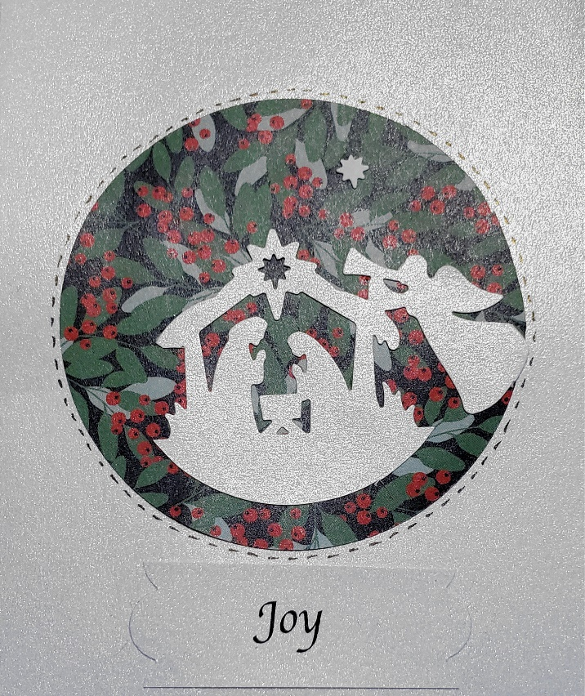
Scripture: Isaiah 12:2-6 CEV https://www.biblegateway.com/passage/?search=Isaiah+12%3A2-6&version=CEV
Contemplation and Conversation:
What brings you joy?
From Rev. Heather Leffler:
Isaiah creates a wonderful picture of a community coming together to worship God with joy. Hearing stories of God’s wonderful deeds and singing praises brings joy.
This time has been filled with wonderful stories, despite all the challenges we faced. Recognizing the incredible commitment of health care and essential workers, people around the world sang from balconies and porches, in the street and online each evening to say thank you. Watching children from across the country offering messages of thanks, warmed hearts. In our congregations, people recorded songs and shared pictures to lift our spirits. Singing Happy Birthday on Zoom has led to much laughter and delight.
O Lord, we give thanks for the songs and stories
that help us find joy in this time. Amen.
Whether you are at home trying to help slow the spread of the virus,
working to help care for those who are impacted most by COVID-19
or working to keep some normalcy in this time,
may you know God’s deep and abiding love in your life.
Know you are a valued part of our Rockwood and Stone United Church families.

Further Conversation … Would you like to talk more about today’s reflection? Email Heather at hleffler@rogers.com. Following worship next Sunday, she will invite others to join you in a Zoom break out room to share in further conversation.

Our Rockwood Stone Family
If you were not able to attend worship on Zoom or at Rockwood, you may want to watch the service on YouTube. The service can only be accessed through this link https://youtu.be/h_UhaBw4cFs .

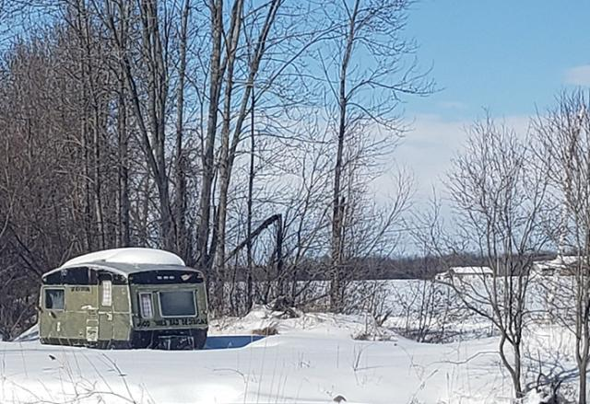
United Church of Canada
Trisha Elliott/The United Church of Canada
Sharing Warmth on the Coldest Nights
Can you imagine sleeping in this trailer in the dead of winter with no heat―or worse? In some Canadian communities, there are no shelters to turn to or public transit to rely on. Too often, people suffer alone.
“We first saw the problem when we began delivering firewood. One person put a woodstove into an old camper to stay warm. It was definitely not safe,” says Cathy Ashby, Executive Director at the House of Lazarus, a rural Mission & Service‒supported community outreach that offers food, clothing, and household goods to those in need. Ashby adds that she has found people sleeping in tents in late November and others who desperately try to heat their homes however they can.
Gary, a senior citizen, lives alone and is in poor health. He tries to keep warm by heating his house with wood. That’s fine―until he runs out. Gary doesn’t have a driver’s licence, so he can’t access social services in the city. Thankfully, a few months ago his doctor referred him to the House of Lazarus satellite location housed in a nearby United Church, where the Rev. Dan Hayward ministers.
“Gary would have starved or frozen to death without House of Lazarus intervening and getting him food and wood,” the Rev. Hayward says.
Homelessness and a lack of adequate, affordable housing affects every community in Canada. The pandemic has made the problem even worse. As colder and colder temperatures roll in, your support is needed more than ever. Working together, we can ensure everyone has a safe, warm, and affordable place to call home.
Thank you for supporting Mission and Service through Rockwood and Stone.
A gift of belonging to a church is that the practice of gathering together for worship … to pray, sing, listen to scripture and share how God touches our lives – helps us grow in deeper relationship to God and each other. With COVID-19 keeping us at home and physically distant from our Stone or Rockwood families, we are missing each other. We are offering this practice of sharing beyond Sunday morning to deepen our connection. Each week you will be offered a picture, a scripture and a question for contemplation, as well as a short reflection for you to contemplate, have conversation with people in your life and/or join an online conversation on our Rockwood Stone Facebook page.

