**Contemplation and Conversation: 3rd Sunday of Easter, May 1, 2022**

**Scripture: Psalm 30** <https://www.biblegateway.com/passage/?search=psalm+30&version=NRSV>

**From Rev. Heather Leffler:**

Many of us were raised to believe we needed to be strong … to always put our best face forward. Especially at church you were to wear your best clothes and be on your best behaviour no matter what was happening your life.

The truth is we are not always at our best. Each of us faces challenges as we journey through life. When we are forced to hide our struggles and weakness, it often impacts our mental, physical and spiritual health and our relationships.

The pandemic has shown us our well being depends on being with others. We see all around us the impacts of people being isolated and frustrated … angry protests, people shouting at care givers, service workers and politicians, erratic driving and other behaviours.

The Psalmist reminds us that just as each new day dawns, there will be an end to the struggles we face. In the meantime, the One who gave us life is always with us and if we are there for each other, we can share the burdens of the difficult times and rejoice together in the good times.

***Contemplation and Conversation***

*Who can you share your struggles and joys with?*

***Prayer***

*Ever present God, you see when we struggle and need support.  
Help us create brave space where we can listen to one another in love  
and feel you with us through prayerful presence. Amen.*

*Whether you are at home trying to help slow the spread of the virus,  
working to help care for those who are impacted most by COVID-19  
or working to keep some normalcy in this time,  
may you know God’s deep and abiding love in your life.  
Know you are a valued part of our Rockwood and Stone United Church families.*

**Further Conversation** … Would you like to talk more about today’s reflection? Email Heather at [hleffler@rogers.com](mailto:hleffler@rogers.com). Following worship next Sunday, she will invite others to join you in a Zoom break out room to share in further conversation.

**Our Rockwood Stone Family**

*If you missed today’s worship service, email* [*rockwoodstoneuc@gmail.com*](mailto:rockwoodstoneuc@gmail.com) *for a YouTube link.*

***Photo call:*** *We are looking for photos to be used during next week’s Offering Praise. If you have a picture that represents how you feel God’s presence in your life or something that reminds you that you are not alone, please email it to Lisa at* [*lleffler@live.ca*](mailto:lleffler@live.ca) *.*

***Wellness Day***

*On* ***Wednesday, May 4*** *from* ***2-5 pm***  *and*  ***6-9 pm*** *you are invited to drop into Stone for a time of quiet reflection, creative expression and/or connecting through conversation.*

*Some activities that will be available are:*

* *A space to chat with a friend*
* *Creative space with colouring pages, markers paint and a neurographic art tutorial*
* *A space to play with fidget toys, Lego, thinking putty, etc.*
* *A place to engage your body with meditation, body prayers, and breathing exercises*
* *A place to pray with quiet reflective music, pictures and prayer guides*

**Lent and Easter Scrabble** **Challenge**

**1st …** Congratulations to Peter and Liz Guthrie for scoring 651 points in our scrabble challenge.

**2nd …** Marg Baker came second with 539 points.

**3rd …** Barb Parker used all the tiles and was third with 384 points.

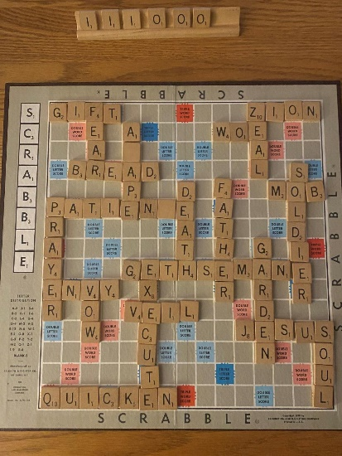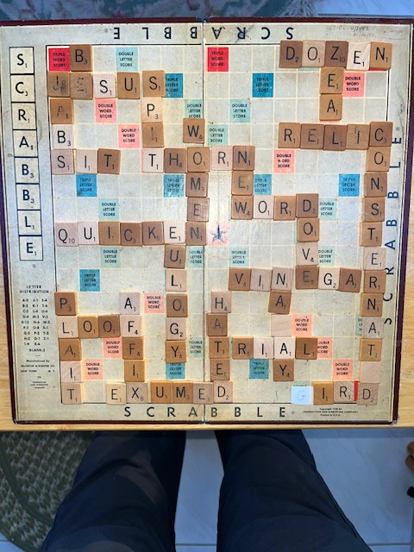

**United Church of Canada** *From Moderator Richard Bott for Mental Health Sunday*

We recognize,  
God of all life,  
all people, all places;  
that many of us continue to not understand  
issues of mental health—  
our own, and that of others’.  
For so many broken reasons  
stigma is placed upon folks  
living with mental health difficulties,  
building walls of isolation,  
rather than the support and love  
of beloved community;  
the support and love  
of radical belonging;  
the support and love  
that Jesus exemplified,  
over and over and over again.

Open our hearts, open our arms,  
open the ways to knowledge  
and comprehension—  
that all your beloved children  
would find safe home, here.  
Now.

Always.

We ask this in the name of the One whose hands and heart always reach out,

Jesus, the Christ.

Amen.

*A gift of belonging to a church is that the practice of gathering together for worship … to pray, sing, listen to scripture and share how God touches our lives – helps us grow in deeper relationship to God and each other. With COVID-19 keeping us at home and physically distant from our Stone or Rockwood families, we are missing each other. We are offering this practice of sharing beyond Sunday morning to deepen our connection. Each week you will be offered a picture, a scripture and a question for contemplation, as well as a short reflection for you to contemplate, have conversation with people in your life and/or join an online conversation on our Rockwood Stone Facebook page.*