Contemplation and Conversation: Trinity Sunday, May 30, 2021
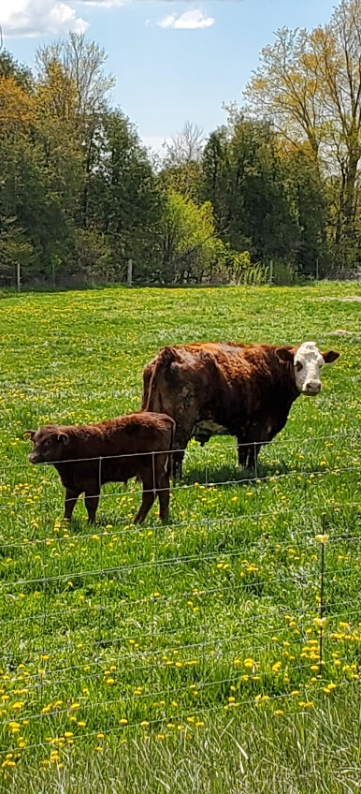
Scripture : Romans 8:12-17 https://www.biblegateway.com/passage/?search=Romans%208%3A12-17&version=NRSV
Contemplation and Conversation: What holds you back from giving God control of your life?
From Brian Mack:
It is Friday the 28th of May and it is snowing. I’m waiting for the veterinarian to arrive to do a re-check on a calf that has pneumonia. Dr. Rau is uncharacteristically late, so I know that something major has intervened that takes precedence over the re-check. While waiting, my mind has wandered to the fact that so many things in my life are not in my control. This is hard to accept because the human species likes to be in charge. From an early age, we reach out and attempt to manipulate our environment. We often seek to use our voice, our gestures, our status in society, and our experiences to obtain our objectives. We are comforted by the familiar—what is considered safe from our viewpoint is rooted in those circumstances which allow us to be in charge. We tend to be obsessed with the self. We tell ourselves that we can handle whatever life throws at us on our own.
In this passage, Paul offers an alternative to thinking that we must always be in charge. As Christians, we are challenged as heirs and co-heirs to be “in the Spirit” or “in Christ”. The journey will not be easy as we seek to overcome our fear of relinquishing control and to experience the freedom and peace that comes with turning control over to God. Through prayer and regular discernment, we are granted the opportunity to experience spiritual growth. Putting God in the driver’s seat provides for a lifelong process of change as we mature in our faith and in our relationship with the One, we call Holy Mystery and Wholly love. We come to a greater understanding of who God is and who we are when we relinquish control and allow God’s Spirit to freely connect with our spirit.
I am thankful that Dr. Rau was late. It gave me the much-needed time to reflect on scripture and to make sense of Paul’s teaching as it applies to my life concerning the rewards involved in turning things over to God. As it turned out, the calf had made a great recovery, and all is well with the world on the 7th line once again. Thanks be to God.

Whether you are at home trying to help slow the spread of the virus,
working to help care for those who are impacted most by COVID-19
or working to keep some normalcy in this time,
may you know God’s deep and abiding love in your life.
Know you are a valued part of our Rockwood and Stone United Church families.

Further Conversation … Would you like to talk more about today’s reflection? Email Heather at hleffler@rogers.com. Following worship next Sunday, she will invite others to join you in a Zoom break out room to share in further conversation.

From our Rockwood Stone Affirming Discernment Circle
The Guelph Chamber Choir, HIV/AIDS Resources and Community Health (ARCH), the Yott Family and Supporters present “The Giving Tree” An evening for Marly Yott (1995-2020)
2 short films: a moving tribute to a young trans person. A minister from WOW Region wrote: I belong to the Guelph Chamber Choir, and about a year ago a young trans person in our choir died, and it was a difficult time for everyone. At this time, 2 amazing short films have been created (some of which our choir sang for), and we are extending the invitation to anyone who wants to view them together this coming Monday evening, May 31st, 7:30PM EDT.To register (no cost) - https://bit.ly/343iYxl

United Church of Canada
Thank you! In 2020, your Mission & Service gifts:
- helped people at home and abroad struggling to put food on the table for their families
- ensured those who are most vulnerable receive medical care and personal protective equipment
- supported those who struggle with addiction and mental health issues to access counselling services
- created networks of support for young people whose rhythms and relationships are disrupted because of the virus
- provided emotional and spiritual care for those in hospital and their families as well as medical staff

A gift of belonging to a church is that the practice of gathering together for worship … to pray, sing, listen to scripture and share how God touches our lives – helps us grow in deeper relationship to God and each other. With COVID-19 keeping us at home and physically distant from our Stone or Rockwood families, we are missing each other. We are offering this practice of sharing beyond Sunday morning to deepen our connection. Each week you will be offered a picture, a scripture and a question for contemplation, as well as a short reflection for you to contemplate, have conversation with people in your life and/or join an online conversation on our Rockwood Stone Facebook page.

