Contemplation and Conversation: 6th Sunday after Pentecost, July 4, 2021
Scripture: Mark 6:1-13 https://www.biblegateway.com/passage/?search=Mark+6%3A1-13&version=NRSV
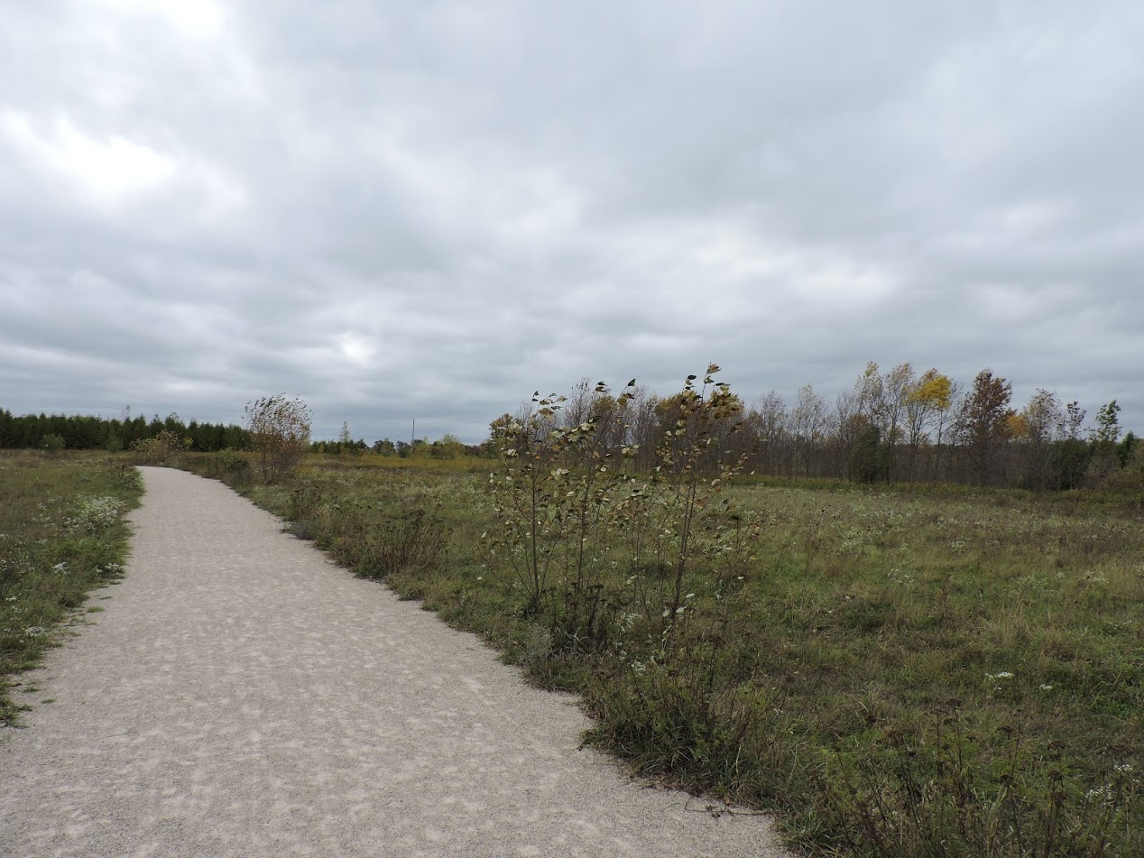
¹ He left that place and came to his hometown, and his disciples followed him. ² On the sabbath he began to teach in the synagogue, and many who heard him were astounded. They said, “Where did this man get all this? What is this wisdom that has been given to him? What deeds of power are being done by his hands! ³ Is not this the carpenter, the son of Mary and brother of James and Joses and Judas and Simon, and are not his sisters here with us?” And they took offense at him. ⁴ Then Jesus said to them, “Prophets are not without honor, except in their hometown, and among their own kin, and in their own house.” ⁵ And he could do no deed of power there, except that he laid his hands on a few sick people and cured them. ⁶ And he was amazed at their unbelief.
Then he went about among the villages teaching. ⁷ He called the twelve and began to send them out two by two, and gave them authority over the unclean spirits. ⁸ He ordered them to take nothing for their journey except a staff; no bread, no bag, no money in their belts; ⁹ but to wear sandals and not to put on two tunics. ¹⁰ He said to them, “Wherever you enter a house, stay there until you leave the place. ¹¹ If any place will not welcome you and they refuse to hear you, as you leave, shake off the dust that is on your feet as a testimony against them.” ¹² So they went out and proclaimed that all should repent. ¹³ They cast out many demons, and anointed with oil many who were sick and cured them.
Contemplation and Conversation:
What are you feeling or what questions are you wrestling with as we look to reopening?
From Brian Mack:
When Jesus commissioned the disciples, a sense of unease no doubt accompanied them as they went out into the community. Prior to their sending forth, he had shown them how to “minister” through his tactful active listening, through his story-telling, and through his actions of showing love and performing miracles. Now, they were given specific instructions as to how to go into the neighboring towns and villages. They were to travel in pairs, depend on those they encountered for physical nourishment, and depart quicky from places they were not welcomed.
As individuals, we are anxious to varying degrees on this first Sunday in July. As we experience the re-opening of our society, we are flooded with questions. Am I ready to leave the comfort of my home on a more regular basis? Will I be masked or not? Will I feel safe in buildings where ventilation may be a concern? How will I react to my neighbors who are not fully vaccinated? Am I ready to go into crowded inside spaces?
As a faith community, we will have many questions to wrestle with over the coming weeks, months, and even years. The doors of our churches will not simply be flung open for us to magically return to the “old ways”. Whether we like it or not, the “old ways” will be refined, re-tooled, and in some instances rejected as we adapt to the new reality of living in a COVID-19 world. Since March 2020, we have found new ways to gather virtually, to partake in missions, and to grow deeper in our walk with God. As we have shared our stories in Conversation time, we have been enriched. Our discussions in Bible Study concerning the teachings of the Apostle Paul have forced us to dig deep within ourselves and to take risks by questioning long held views. We have discovered creative ways to offer God praise and thanksgiving in word and in song. Over the course of the last sixteen months, God has been preparing us for new ways to be disciples and to be the Church. Through prayerful discernment, a new path is emerging as we take steps to safely balance the familiar with the potentialities of technology in hybrid worship. Like the apostles commissioned by Jesus, we are comforted in knowing that we are not venturing forth alone. In these times of both uncertainty and great possibility, we continue to put our trust in the one we call both Holy Mystery and Wholly Love. Thanks be to God.
Whether you are at home trying to help slow the spread of the virus,
working to help care for those who are impacted most by COVID-19
or working to keep some normalcy in this time,
may you know God’s deep and abiding love in your life.
Know you are a valued part of our Rockwood and Stone United Church families.

Further Conversation … Would you like to talk more about today’s reflection? Email Heather at hleffler@rogers.com. Following worship next Sunday, she will invite others to join you in a Zoom break out room to share in further conversation.

From our Rockwood Stone Affirming Discernment Circle and United Church of Canada
From The United Church of Canada
The month of June was celebrated across Canada as Pride Month. For this celebration, we interviewed three queer Christians of Asian descent who have found refuge in the affirming congregations of the United Church. We hope it brings encouragement to our congregations and a light of hope to those needing refuge and healing in their body, soul, and spirit. To view these videos, go to https://united-church.ca/blogs/round-table/celebrating-asian-lgbtqi-voices.
As a key theological tenet, The United Church "affirms that gender and sexuality are gifts of God, and that all persons are made in the image of God. We welcome into full membership and ministry people of all sexual orientations and gender identities. The United Church is opposed to discrimination against any person on any basis by which a person is devalued" (from "Commitment to Inclusion" in the United Church Commons).

A gift of belonging to a church is that the practice of gathering together for worship … to pray, sing, listen to scripture and share how God touches our lives – helps us grow in deeper relationship to God and each other. With COVID-19 keeping us at home and physically distant from our Stone or Rockwood families, we are missing each other. We are offering this practice of sharing beyond Sunday morning to deepen our connection. Each week you will be offered a picture, a scripture and a question for contemplation, as well as a short reflection for you to contemplate, have conversation with people in your life and/or join an online conversation on our Rockwood Stone Facebook page.

