Contemplation and Conversation: 2nd Sunday of Lent, March 13, 2022
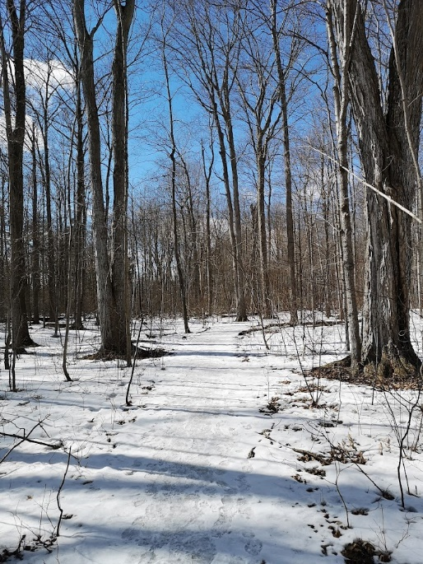
Scripture: John 14:1-7 CEV
¹ Jesus said to his disciples, “Don’t be worried! Have faith in God and have faith in me. ² There are many rooms in my Father’s house. I wouldn’t tell you this, unless it was true. I am going there to prepare a place for each of you. ³ After I have done this, I will come back and take you with me. Then we will be together. ⁴ You know the way to where I am going.”
⁵ Thomas said, “Lord, we don’t even know where you are going! How can we know the way?”
⁶ “I am the way, the truth, and the life!” Jesus answered. “Without me, no one can go to the Father. ⁷ If you had known me, you would have known the Father. But from now on, you do know him, and you have seen him.”
From Rev. Heather Leffler:
It was unimaginable. The disciples couldn’t take in what Jesus was saying. He was preparing them for his death and assuring them that his Spirit would still be with them, but it made no sense. Thomas couldn’t just nod and pretend he understood. He needed answers. If they didn’t know where Jesus was going, how could they possibly know the way?
Everyday we face new choices. Some paths are tried and true by people around us. We can follow them without question. In those other times when there are multiple paths, it is knowing Jesus is our way, our truth and our life that guides us.
Is the way I am about to embark on loving to myself, to those I care about, to the people and creation around me? Is it the choice I am making true to the One who wants only the best for me and all creation? Will my decision bring the fullness of life God longs for me?
Contemplation and Conversation: x
When has knowing Jesus helped me make a difficult decision?
Prayer
Holy Mystery and Wholly Love, thank you for the gift of knowing
Jesus, for the stories of his life and his teachings
that help me chose the loving way. Amen.

Whether you are at home trying to help slow the spread of the virus,
working to help care for those who are impacted most by COVID-19
or working to keep some normalcy in this time,
may you know God’s deep and abiding love in your life.
Know you are a valued part of our Rockwood and Stone United Church families.

Further Conversation … Would you like to talk more about today’s reflection? Email Heather at hleffler@rogers.com. Following worship next Sunday, she will invite others to join you in a Zoom break out room to share in further conversation.

Our Rockwood Stone Family
If you missed today’s worship service, email rockwoodstoneuc@gmail.com for a YouTube link.
Thanks to the 2021 Lenten Study Group for A Lenten Blessing shared in worship. It is posted at https://youtu.be/9xNdkFp82FQ and https://www.facebook.com/profile.php?id=100014279615194 .
United Church of Canada from Moderator Richard Bott, March 11, 2021
Over Six Million people
around the world...
thirty-seven thousand of them
neighbours, here in Canada...
dead from Covid-19, in all of its forms...
and millions upon millions more
whose lives have been changed,
by the grief over the death of loved ones,
by the illness, themselves.
God?
Help me to remember the last two years.
Help me to remember that each of the numbers
that will be spoken today,
represents real people, with real lives,
who are gone from this world,
because of this pandemic.
Even as I give thanks,
for all of the work that has been done,
to get us as safely as could be to this time,
two years later,
I will remember and grieve
all those who died.
As the masks go on and off,
as we continue to work for
vaccine equity, the world around,
help us, I pray,
to learn from these past two years,
and work for the good of all,
the health of all,
the life of all,
in the days and weeks, and years
to come.
In Jesus' name...
amen.

A gift of belonging to a church is that the practice of gathering together for worship … to pray, sing, listen to scripture and share how God touches our lives – helps us grow in deeper relationship to God and each other. With COVID-19 keeping us at home and physically distant from our Stone or Rockwood families, we are missing each other. We are offering this practice of sharing beyond Sunday morning to deepen our connection. Each week you will be offered a picture, a scripture and a question for contemplation, as well as a short reflection for you to contemplate, have conversation with people in your life and/or join an online conversation on our Rockwood Stone Facebook page.

