Contemplation and Conversation: Reign of Christ Sunday, November 21, 2021
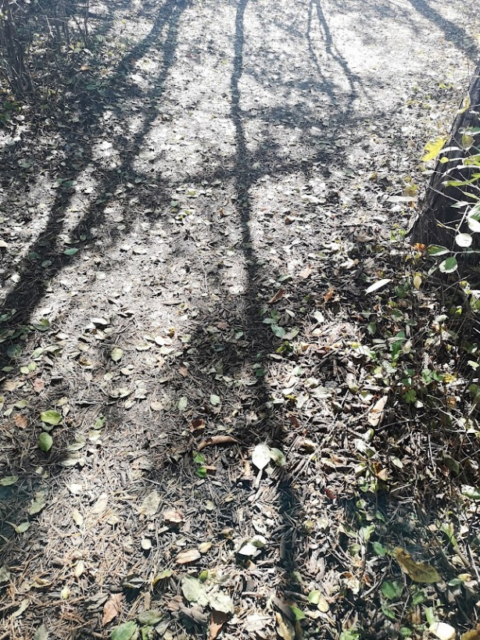
Scripture: John 18:33-37 https://www.biblegateway.com/passage/?search=John%2018%3A33-37&version=NRSV
Contemplation and Conversation:
What story of Jesus speaks to you today?
From Rev. Heather Leffler:
Today is reign of Christ Sunday. It is a day when we remember that Jesus was with God at the beginning of creation and came and walked with the people of Palestine at a particular time. Through his birth, ministry, death and resurrection he continues to touch people’s lives and he has promised that God’s kingdom will come on earth as it is in heaven.
Pilate and the Jewish people had a picture of a king in mind. They were looking for a king that would lead people into battle and defeat enemies.
Jesus is clear that is not what his kingdom looks like. His kingdom is one where a woman who has been bleeding for 12 years can reach out and touch the hem of his robe and be healed; where a crowd of thousands can be fed with five loaves and two small fish; and where Saul could turn from condemning Jesus’ followers to Paul leading them. Jesus’ kingdom is one where knowing him transforms our lives. Instead of taking care of our needs first we look after each other and instead of seeing scarcity we discover there is enough for everyone. May it be so.
Whether you are at home trying to help slow the spread of the virus,
working to help care for those who are impacted most by COVID-19
or working to keep some normalcy in this time,
may you know God’s deep and abiding love in your life.
Know you are a valued part of our Rockwood and Stone United Church families.

Further Conversation … Would you like to talk more about today’s reflection? Email Heather at hleffler@rogers.com. Following worship next Sunday, she will invite others to join you in a Zoom break out room to share in further conversation.

Our Rockwood Stone Family
From Worship … Prayers to Share by David Sparks
Loving God, enable us to prepare for the reign of Christ.
When the reign of Christ begins, all will be free to worship and to express their opinions.
When the reign of Christ begins, weapons of war will be destroyed and all children will be secure.
When the reign of Christ begins, Mother Earth will be respected and her waters will be pure.
When the reign of Christ begins, prayer and praise will flow spontaneously to God
and worship will be wholehearted and joyful.
But when will the reign of Christ begin?
We will bring it closer! Amen.

United Church of Canada Moderator Richard Bott on November 17, 2021
There is so much beauty from sea to sky,
on roads that twist and turn
along the sides of mountains,
where one can look down from dizzying heights
into valleys that are lush and green,
or into ocean waters, salty, and full of life;
and look up to see mountain peaks
that have stood, sturdy, far longer
than humankind has walked your earth, God!
But when the rains come down,
hard and fast,
turning the soil into liquid slurry,
tonnes upon tonnes of rock and mud will move
with an unimaginable force,
and the rivers rise, flooding more than the plains,
sweeping over and away everything in its path.
Nothing human-made can stand
in the face of that force,
God of all creation.
That is what the people of British Columbia
have been facing, these past days,
with loss of life;
with communities cut off from each other,
some lacking power,
some in places already touched by fire
this season.
We pray for those who have died or been injured,
and all those who are grieving;
we pray for the crews who are out,
trying to figure out how to clear the way,
safely;
we pray for those who are in need,
and those who are wondering, "What next?!";
and we pray that we would come together
as this community of Canada,
to offer what support is needed.
And, God, we pray that the rains would quiet,
to their normal, seasonal, flow;
that the land would remain sturdy,
that we would be held by its beauty,
once again.
Amen.

A gift of belonging to a church is that the practice of gathering together for worship … to pray, sing, listen to scripture and share how God touches our lives – helps us grow in deeper relationship to God and each other. With COVID-19 keeping us at home and physically distant from our Stone or Rockwood families, we are missing each other. We are offering this practice of sharing beyond Sunday morning to deepen our connection. Each week you will be offered a picture, a scripture and a question for contemplation, as well as a short reflection for you to contemplate, have conversation with people in your life and/or join an online conversation on our Rockwood Stone Facebook page.

