Contemplation and Conversation: 4th Sunday of Advent, December 19, 2021
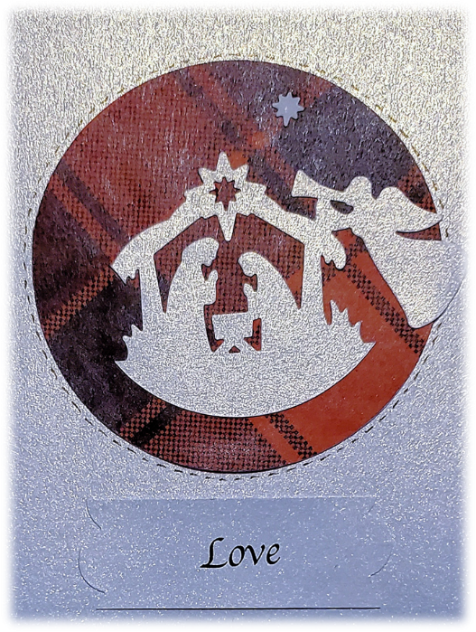
Scripture: Luke 1:47-55 CEV https://www.biblegateway.com/passage/?search=Luke+1%3A47-55&version=CEV
Contemplation and Conversation: What relationship has deepened for you in this time?
From Rev. Heather Leffler:
After the angel visited her and told her that she would give birth to the Son of God, Mary went to visit Zechariah and Elizabeth. Elizabeth’s baby leaped for joy in her womb as the cousins embraced. Mary’s heart was filled with song. She trusted that God’s love would come into the world and transform it.
During lockdown people reached out in countless ways… checking on neighbours and dropping off groceries … joining with firetrucks, cars and trucks to celebrate birthdays and special occasions … painting colourful messages of hope on rocks and sidewalks … wrestling with new technology and then encouraging others to meet with family and church family online ... and so many more. The pandemic has reminded us to take time to reach out in love.
Loving God, transform us so that our words and actions
share your love and transform your world. Amen.
Whether you are at home trying to help slow the spread of the virus,
working to help care for those who are impacted most by COVID-19
or working to keep some normalcy in this time,
may you know God’s deep and abiding love in your life.
Know you are a valued part of our Rockwood and Stone United Church families.

Further Conversation … Would you like to talk more about today’s reflection? Email Heather at hleffler@rogers.com. Following worship next Sunday, she will invite others to join you in a Zoom break out room to share in further conversation.

Our Rockwood Stone Family
Just a reminder that our worship will be on Zoom each Sunday at 10 am. Please join us.
Reach out to someone in our church family. If they are lonely, you will brighten their day. If you are lonely, you will know you are not alone in this challenging time.

United Church of Canada from Moderator Richard Bott, December 17 at 6:59 pm·
When I put on my mask,
I will unmask my heart.
When I wash my hands,
it is an act of prayer.
When my body responds
to the vaccine's task,
I will take the time to sit and be.
As plans need to change,
and family is far away,
as frustrations and fears
gnaw away at my calm,
help me, my God,
to live in Advent waiting,
and to love in Christmas joy.
Turn my grumbles into laughter,
my eye-rolling into smiles,
my challenge into possibility...
and, in all of it,
help me to be one of those shepherds,
leaving the Christ child,
and sharing - for the rest of my life -
everything I have seen and heard,
all of the peace, and hope, and love, and joy
that Christmas,
(even *this* Christmas!)
pours into my heart.
Amen, beloved God...
Alleluia, Amen.

A gift of belonging to a church is that the practice of gathering together for worship … to pray, sing, listen to scripture and share how God touches our lives – helps us grow in deeper relationship to God and each other. With COVID-19 keeping us at home and physically distant from our Stone or Rockwood families, we are missing each other. We are offering this practice of sharing beyond Sunday morning to deepen our connection. Each week you will be offered a picture, a scripture and a question for contemplation, as well as a short reflection for you to contemplate, have conversation with people in your life and/or join an online conversation on our Rockwood Stone Facebook page.

