Contemplation and Conversation: 5th Sunday after Epiphany, February 7, 2020
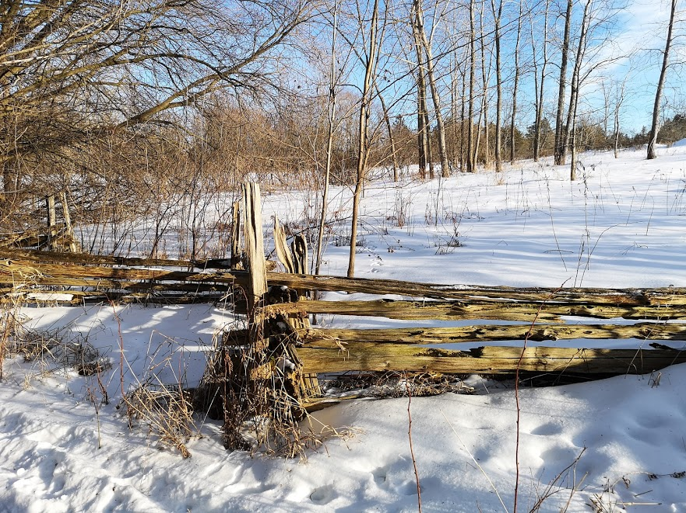
Scripture: Mark 1:29-39 https://www.biblegateway.com/passage/?search=mark+1%3A29-39&version=NRSV
Contemplation and Conversation: When have you found gift in returning to a task?
From Rev. Heather Leffler:
Simon Peter’s mother-in-law was in bed with a fever. When Jesus came to the house, they told him about her illness. Jesus took her by the hand, lifted her up and her fever left her. She immediately began to serve Jesus and his companions. We aren’t told how she served, but I imagine her being filled with joy that she was well and could provide a meal for the One who healed her.
Sometimes its illness, sometimes busyness that hold us back from doing something that needs to be done. Sometimes we just can’t find the motivation to complete a task or project. When we feel better or life slows down (even if that slow down is forced by a pandemic) or the mental fog that held us back clears, it can be a wonderful gift to work especially if that work makes a difference in someone else’s life. Jesus’ healing comes in many forms as do our responses to that healing. May you experience Jesus’ healing where you need it most and you may find joy in the work you are given.

Whether you are at home trying to help slow the spread of the virus,
working to help care for those who are impacted most by COVID-19
or working to keep some normalcy in this time,
may you know God’s deep and abiding love in your life.
Know you are a valued part of our Rockwood and Stone United Church families.

Further Conversation … Would you like to talk more about today’s reflection? Email Heather at hleffler@rogers.com. Following worship next Sunday, she will invite others to join you in a Zoom break out room to share in further conversation.

From our Rockwood Stone Affirming Discernment Circle
We invite you to watch this Minute for Mission which reflects on Black History Month in our United Church of Canada https://www.youtube.com/watch?v=LqHH9Tm63R8.

United Church of Canada Moderator Richard Bott shared this 8:38 minute video https://www.facebook.com/ModeratorRichardBott/videos/727581141330210 a response from members of the Black Clergy Network in The United Church of Canada to the Black Lives Matter protests is worth revisiting in this Black History month.
A gift of belonging to a church is that the practice of gathering together for worship … to pray, sing, listen to scripture and share how God touches our lives – helps us grow in deeper relationship to God and each other. With COVID-19 keeping us at home and physically distant from our Stone or Rockwood families, we are missing each other. We are offering this practice of sharing beyond Sunday morning to deepen our connection. Each week you will be offered a picture, a scripture and a question for contemplation, as well as a short reflection for you to contemplate, have conversation with people in your life and/or join an online conversation on our Rockwood Stone Facebook page.

