Contemplation and Conversation: 2nd Sunday of Lent, February 28, 2021
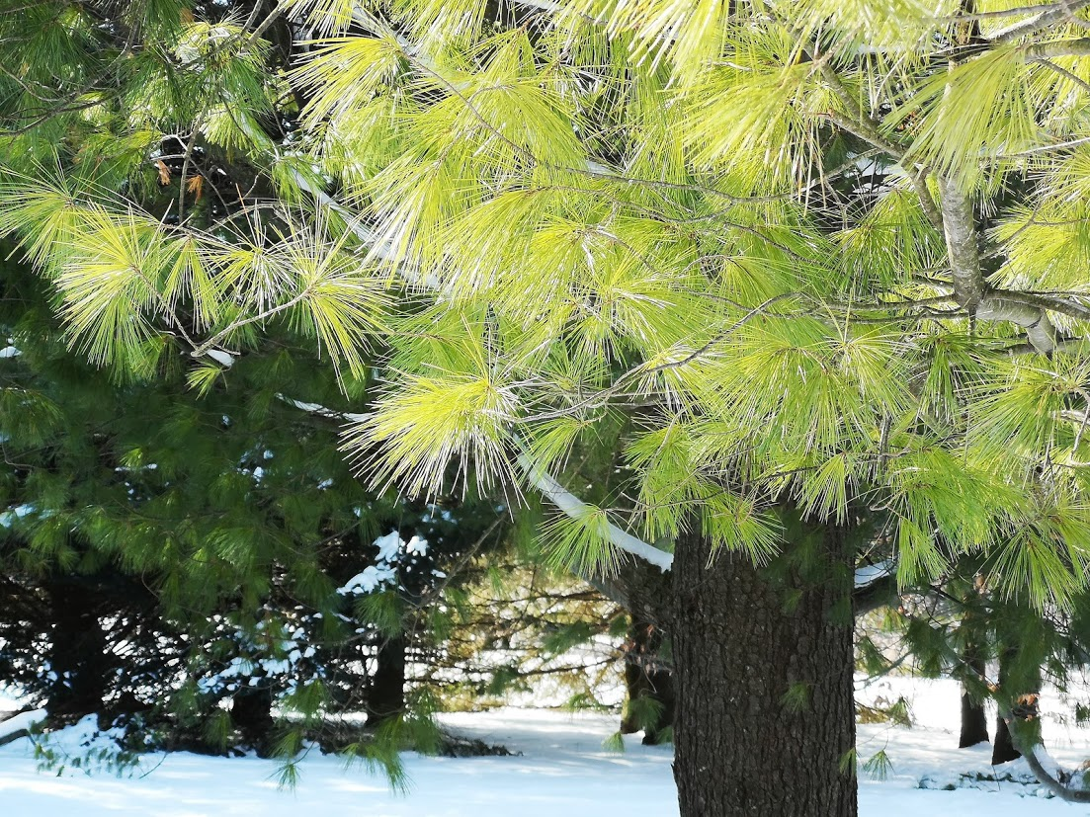
Scripture: Mark 8:31-38 NRSV https://www.biblegateway.com/passage/?search=Mark%208:31-38&version=NRSV
Contemplation and Conversation:
What does it mean for you to be a follower of Jesus?
What gets in the way of you following Jesus?
From Rev. Heather Leffler:
This is an especially challenging passage and would be easy to skip over. Pausing to think about Peter’s response to Jesus challenges me to ask if I let things get in the way of following Jesus.
Peter and the other disciples had travelled with Jesus for three years. They watched him feed people who were hungry, heal people who were sick, and stand with people who were oppressed or isolated. They believed he was the Messiah and trusted that he was changing the world around them.
How could Jesus say that he must be killed and rise again? Peter couldn’t let himself imagine this. What would they do without Jesus? He might be forgiven for wondering what would happen to him and the other disciples if Jesus was killed. Would their lives be at risk?
While we don’t face the kind of danger Jesus and his disciples faced, there are times our faith sets us apart from family and friends. There are other times the Spirit invites us to take a next step in prayer or serving and we hesitate, like Peter, for fear of how our lives will be impacted.
Jesus was clear, following him will not always be easy. Following him will make a difference in our lives and the world. May it be so.
Whether you are at home trying to help slow the spread of the virus,
working to help care for those who are impacted most by COVID-19
or working to keep some normalcy in this time,
may you know God’s deep and abiding love in your life.
Know you are a valued part of our Rockwood and Stone United Church families.

Further Conversation … Would you like to talk more about today’s reflection? Email Heather at hleffler@rogers.com. Following worship next Sunday, she will invite others to join you in a Zoom break out room to share in further conversation.

Links from Worship
Thanks to Brent Stiles for our special music today. https://youtu.be/KdR3neoYm5k .
The Mission and Service video can be found at https://youtu.be/Cs-JTMFt5TE?list=PLQDu-SgFb3Rjbi4t2qvhNhbEA17GXiLNo .

From our Rockwood Stone Affirming Discernment Circle
We invite you to listen to these stories about how the pandemic has affected people with disabilities and the transgender community.
https://www.cbc.ca/news/canada/kitchener-waterloo/disability-transgender-pandemic-impacts-1.5889984

United Church of Canada
Pastor Samuel Vauvert Dansokho recounts the devastating and lasting impact of colonialism on Africa. https://united-church.ca/blogs/round-table/come-join-me-under-palaver-tree
A gift of belonging to a church is that the practice of gathering together for worship … to pray, sing, listen to scripture and share how God touches our lives – helps us grow in deeper relationship to God and each other. With COVID-19 keeping us at home and physically distant from our Stone or Rockwood families, we are missing each other. We are offering this practice of sharing beyond Sunday morning to deepen our connection. Each week you will be offered a picture, a scripture and a question for contemplation, as well as a short reflection for you to contemplate, have conversation with people in your life and/or join an online conversation on our Rockwood Stone Facebook page.

