Contemplation and Conversation: 4th Sunday after Pentecost, June 20, 2021
Scripture: Psalm 133 https://www.biblegateway.com/passage/?search=Psalm%20133&version=NRSV
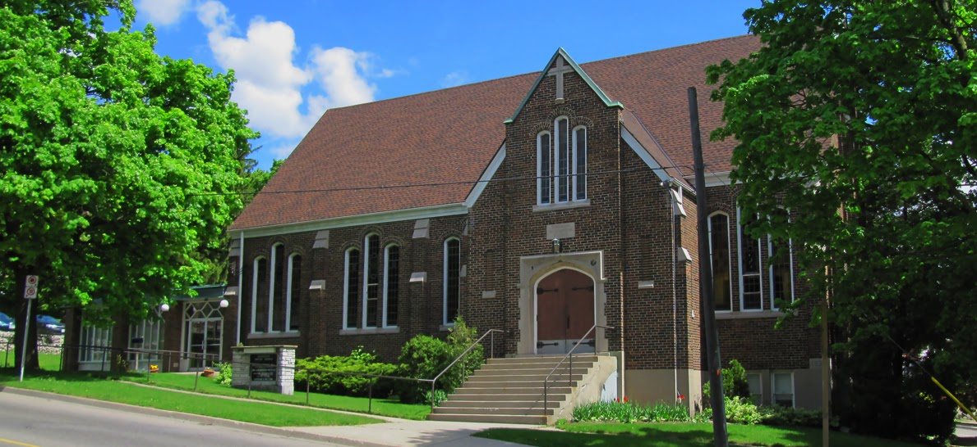
¹How very good and pleasant it is
when kindred live together in unity!
²It is like the precious oil on the head,
running down upon the beard,
on the beard of Aaron,
running down over the collar of his robes.
³It is like the dew of Hermon,
which falls on the mountains of Zion.
For there the Lord ordained his blessing,
life forevermore.
Contemplation and Conversation:
What is good and pleasant about being part of Rockwood and Stone United Churches?
From Rev. Heather Leffler:
The church has always been part of my life. Growing up it was the place where I met four generations of my mom and dad’s family each Sunday. We worshipped together, took part in Sunday School and studies, fundraisers and other activities, arranged family gatherings and celebrated special events and the lives of those we loved. The church was so much a part of the fabric of our lives I never thought about how I would describe what it meant to me.
Entering ministry and serving four wonderful congregations over the last 22 years, I began to realize how hard it is for those of us who are active in the church to describe what it means to us. It is challenging to convince our children and grandchildren who grew up with “Don’t eat those squares they are for the church” or “Shh … quiet the minister is talking” or “We have tried that before” to know that they are welcome and valued as part of the church.
One of the things we have learned in the pandemic is how much being “kindred liv[ing] together in unity” has meant for us in this time. Worshipping on Zoom, sharing reflections, phone, calls and emails, and socially distanced visits and fundraisers has drawn us closer as Rockwood and Stone congregations. It has offered us a place to sort through or set aside the noise and confusion of contradictory messages and grounded us in the love of God we know through Jesus. We have had the chance to share our joys and challenges and been assured we are not alone. This time has reminded us that being a part of our church family is indeed a gift. I pray this time helps us find the words to share this gift with others so they may experience the blessing of our Lord forever more.

Whether you are at home trying to help slow the spread of the virus,
working to help care for those who are impacted most by COVID-19
or working to keep some normalcy in this time,
may you know God’s deep and abiding love in your life.
Know you are a valued part of our Rockwood and Stone United Church families.

Further Conversation … Would you like to talk more about today’s reflection? Email Heather at hleffler@rogers.com. Following worship next Sunday, she will invite others to join you in a Zoom break out room to share in further conversation.

Our Church Family
We were grateful to have Rev. Tim Reaburn, a member of Affirm United, speak last week for Rockwood’s 154th Anniversary. You can find Tim’s message for us on our YouTube Channel https://youtu.be/pR_OYLG-N64 or read the attached transcript.

From our Rockwood Stone Affirming Discernment Circle
We would like to lift up this virtual event at the Milton Public Library.
Join Milton Public Library for a virtual and engaging discussion with author Joshua Whitehead to discuss his 2021 Canada Reads Winner Jonny Appleseed.
"You're gonna need a rock and a whole lotta medicine" is a mantra that Jonny Appleseed, a young Two-Spirit/Indigiqueer, repeats to himself in this vivid and utterly compelling novel. Off the reserve and trying to find ways to live and love in the big city, Jonny becomes a cybersex worker who fetishizes himself in order to make a living. Self-ordained as an NDN glitter princess, Jonny has one week before he must return to the "rez," and his former life, to attend the funeral of his stepfather. The next seven days are like a fevered dream: stories of love, trauma, sex, kinship, ambition, and the heartbreaking recollection of his beloved kokum (grandmother). Jonny's world is a series of breakages, appendages, and linkages--and as he goes through the motions of preparing to return home, he learns how to put together the pieces of his life. Jonny Appleseed is a unique, shattering vision of Indigenous life, full of grit, glitter, and dreams.
https://www.crowdcast.io/e/an-evening-with-author-8/register

The United Church of Canada and National Indigenous Peoples Day
June 21, 2021 is the national 25th anniversary of celebrating the heritage, diverse cultures and outstanding achievements of First Nations, Inuit and Metis peoples. To learn more about National Indigenous Day go to the Government of Canada website https://www.rcaanc-cirnac.gc.ca/eng/1100100013248/1534872397533.
The United Church of Canada offers opportunities for Prayer, Action and Community at https://united-church.ca/social-action/justice-initiatives/reconciliation-and-indigenous-justice/prayer-action-and-community .

A gift of belonging to a church is that the practice of gathering together for worship … to pray, sing, listen to scripture and share how God touches our lives – helps us grow in deeper relationship to God and each other. With COVID-19 keeping us at home and physically distant from our Stone or Rockwood families, we are missing each other. We are offering this practice of sharing beyond Sunday morning to deepen our connection. Each week you will be offered a picture, a scripture and a question for contemplation, as well as a short reflection for you to contemplate, have conversation with people in your life and/or join an online conversation on our Rockwood Stone Facebook page.

